**A WEB-BASED RENTAL HOUSE LOCATOR WITH FILTERED**

**SEARCH AND MAPPING**

Undergraduate Capstone Project

Submitted to the Faculty of the

Department of Computer Studies of the

Cavite State University-CCAT Campus

Rosario, Cavite

In partial fulfilment

of the requirements for the degree of

Bachelor Science in Information Technology

**ALEX B. BANUG JR.**

**MARVIN D. NOEL**

May 2024

# **APPROVAL SHEET**



# **BIOGRAPHICAL DATA**

Alex B. Banug Jr. was born on October 20, 2001 in Pasig City. He is the second eldest of the six children of Mr. Alex L. Banug Sr. and Ms. Jenalyn B. Banug. He lives in Naic, Cavite.

In 2014, he finished his elementary at Petronilo L. Torres Memorial Elementary School in Sabang Naic, Cavite. He finished her junior high school in Ciudad Nuevo De Naic National High School at Sabang Naic, Cavite in 2018. His senior high school was taken in Amaya School of Home Industries at Sahud-Ulan, Tanza, Cavite and he finished in 2020 with honors.

He is now currently in college taking a Bachelor of Science in Computer Science at Cavite State University - CCAT Campus.

**BIOGRAPHICAL DATA**

Marvin D. Noel was born on January 26, 2002 in Las Piñas. He is the eldest of the two children of Mr. Felix Venida and Ms. Marlyn Venida and currently lives in Naic, Cavite.

In 2014, he finished his elementary at Masville Elementary School in Sucat Parañaque. He finished his junior high school in Ciudad Nuevo De Naic National High School at Sabang, Naic Cavite in 2018. His senior high school was taken in Amaya School of Home Industries at Halayhay, Sahud Ulan Tanza Cavite and he finished in 2020 with honors.

He is now currently in college taking Bachelor of Science in Information Technology at Cavite State University - CCAT Campus

**BIOGRAPHICAL DATA**

Juana B. dela Cruz was born on April 11, 2001, in Tabon 2, Kawit, Cavite. She is the eldest of the three children of Mr. John C. dela Cruz and Mrs. Juana D. dela Cruz. She lives in Tanza, Cavite.

In 2012, she finished his elementary at Amaya Elementary School in Amaya 2, Tanza, Cavite. She finished his junior high school in Amaya School of Home Industries at Sahud-Ulan, Tanza, Cavite in 2016 with Honors. Her senior high school was taken in Montessori Professional College of Asia-Bacoor Branch at Habay 2, Bacoor City, Cavite and she finished in 2018 with high honors.

She earned his degree in Bachelor of Science in Information Technology at Cavite State University-CCAT Campus in 2024.

# **ACKNOWLEDGMENT**

The authors would like to extend their warmest thanks and gratitude to the following persons who had been part of the conduct of this study:

Dr. Jose P. Rizal, capstone project adviser, for guiding and providing the researchers with the comments and suggestions which greatly contributed in the success of the study.

Dr. Pedro A. dela Cruz, technical critic, for giving them complete guidance and encouragement;

Ms. Jenery Y. Abad and Mr. Renato M. Bautista, DCS research coordinator, for their professional assessment and review of this capstone project;

Prof. Karlo Jose E. Nabablit, department chairperson, for had shared and for his professional assessment of this capstone project;

Dr. Aries M. Gelera, director of research and extension, for his..

Dr. Ariel G. Santos, director of instructions, for his…

Dr. Lauro B. Pascua, campus administrator, for his approval of this capstone project.

Their respondents, tester and evaluators of the system, for sharing their time and efforts in helping to accomplish the study.

Their classmates..

Their family…

Most importantly, to God Almighty, for all the strengths, guidance, and protection to the researchers to accomplish this research.

**THE AUTHORS**

# **ABSTRACT**

**ESTONILO, CHRISTOPHER G., GELERA, ARIES M., MUYOT, ALLEN JHON C., NABABLIT, KARLO JOSE E. Development of a Computerized Scheduling System for Computer Laboratory of Cavite State University-CCAT Campus.** Undergraduate Capstone Project. Bachelor of Science in Information Technology. Cavite State University-CCAT Campus, Rosario,Cavite. May 2024. Adviser: Dr. Jose P. Rizal. Technical Critic: Mr. Pedro A. dela Cruz.

Abstract states the time and place, objectives, methods, and overall results of evaluation of the system. Maximum of 200 words.

# **TABLE OF CONTENTS**

**APPROVAL SHEET ii**

**BIOGRAPHICAL DATA iii**

**ACKNOWLEDGMENT vi**

**ABSTRACT vii**

**TABLE OF CONTENTS viii**

**LIST OF TABLES x**

**LIST OF FIGURES xi**

**LIST OF APPENDIX TABLES xii**

**LIST OF APPENDIX FIGURES xiii**

**LIST OF APPENDICES xiv**

**INTRODUCTION 1**

Project Context 2

Objectives of the Study 2

Purpose and Description 3

Time and Place of the Study 3

Scope and Limitation of the Study 3

Conceptual Framework 3

Definition of Terms 4

**REVIEW OF RELATED LITERATURE 5**

Related Literature/Studies 5

System Technical Background 5

Synthesis 6

**METHODOLOGY** 7

Design of Software, Systems, Product and/or Processes 7

Requirement Analysis 8

Requirement Documentation 10

System Development 10

System Testing 10

System Evaluation 10

Implementation Plan 14

**RESULTS AND DISCUSSION** 16

System Design and Development 16

System Testing 16

System Evaluation 17

System Implementation 21

**SUMMARY, CONCLUSION AND RECOMMENDATIONS** 23

Summary 23

Conclusion 23

Recommendations 23

**REFERENCES** 24

**APPENDIX TABLE** 25

**APPENDIX FIGURES** 26

**APPENDICES** 27

# **LIST OF TABLES**

**Table Page**

Table 1. List of technical resources available in the organization 9

Table 2. Estimated cost of the system 9

Table 3. Software and data quality evaluation instrument 11

Table 4. Descriptive interpretation of the mean 14

Table 5. Implementation plan 14

Table 6. Functional testing 16

Table 7. Distribution of the evaluators 17

Table 8. Perception of the respondents on functional suitability 17

Table 9. Perception of the respondents on performance efficiency 17

Table 10. Perception of the respondents on compatibility of the system 18

Table 11. Perception of the respondents on interaction capability of the system 18

Table 12. Perception of the respondents on reliability of the system 19

Table 13. Perception of the respondents on security of the system 19

Table 14. Perception of the respondents on security of the system 20

Table 15. Perception of the respondents on flexibility of the system 20

Table 16. Perception of the respondents on the safety of the system 20

Table 17. Summary of the perception of the evaluators 21

Table 18. Summary of implementation results 22

# **LIST OF FIGURES**

**Figure Page**

Figure 1. Conceptual framework of the study 4

Figure 2. HIPO diagram of the system 7

Figure 3. Use-case diagram of the system 7

Figure 4. Graphical user interface of the system 8

Figure 5. Fishbone diagram of the system 9

Figure 6. Software methodology of the system using RAD 10

Figure 7. Login screen 16

# **LIST OF APPENDIX TABLES**

**Appendix Table Page**

Appendix Table 1. Title of Appendix Table 1 25

Appendix Table 2. Title of Appendix Table 2 25

# **LIST OF APPENDIX FIGURES**

**Appendix Figure Page**

Appendix Figure 1. Title of Appendix Figure 1 26

Appendix Figure 2. Title of Appendix Figure 2 26

# **LIST OF APPENDICES**

**Appendix Page**

Appendix A. Relevant Source Code 27

Appendix B. Evaluation Tool or Test Documents 27

Appendix C. Sample Input/Output/Reports 27

Appendix D. User’s Guide 27

Appendix E. Process/Data/Information Flow 27

Appendix F. Screen Layouts 27

Appendix G. Test Results 27

Appendix H. Sample Generated Outputs 27

Appendix I. Photo Documentation (during data gathering and evaluation) 27

Appendix J. Curriculum Vitae 27

Appendix K. Request for Title Approval Defense 27

Appendix L. Title Approval Sheet 27

Appendix M. Request for Adviser and Technical Critic 27

Appendix N. Program of Work (Gantt Chart) 28

Appendix O. Budgetary Requirements 28

Appendix P. Request for Proposal Defense 28

Appendix Q. Proposal Defense Evaluation 28

Appendix R. Outline Approval Sheet 28

Appendix S. Routing Slip before ERB 28

Appendix T. Certificate of Approval (Ethics Review Board) 28

Appendix U. Request for Final Defense 28

Appendix V. Final Defense Evaluation 28

Appendix W. Certificate of Completion 28

Appendix X. Routing Slip 28

Appendix Y. Certificate from the English Critic 28

**DEVELOPMENT OF A COMPUTERIZED SCHEDULING SYSTEM**

**FOR COMPUTER LABORATORY OF CAVITE STATE**

**UNIVERSITY-CCAT CAMPUS**

**CHRISTOPHER G. ESTONILO**

**ARIES M. GELERA**

**ALLEN JHON C. MUYOT**

**KARLO JOSE E. NABABLIT**

An undergraduate capstone project manuscript submitted to the faculty of the Department of Information Technology, Cavite State University-CCAT Campus, Rosario, Cavite in partial fulfillment for the degree of Bachelor of Science in Information Technology. Contribution No. _______________. Prepared under the supervision of Dr. Jose P. Rizal and Mr. Pedro A. dela Cruz.

# **INTRODUCTION**

Providing a safe and secure shelter is a basic human need. It protects us from the elements, provides privacy, and acts as the foundation for both physical and mental health. It is what humanity intended for home. Having a roof over our heads allows us to sleep well, store our stuff, and create a relaxing and healthy environment. Many people cannot afford to be homeowners or to purchase land on which to build a permanent home owing to a lack of funds, or their salary is only enough to feed their family every day, so they prefer to rent a home.

Rental property owners, often known as landlords, provide a home for renters who are with a group, family, or individual who are looking for a place to stay for months or on a contract basis. Once the property is bought, the rental owners will collect the rental payment as per their agreement with the renter, which will continue until the next due date. There are numerous rental housings throughout the city that people may be interested in based on their individual circumstances and personal needs, which is why they are important to the economy because of their convenience and play a critical role. As crucial as it may appear, many rental housings are inaccessible or difficult to locate due to their location and position in the neighborhood. Despite its convenience, it lacks a commercial potential to attract a tenant, which may impede their company; nevertheless, such a problem can be solved by utilizing technology and the power of the Internet.

## The researcher’s solution is to create a web application entitled “A web-based rental house locator with filtered search and mapping” where both renter and property owner can benefit. The renter can locate a nearby rental house base on his/her preferences and which to think more affordable. The property owner can showcase and display his/her rental house and attract a potential tenant by the use of the website and with the locator embedded, it can trace the location of its position to the renter who might use the said web application.

## **Project Context**

Finding suitable rental property in the ever-changing world of urban living has become a major challenge for both individuals and families. Rent that is commonly heard of, is a source of revenue gained by the ownership, control, or possession of valuable assets in the face of little to no competition (Christophers, 2019). Rent-generating assets do not always have to be land but they could be financial assets or intellectual property, for example. However, land is undoubtedly the most rentable asset. According to James Chen (2022), homes bought by an investor and leased to tenants under some other forms of rental agreement are referred to as residential rental property. These homes serve as a vital part of the housing market, giving people and families a place to live while also giving investors a way to make rental income and perhaps even experience long-term capital growth.

The challenges faced by someone especially, newcomers in a city, such as their unfamiliarity with the area and the time-consuming nature of finding a suitable rental house without proper context, result in a state of confusion and frustration. Spending too much money on a place to live or stay is out of the question because it can be difficult if you run out of money, especially if you're a low-income earner or rely solely on parental allowance. Buying pricey locations and you'll never make money (Smith, 2023). While rent control rules and regulations vary by location, most rent control consists of price rises caps within the period of a tenancy, and sometimes beyond the duration of a tenant, as well as eviction restrictions (Diamond, 2018). The appearance of a rental house is far more crucial for the renter in terms of their preferences and health concerns. Rental properties are more likely to have mold than other types of homes. This is a problem because excessive mold development is known to be harmful to human health (Bently et al, 2023). This is why most renters are cautious to rent residences in a given location or condition. Finding an affordable rental house can be challenging for someone who is saving money or who is on a tight budget for several months (Ward, 2017). Students and other boarders are also the one’s affected in an instance looking for an affordable rental housing. According to Lamudi.com (2021), many students have trouble obtaining suitable and inexpensive student accommodation due to high demand for spaces near schools or higher prices for freshly developed ones. These issues are constantly destroying the peace of mind of any tenants who aspires to find and rent a residence.

As the world's population continues to concentrate in cities, there is a greater need for efficient and user-friendly solutions for finding rental properties. With the widespread use of technology and the increasing reliance on web applications, there is an opportunity to employ technology to simplify the house-hunting process. The impact of information and communication technologies (ICT) on how people search for rental property has been significant. The incorporation of ICT technologies into the real estate sector has not only streamlined but also made the process more accessible and efficient in this digital era.

The project entitled A Web-Based Rental House Locator with Filtered Search and Mapping is one of the products of the ICT technologies in progress that will develop an innovative Web-based application that will simplify the process of discovering rental properties while increasing the user search experience. The program will contain complex features such as filtered search functionality and interactive mapping to allow users to tailor their search to their specific interests and needs. The incorporation of new application aims to improve not only the efficiency of finding rental properties, but also the user experience.

## **Objectives of the Study**

The objective of the study is to provide an innovative web application that can simplify the finding of rental houses/apartments when the renters need and to showcase the rental housing of the property owner. Specifically, this study aims to:

1. develop a project title “A Web-Based Rental House Locator with Filtered Search and Mapping” using Visual Studio as a software material with JavaScript as programming language, and MySQL for database included and the following features:

a. User Registration and Login - It allows the user to create an account and login to start personalizing their experience in finding a rental house using the mobile application.

b. Filtered Search - Allow the users to use filters like location, price range, number of bedrooms, amenities, and more.

c. Mapping Interface - Using a map interface to display rental property listings in a certain area.

d. Property Description - It consists of a detailed property description of a rental house/ apartment such as images, rental terms, the contact information, etc. that is chosen by the user.

e. Booking – Allows users to save the rental house that they might settle in based on users own preferences and interest.

2. evaluate the apartment management system using the modified International Organization for Standardization and International Electro-technical Commission (ISO-IEC) 25010; and

3. deploy the website to a web hosting site to make it available on the web. monitor the website performance continuously to ensure seamless functioning and user experience.

## **Purpose and Description**

The purpose of creating a mobile application titled "A Web-Based Rental House Locator with Filtered Search and Mapping" is to help consumers find rental houses or apartments more successfully. The project's purpose is to provide a user-friendly interface that allows users to search for rental properties based on certain criteria and visualize them on a map, improving the entire rental property search experience. Those who will benefit include the following:

Renters - Individuals or families looking for rental houses are the key benefits. The program simplifies the process of discovering suitable rental houses, saving users time and effort.

Property Owner - Increased visibility for rental listings benefits both property owners and real estate agents. The software could attract potential tenants while also making the property advertising process more effective.

Developer - The app's developers benefit from building a functional and potentially popular application, which may lead to financial benefits, recognition, and future development opportunities.

**Time and Place of the Study**

The study will be conducted at Tejeros Convention from December 2023 to May 2024.

**Scope and Limitation of the Study**

This study focused on developing the web-based rental house locator that may help the renters easily locate their preferred rental houses around the area in Tejeros Convention. The study was conducted during December 2023 to May 2024.

Furthermore, this study will not extend to the factors that may include any kind of payment method. Also, the web application’s effectiveness only relies on an internet connection for real-time data retrieval and communication.

**Conceptual Framework**

This section uses the Input-Process-Output (IPO) model that will provide the general structure and guide for the direction of the study as shown in Figure 1.

Evaluation

**Figure 1. Conceptual framework of the study**

The Input Process Output (IPO) diagram of A Web-Based Rental House Locator with Filtered Search and Mapping is shown in Figure 1. In order to conceptualize the idea of this study, the researcher makes use of the related studies for further knowledge about the study itself. The process is composed of planning, design, development, testing, evaluation, and deployment of the system.

## **Definition of Terms**

**Blockchain** - a decentralized, distributed and public digital ledger that is used to record transactions across many computers so that the record cannot be altered retroactively without the alteration of all subsequent blocks and the consensus of the network.

**E-commerce** - buying and selling of goods and services, or the transmitting of funds or data, over an electronic network, primarily the internet. These business transactions occur either as business-to-business (B2B), business-to-consumer (B2C), consumer-to-consumer or consumer-to-business.

**User-Friendly** - describes something such as a machine or system as user-friendly, you mean that it is well designed and easy to use.

# **REVIEW OF RELATED LITERATURE**

This chapter discusses the different related literature and studies for the computerized scheduling system of the computer laboratory. This literature and study review aided the researchers in gaining familiarity and understanding of the topic.

## **Related Literature/Studies**

According to Bashari & Hashim (2019), In Nigeria, it shown that the people live there has over 7 out of every 10 people live below minimum poverty level and 9 of every 10 are in the low-income group which indicates that these people are hardly or cannot provide permanent houses for themselves so that they need the intervention of government to push the public low-cost housing. Given that the situation of the families is in a crucial state, they are in need of shelter that will cost them only a minimum penny considering they are low-income earner, they can at least spend the rest for foods and everyday necessities. As public low-cost housing has been heard and funded by the government or in partnership with the government to provide affordable housing for low-income earners, the results have shown that there is a need to consider user preferences when building public low-cost housing in order to achieve maximum satisfaction.

In Addition, PD&R (2023) states that the low-income renters are struggling with the high cost of housing by which only favors people with wealthy lifestyle and because of its widening gap, the insufficient affordable housing cannot be apply for them however, the enterprise community partners gathered affordable advocates, practitioners and government officials to discuss about the said issue and as a result, the speakers discussed for the housing affordability crisis which will enlighten the low-income earners and since some of its factor is for education purposes and job opportunities, a nearby and close housing with affordable cost is a better option in underscoring the importance of investing in affordable rental housing. Strategies for wealth creation and community ownership can help low-income renters and their neighbors share social and economic returns.

In an era of rapid internet expansion, digital technology is becoming an increasingly important aspect of everyday life. With this comes the usage of digital technology in a variety of domains, and brands are increasingly transitioning away from traditional marketing approaches and towards digital marketing. To better understand the role of digital marketing strategies in brand promotion, the literature was analyzed using case studies of several brands that use the Integrated Marketing Communication Strategy and the Online to Offline model. It was concluded that digital marketing strategies can help brands gain attention, increase profits, and promote brands, providing effective advice for brands looking to go digital in the future (Wu, 2022).

The constant development of Internet and technology in China has revolutionized real estate firms' marketing strategies. Relevant people might investigate more effective marketing programmed based on current situations in order to increase the sales performance of real estate firms. In this light, this paper first examined the necessity of a real estate marketing model in an Internet environment, and then discussed the issues with its implementation. Finally, it merged these concerns to build unique marketing methods that address the actual development demands of local businesses. (lisa Zhu & Feng Yang, 2020)

Renting a room is not easy for a renter, especially for a newcomer in a city who’s not familiar with the area and a low-income earner. According to Ashfaq Khan et al. (2022), those with a deeper pocket, greater salaries and wealth can afford a fancy rent of a highest offer but on the other hand, those who are low-income earner and those dependent to the allowance given by their parents, they will fight over a limited pool of available rental housing. The United States experienced a 7 million affordable housing deficit for low-income renters in January 2019, resulting in just 37 affordable rental houses for every 100 low-income renter households. Because of these market forces, the most economically vulnerable people experienced the most housing insecurity. As a result, millions of Americans have faced eviction, homelessness, and housing instability, all of which contribute to financial insecurity, toxic stress, poor health outcomes, and low academic achievement for children, food insecurity, and other negative outcomes. (Khan, Weller, & Roberts, 2022)

The majority of governments' policy goals have ignored rental housing. Too many governments believe that encouraging home ownership would solve their housing problems. Unfortunately, this strategy has not solved the world's housing crisis, and the presence of nearly one billion tenants implies that rental housing is an essential supplement to home ownership. Gilbert (2016). Creating an application to identify a suitable rental residence and filtering the price range that is acceptable would assist low-income earners in adjusting their monthly rent budget.

According to the study, while informal rentals provide migrants with advantages such as cost, flexibility, and closeness to livelihoods, they are also sites of exploitation and terrible living conditions. Furthermore, the study finds that social networks that transfer over from places of origin, as well as household migration plans, have a significant impact on housing choices in the informal rentals market. (Naik, 2015)

There may be cheap, advantageous and affordable housing available but this still comes with risks and danger of leaning towards informal rental housing. It should be able to classify and identify factors that can affect long term benefits and prioritize safe and legal processes for tenants to settle without issues.

Rental fraud being a concern in the community tarnishing the image of the rental industry. Both included parties undergo such unpractical practices that makes transactions and agreements go haywire and not suitable for life long connections. Property owner rents the property without a written rental agreement which leads to charging excessive charges that aren't included in the contract. Also, tenants proceed to give false information or refuse to pay rent. Without establishing trust by being dishonest about the credentials they include in such important information; no loyalty and relationship is going to be formed. This article proposes a decentralized profile reputation system using soul bound tokens and digital currency to implement in transactions to minimize rental frauds. Providing non-fungible tokens to their users or tenants ensures credibility. (Sharma et. al)

To furtherly avoid or mitigate rental scams/frauds, it should look out for strengthening verification processes that can prove the included party is giving genuine information about them. Giving rightfully comprehensive agreements and policies about the establishment so that the process can go smoothly and supervised.

Managing in the traditional way of collecting and keeping the information by the rental house managers includes a lot of paperwork involved. According to (Gommans, Njiru, Owange, 2014), papers can easily get damaged or get lost leading to loss of data and data redundancy. It was also expensive to keep buying files to store your records such as documents and forms resulting in lots of files looking untidy, cluttered and consuming a lot of space. Getting a specific file to check data becomes a very difficult task in this kind of scenario. Considering the disadvantages of managing handful information manually, a rental house management system can solve and compensate for the lack of organization in manual management. Keeping your files tidy and organized in one specialized place will create a more efficient and effective workflow and work ethic that can contribute to growth of the business.

Strengthening the justification of having extreme difficulties finding a suitable accommodation in places physically, an online platform can play a vital role in this kind of dilemma. This also enables landowners to advertise and promote their rental business rather than hanging a lease sign on the streets resulting in a waste of money that does not reach far from potential tenants that might settle in the establishment. Developing a web-based platform will mutually benefit both parties from the system promoting user-friendly, efficient and unique features that will ensure more concurrency and give comprehensive detailed information about necessary data. The rental housing web application will present opportunities, availability and provide trustworthy services. (Voumick, Deb, Sutradhar, Khan, 2021)

The waterfall model was picked by the researchers as their methodological framework for the study as they were developing the web-based application. While the growth of smartphones, which provide the target consumers more mobility and convenience, has reduced the number of individuals who have access to PCs

E-commerce is a great business prospect due to the rapid expansion of Internet users. There is no actual interaction between buyers, sellers, or payments in the e-commerce industry. Because there is a scarcity of off-campus, student-friendly housing in most college cities, rentals are in high and consistent demand. The majority of apartment tenants are students enrolled in a higher education program that runs on a term or semester system. In this regard, they acknowledged that it is difficult to find an apartment in the Philippines when one is unfamiliar with the area and atmosphere. Furthermore, the location of an apartment is important when deciding on a neighborhood because security and personal convenience must be considered.

To increase the application's effectiveness and performance, it advises expanding system coverage and adding a user guide and directions on the simplest ways to get to a chosen residence (Consignado , Velasco, Sanvictores, Jain, & Balahadia, 2017).

Development of the sharing economy has been more streamlined with the new industry of home sharing that helps people to find temporary homes for their convenience. Alongside the rise of technology particularly smartphones has often been used as a tool for every task and work they do that offers vast majority of accessibility and purpose. A rental house locator platform application is an essential tool for possible tenants to be informed and consider different aspects of the place they want to settle in. House images are an important way to emphasize the overall situation of the house information. With detailed content and description, including the house structure, state and availability, will help their decision-making for the house they want to choose. This will also ensure a positive impression and connection to the relationship between the tenant and the property owner. It should create the right images and description that will create impact for consistent and meaningful negotiation throughout the process. (Yang & Tian, 2022)

Embracing customer care and needs, ensuring tenant satisfaction will be in a better position to achieve financial goals, putting them in a better position to stay relevant and take advantage of emerging market trends. Property managers can realize these benefits by adopting a series of straight forward best practices that explores themes increasing awareness of the value by prioritizing customer service. Determining how much work to be done to quantify the impact of property management by setting up the standard to create an organized data set of information will help tenants to stay in touch of what process they are going through.

This web application helps users to register individual homes or apartments to accommodate and guide potential clients in finding the perfect rental home and property to settle in within the targeted area. The website assists the need from acquiring rent information and comprehensive structure of policies and guidelines. Benefits both parties which can save time as it doesn’t need to explain in person. According to (Shriram, P.nandhakumar, Dr. N.Revathy, Dr. V.Kavitha), it is tiring to call individual property agents, arrange appointments, and find better time for appointments thus providing a simple online platform is needed to assist potential tenants in a sorted time period.

The package should satisfy all the requirements of the users. Prioritizing needs and creating a comprehensive way of displaying information interesting to the users. This can be improved by expanding the database and integrating the GPS mechanism to create a descriptive and visual representation of the establishment.

## **System Technical Background**

The web application consists of various kinds of tools and technologies that will assist researchers in constructing the system. During the development process, we adhere to a structured workflow that involves design, frontend development, and backend development. The researchers utilized Visual Code Studio, a widely employed source code editor for programming and development operations. HTML, short for Hypertext Markup Language, is used to construct the framework of online pages. It offers a collection of markup tags that specify the many components of a webpage, including headings, paragraphs, pictures, links, forms, and additional features. CSS, short for Cascading Style Sheets, is a programming language that is utilized to apply visual styles to HTML elements, enabling precise control over their appearance on web pages. Moreover, JavaScript is a computer language employed in web development to deliver interactivity and ensure the adaptability of online sites. PHP is a server-side scripting language that is utilized in web development to create dynamic website content and facilitate communication with databases. MySQL is a widely used open-source relational database management system that is commonly paired with PHP to store and retrieve data for online applications. Using these tools will help create a flexible platform that ensures smooth operation and enhances customer happiness.

## **Synthesis**

By the help of gathered resources throughout the related articles, the Researchers follow and use it as a guideline for developing the web application, The preferences of the renters vary according to their personal circumstances or the salary basis for choosing a rental housing and since some of it only favors with someone wealthy, people demand for a low-cost housing that is affordable. As for the property owner, they lack of commercial of their houses in order to attract tenant to live for the spaces.

# **METHODOLOGY**

This chapter includes the design of software. Systems. Products, or processes, system development, system testing and evaluation, data analysis and implementation plans of the study.

## **Design of Software, Systems, Product and/or Processes**

The researchers used the Flowchart diagram as shown in Figure 2 to illustrate the logical steps and connections throughout the system.

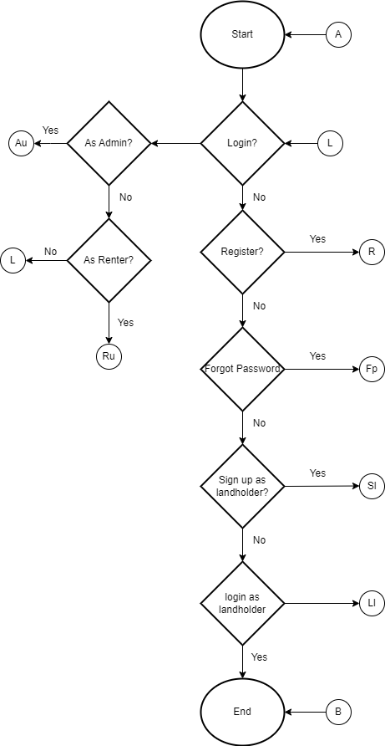

**Figure 2. Flow chart for user login depends on their position**

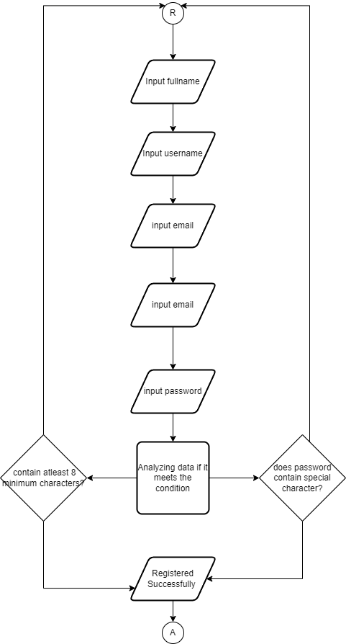

**Figure 3. Flowchart for registration page (user)**

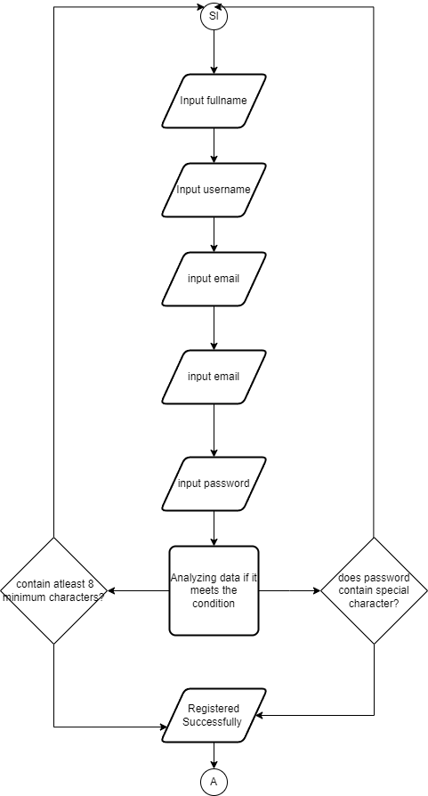

**Figure 4. Flowchart for registration page (property owner)**

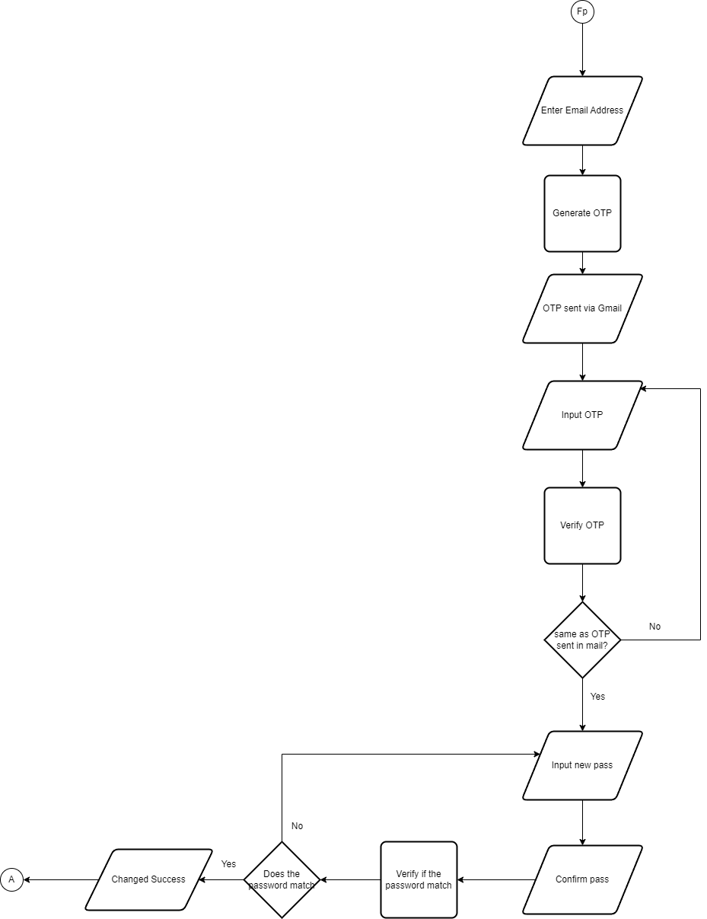

**Figure 5. Flowchart for Forgot Password**

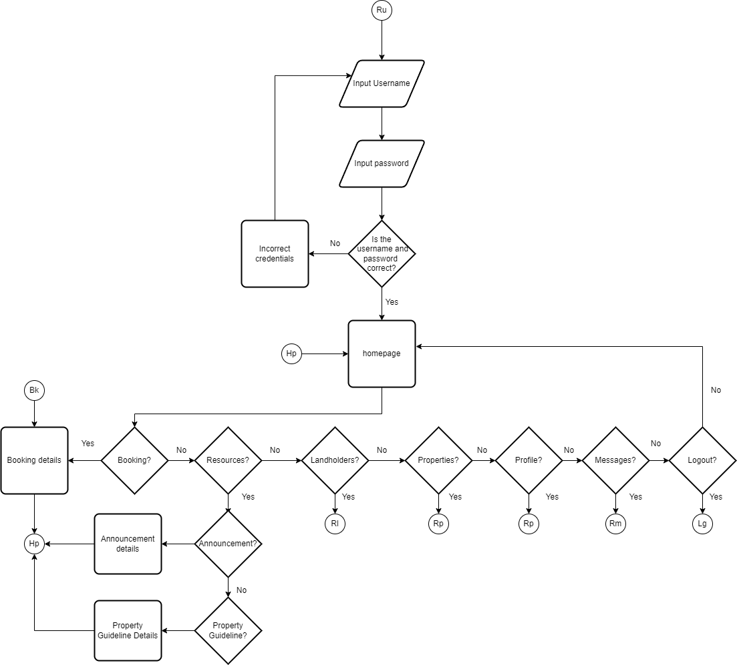

**Figure 6. Flowchart for Homepage, Booking page, and Resources(user)**

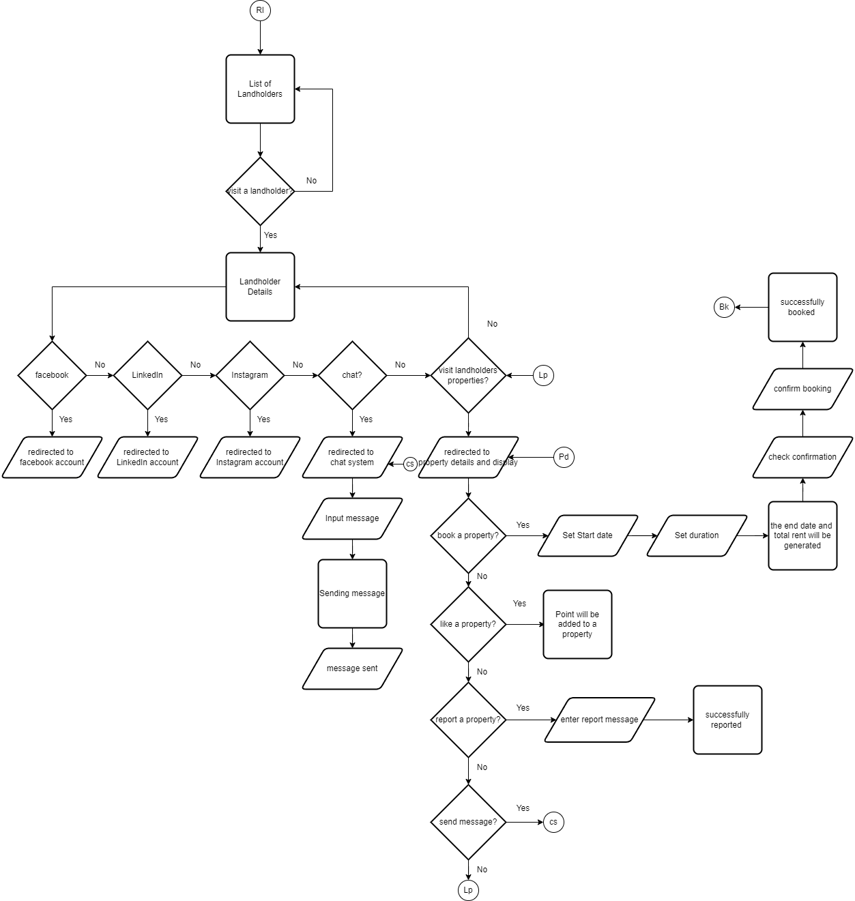

**Figure 7. Flowchart of Property owner details (user)**

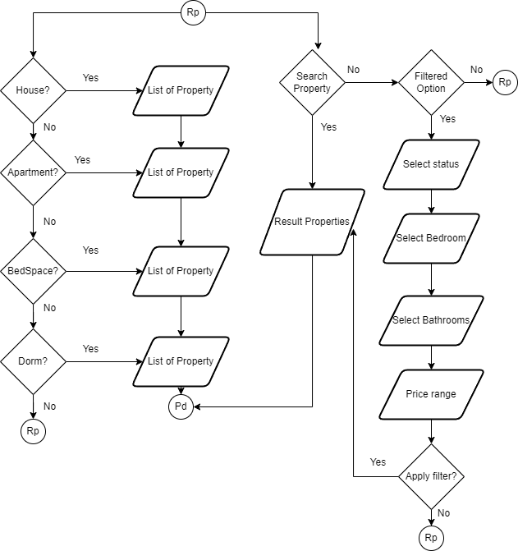

**Figure 8. Flowchart for Properties Page (user)**

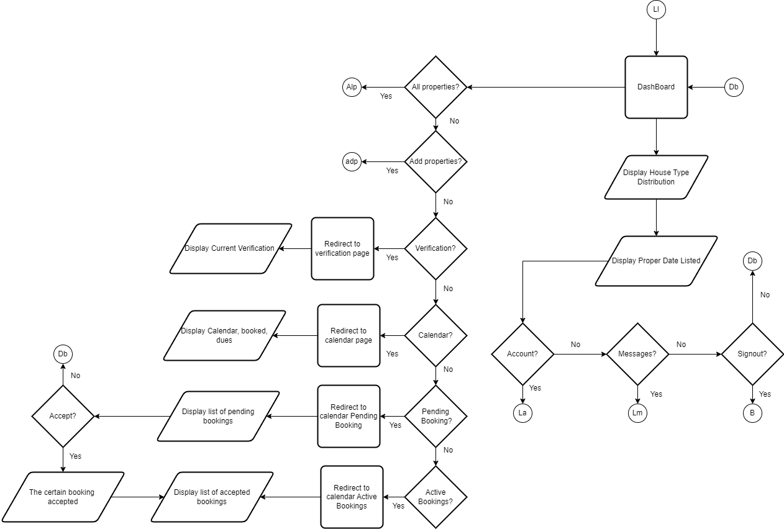

**Figure 9. Flowchart for Dashboard (property owner)**

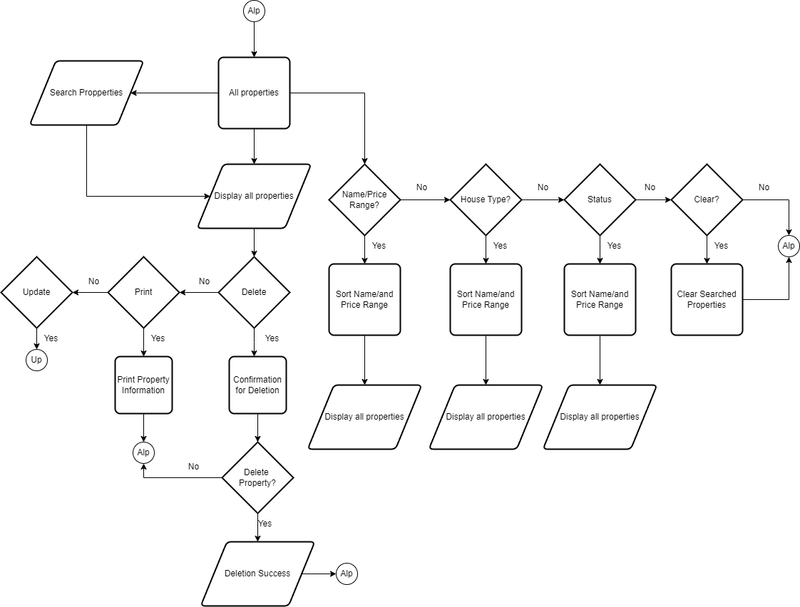

**Figure 10. Flowchart of all properties that landlords owned (property owner)**

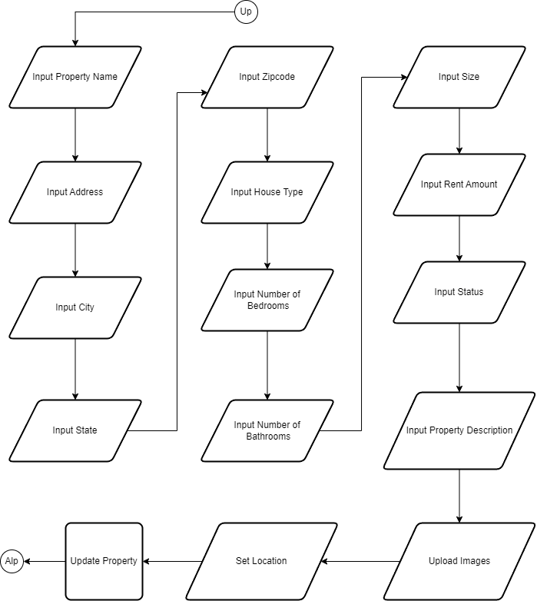

**Figure 11. Flowchart for updating properties (property owner)**

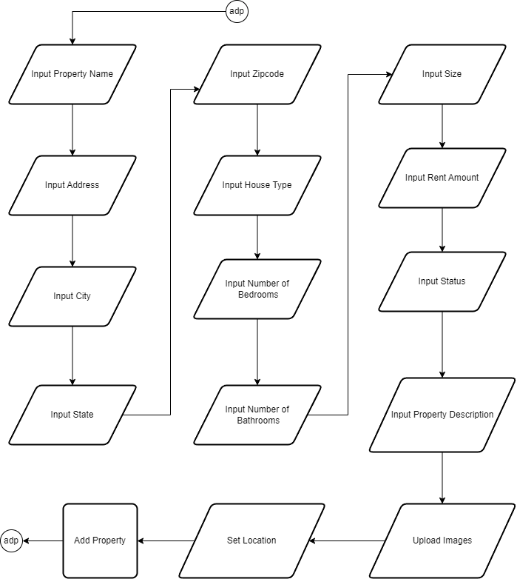

**Figure 12. Flowchart for adding property (property owner)**

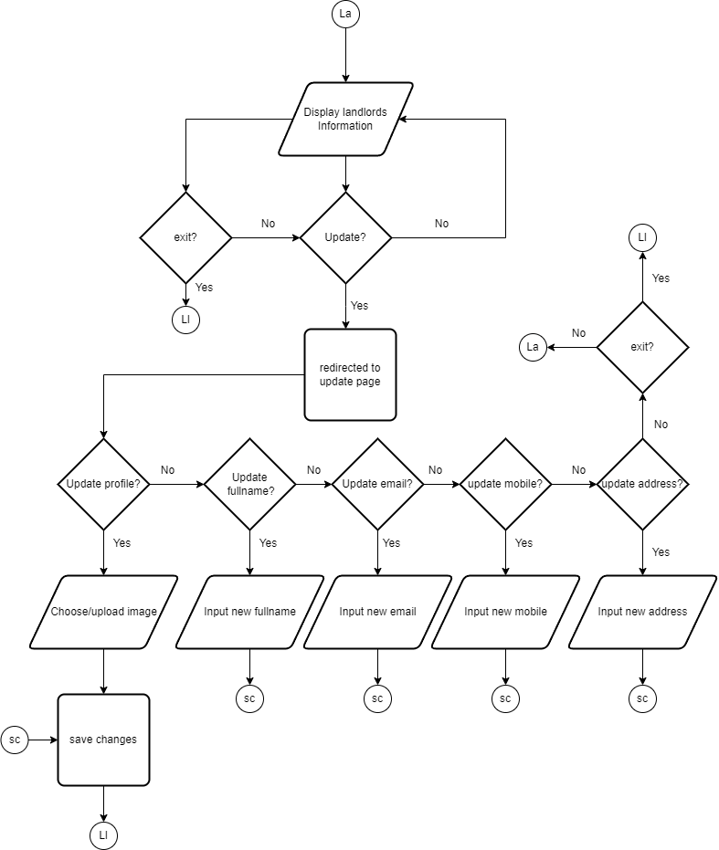

**Figure 13. Flowchart for landlords account information (property owner)**

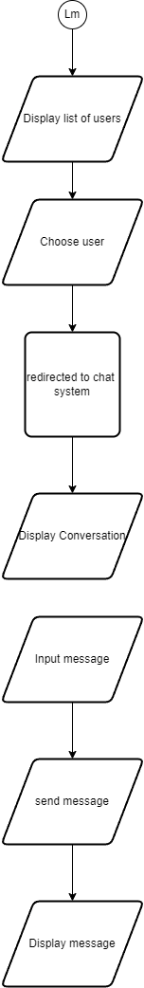

**Figure 14. Flowchart for chat system (property owner)**

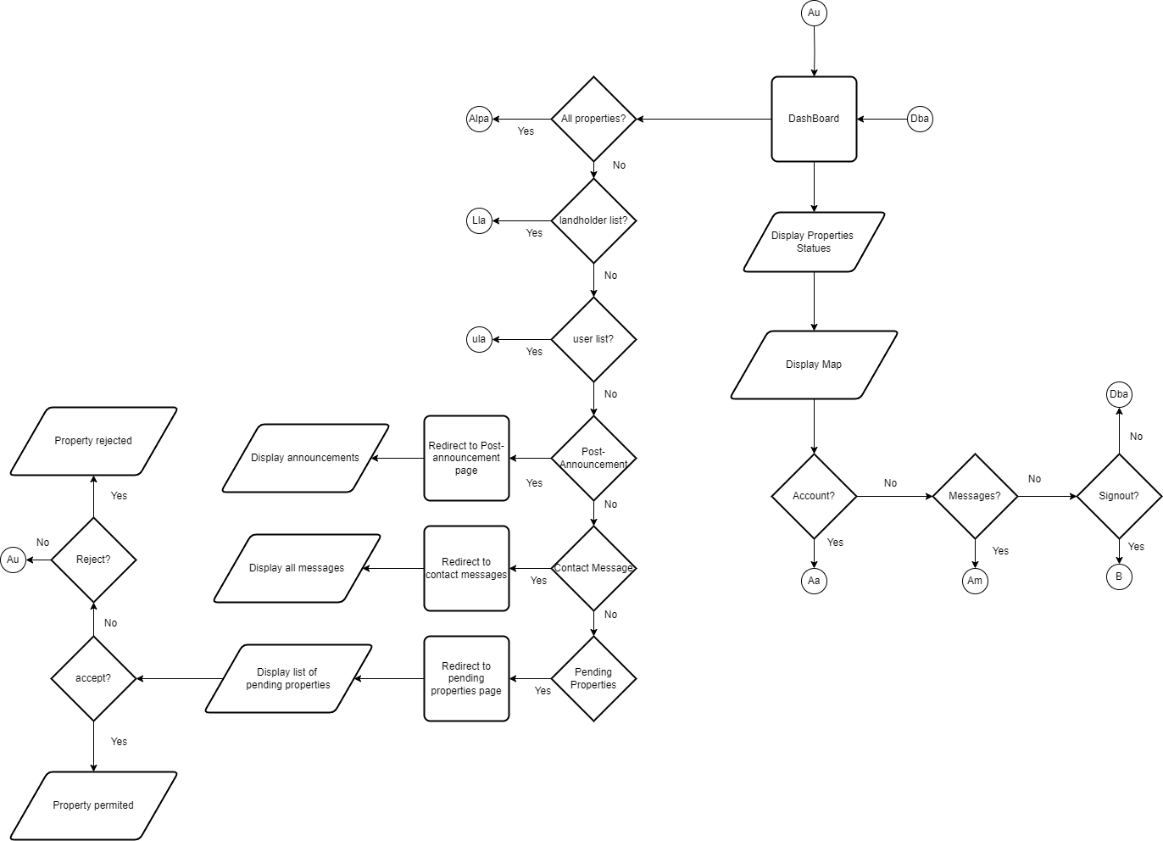

**Figure 15. Flowchart of a Dashboard (admin)**

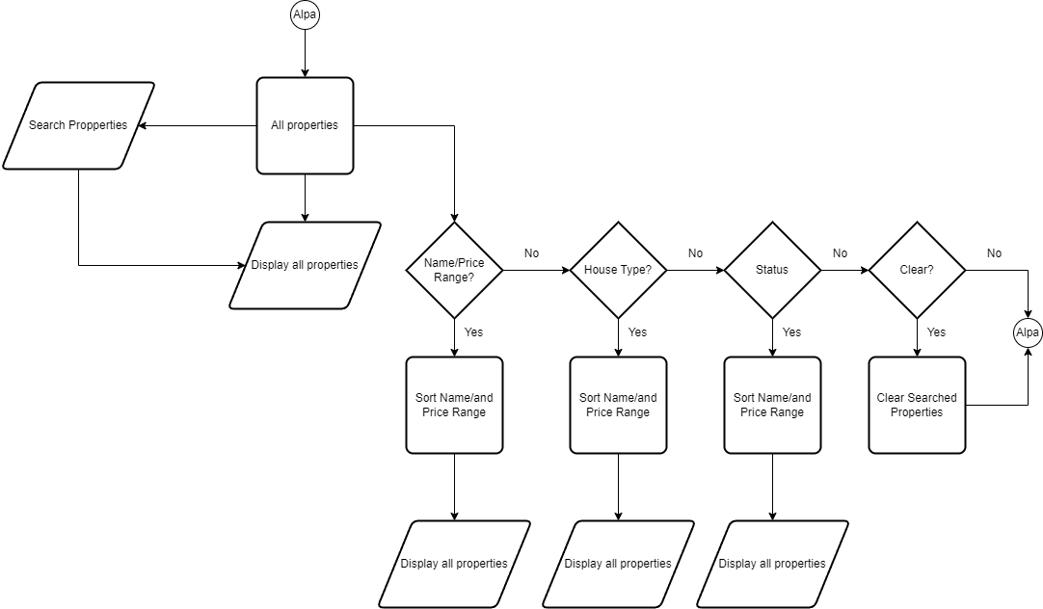

**Figure 16. Flowchart of listed Properties (admin)**

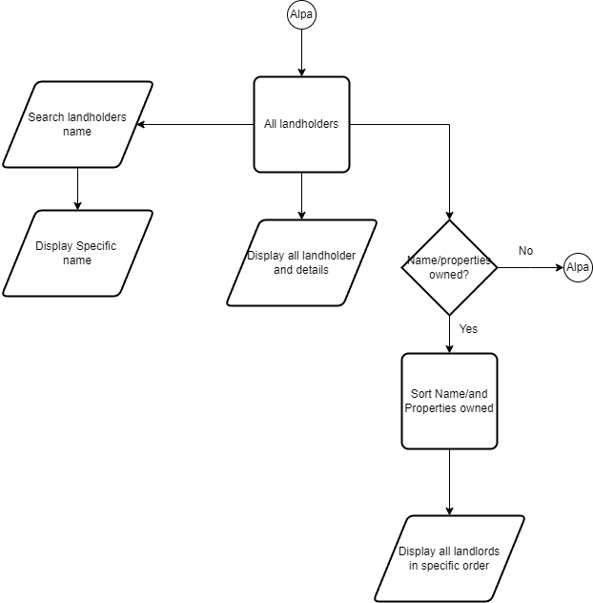

**Figure 17. Flowchart of a list of all registered property owner (admin)**

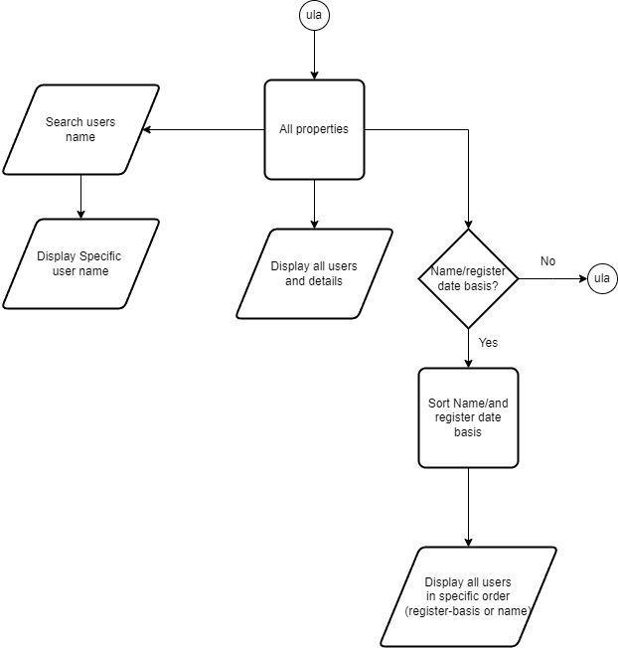

**Figure 18. Flowchart of all the listed Users (admin)**

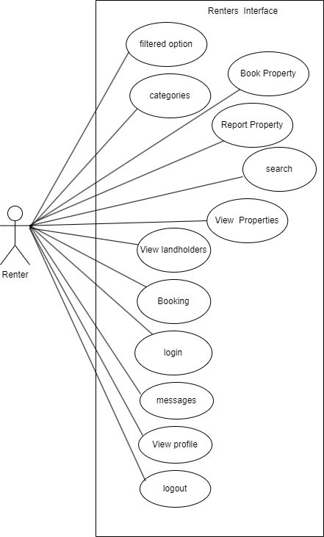

**Figure 19. Use-case diagram of user’s interface**

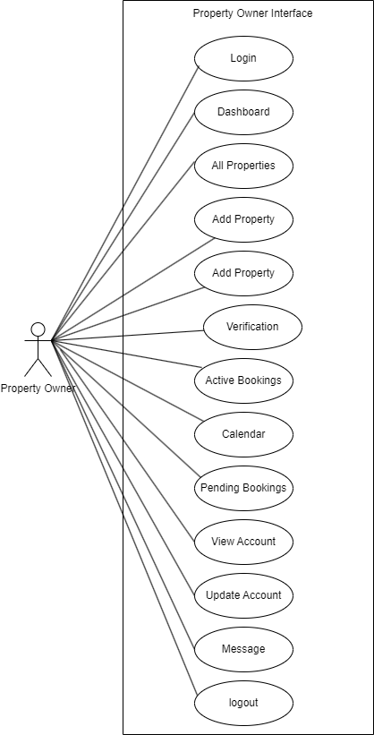

**Figure 20. Use-case diagram for property owner’s interface**

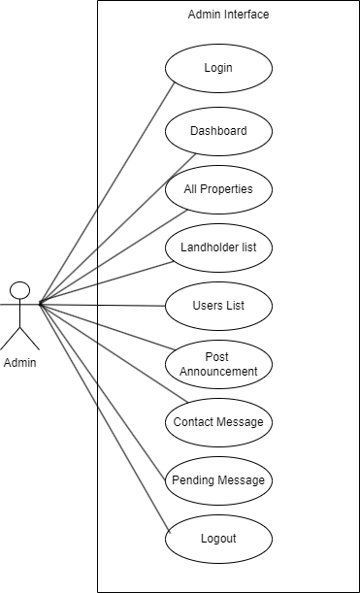

**Figure 21. Use-case diagram of admin interface**

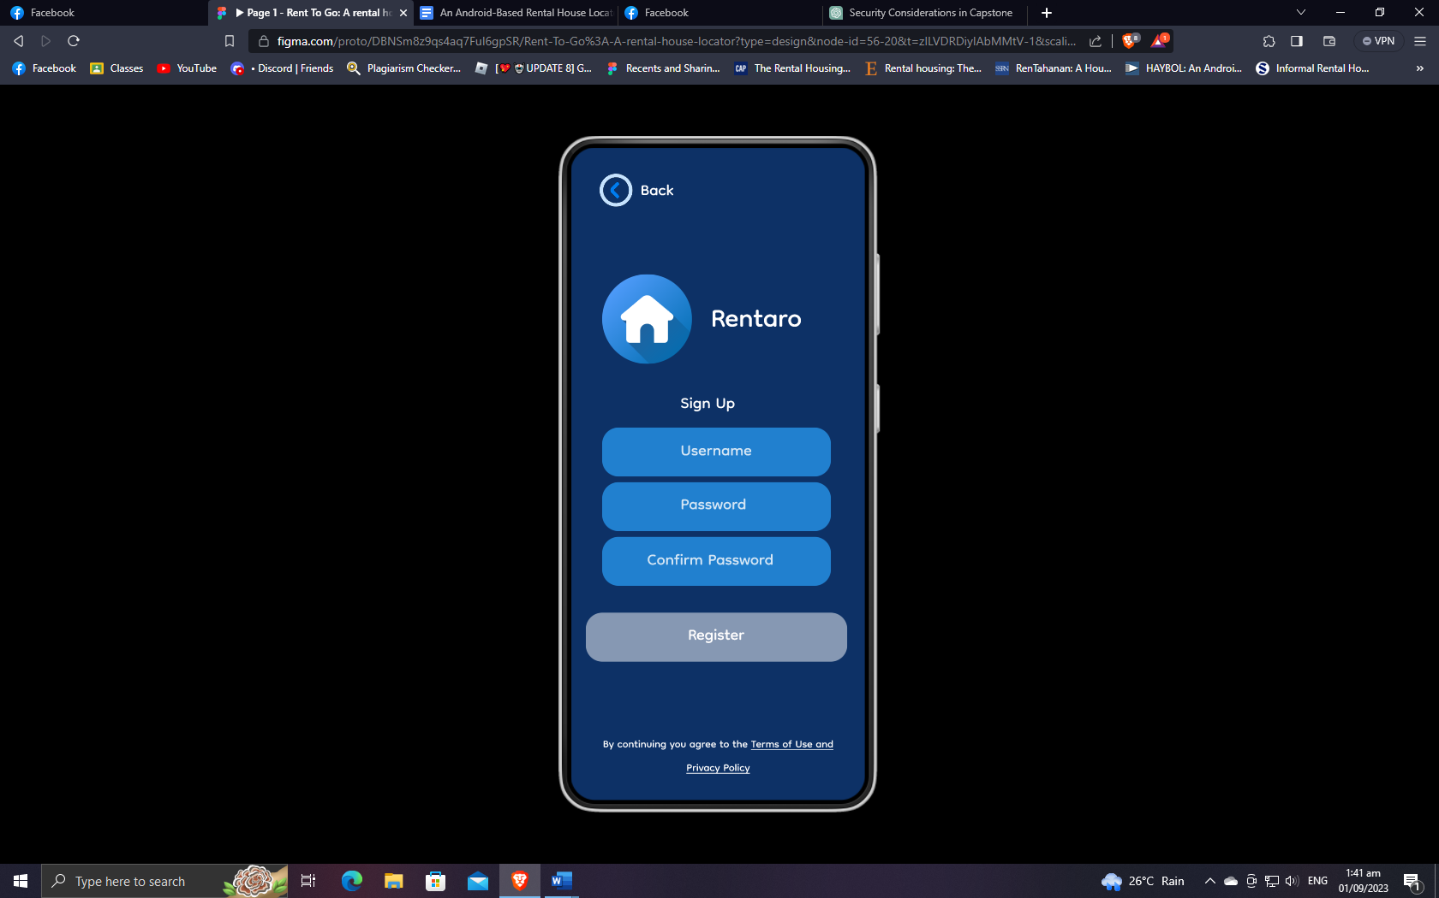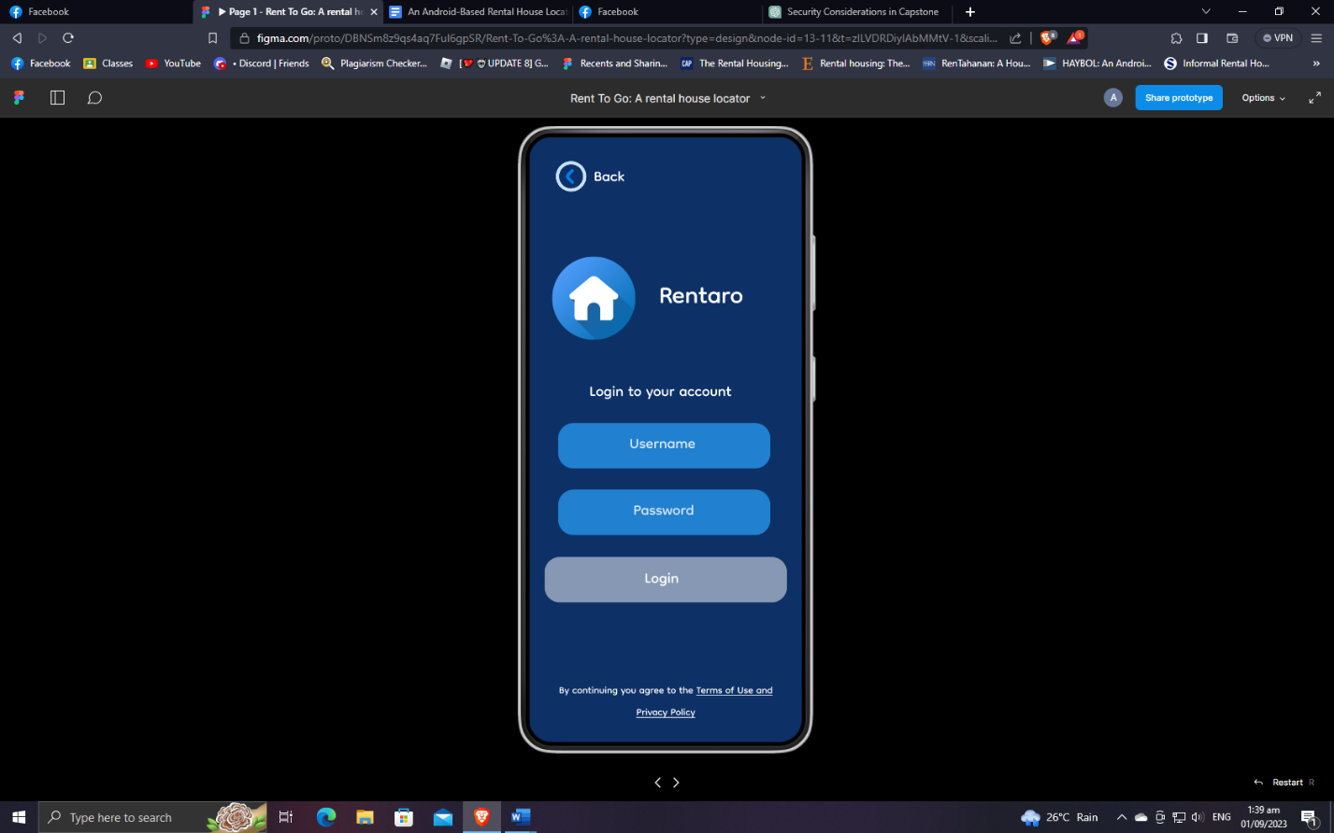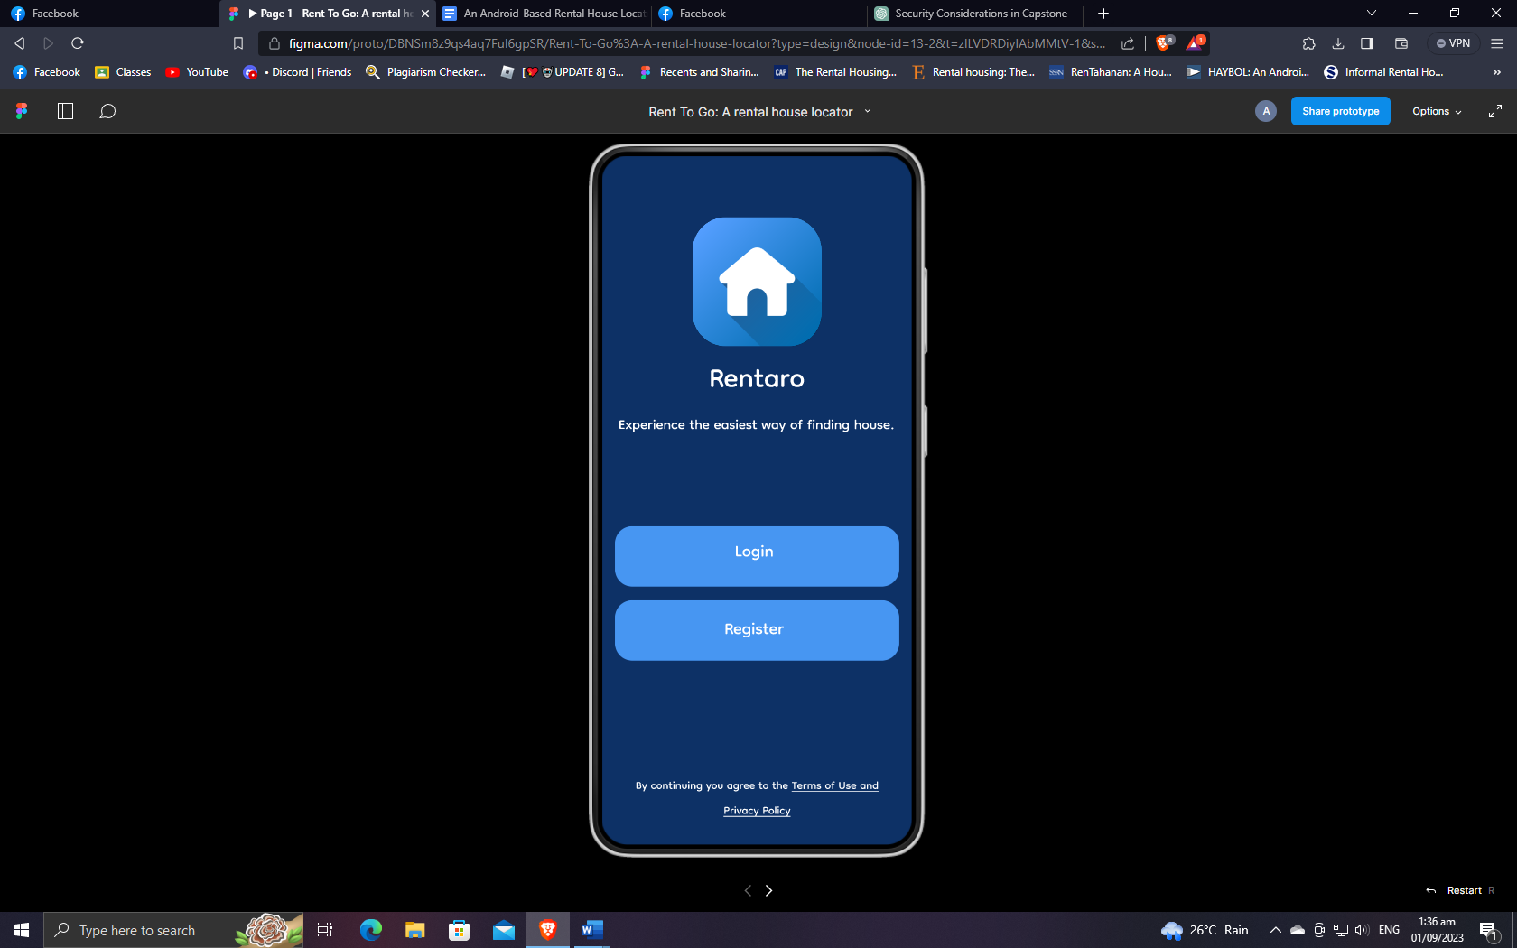

**Figure 22. User Login and Registration**

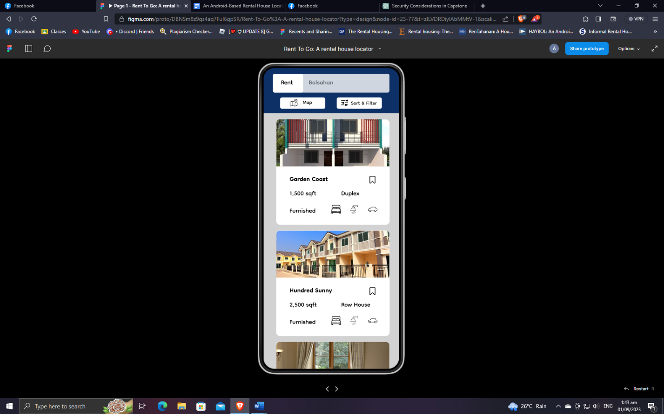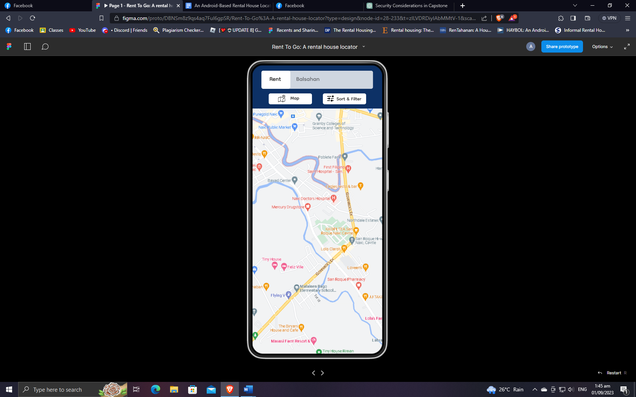

**Figure 23. Navigation Map**

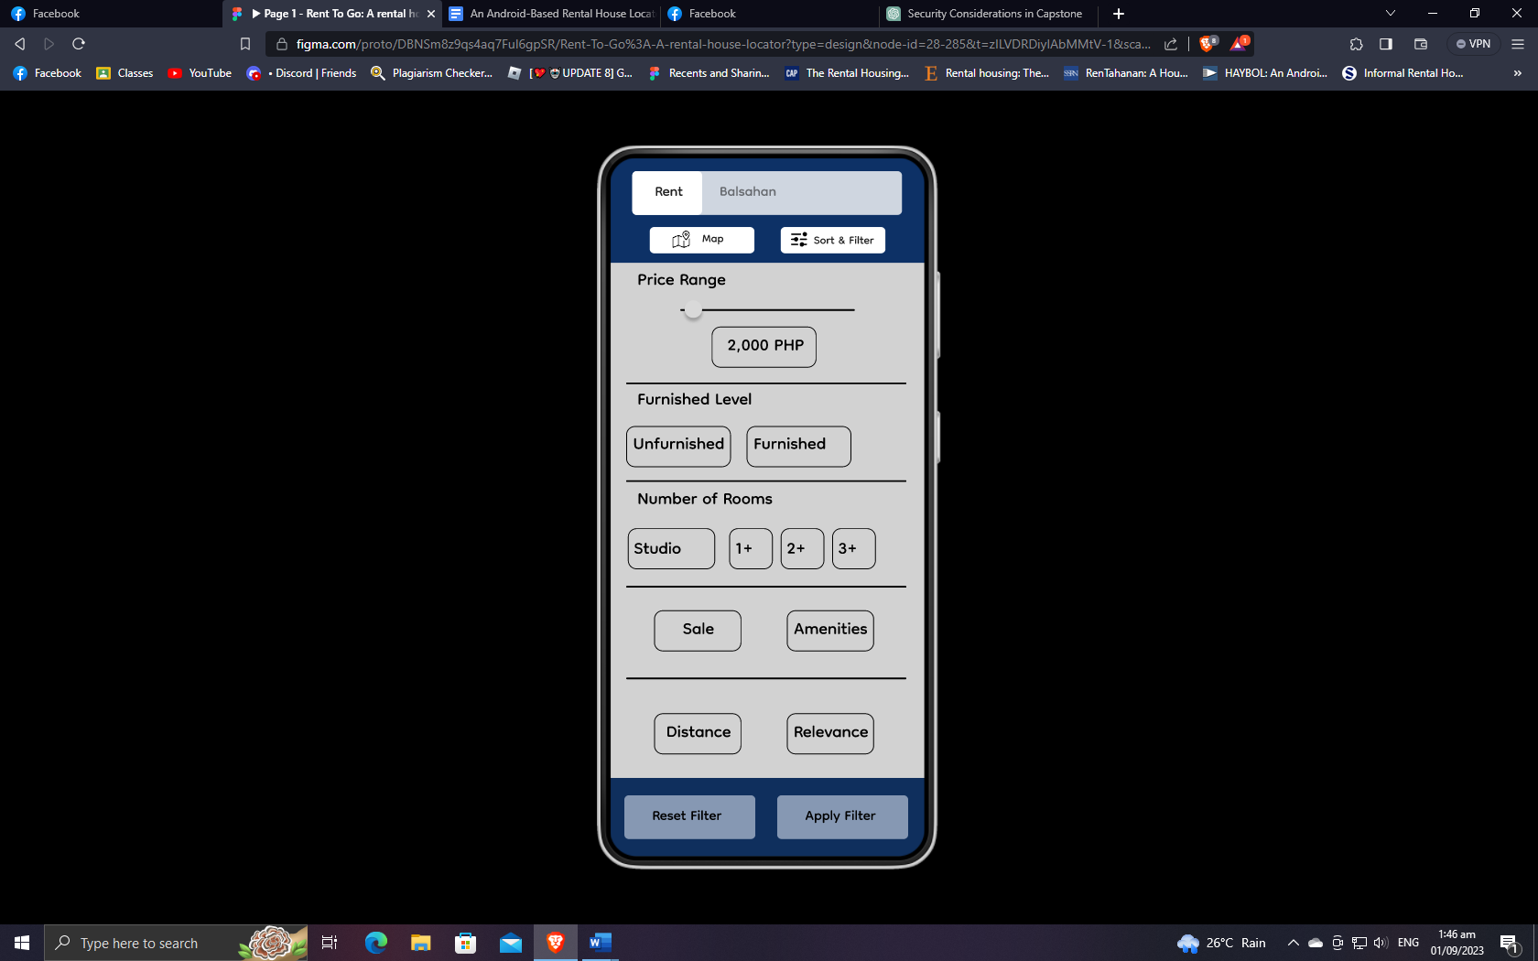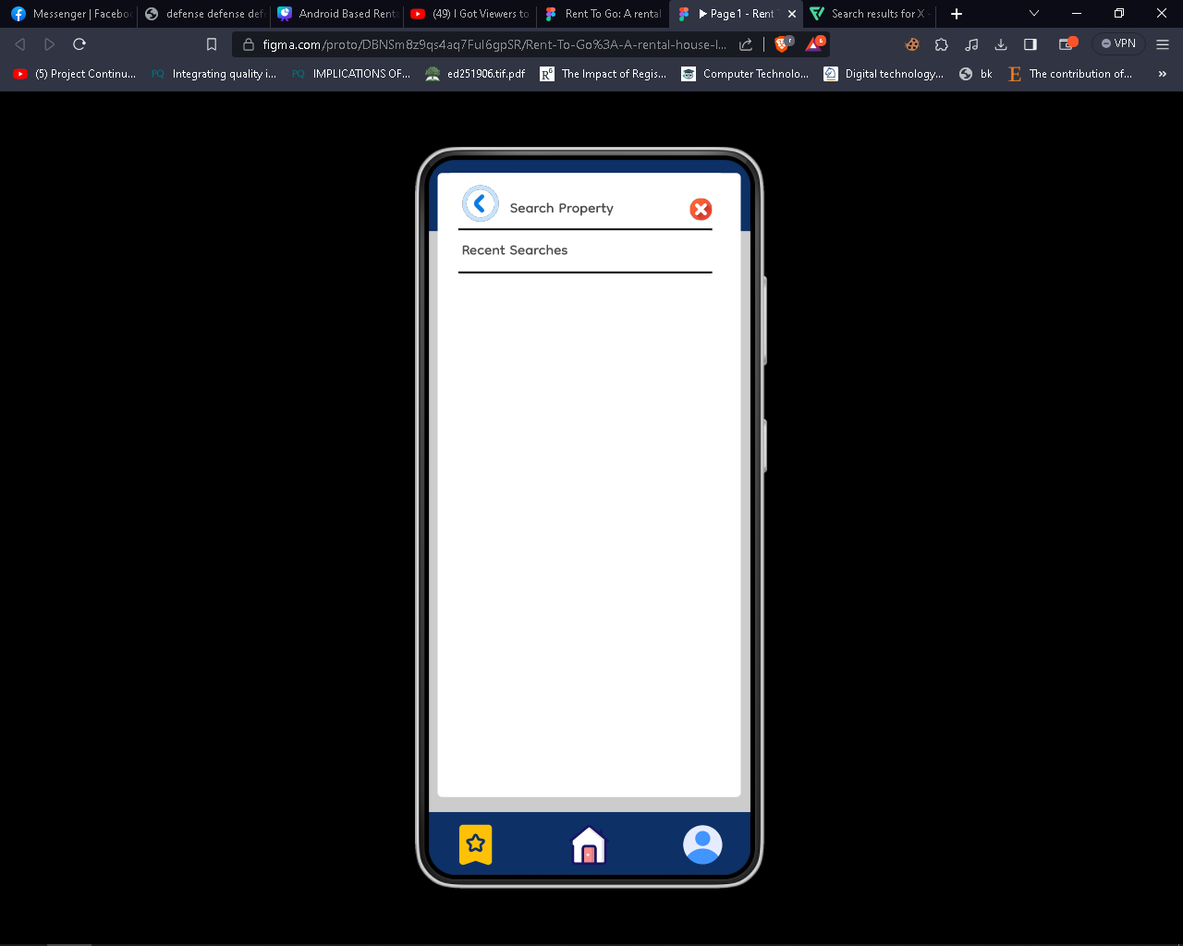

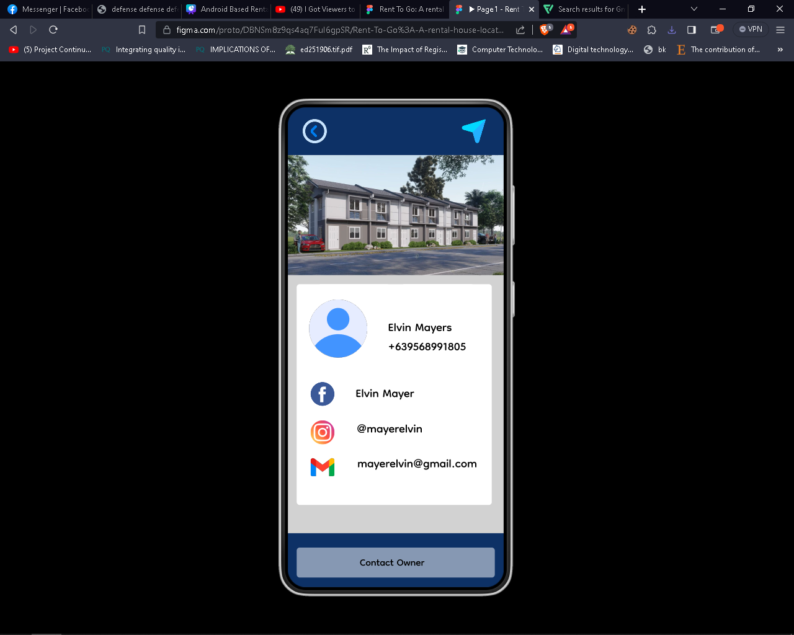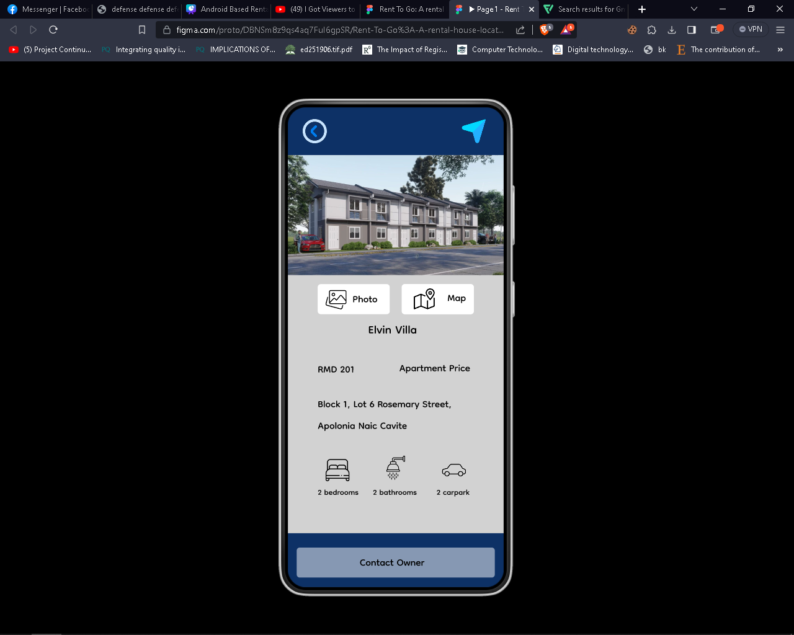**Figure 24. Filtered Search**

**Figure 25. Property Description**

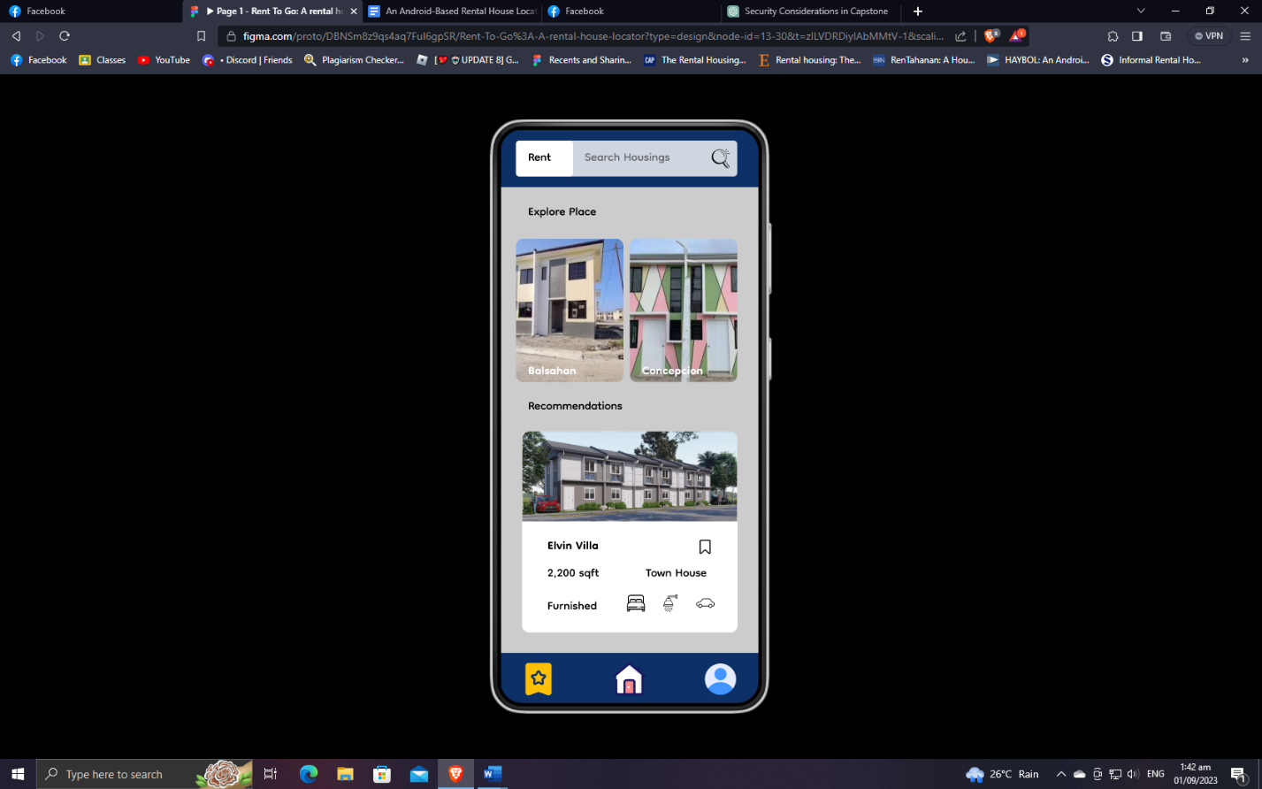

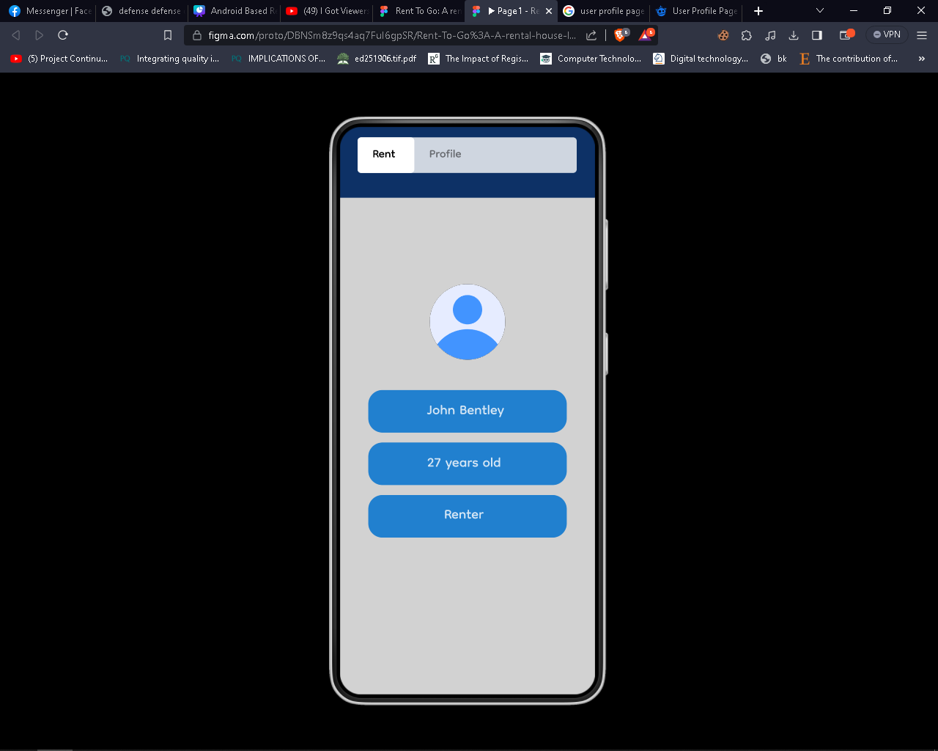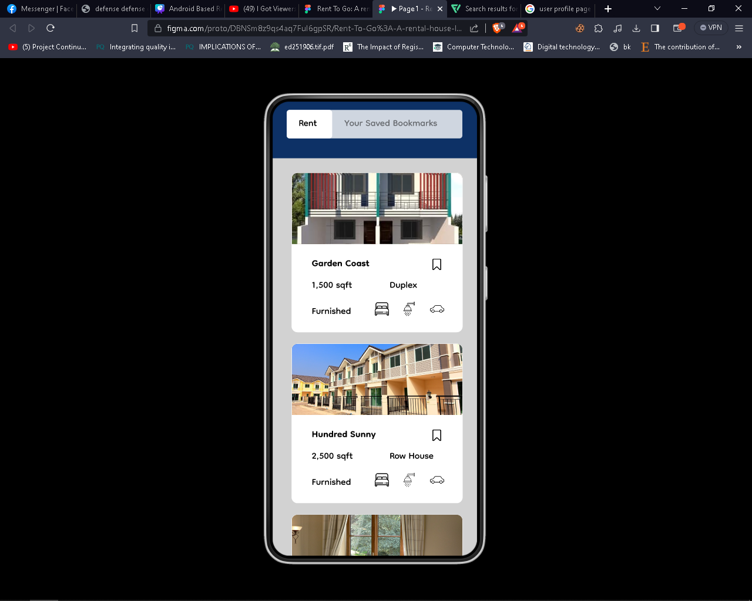**Figure 26. Main Menu**

**Figure 27. Bookmark and User Profile**

### **Requirement Analysis**

The primary objective of requirement analysis is to address the significant challenges encountered by both renters and property owner. The diagram below illustrates the prevalent issues.

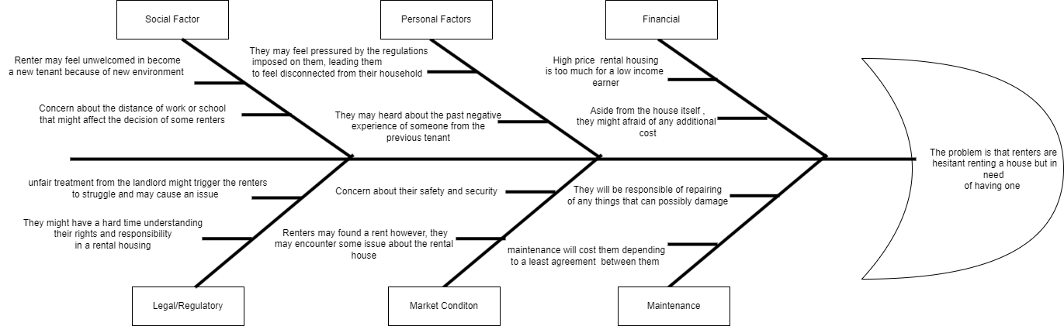

**Figure 28. Fishbone diagram of the system**

Table 1 presents the list of technical resources available in the organization that can be used to run the system to be developed.

**Table 1. List of technical resources available in the organization**

|  |  |
| --- | --- |
| **LIST OF RESOURCES AVAILABLE** | **STATUS** |
| 3 units of Personal Computer | Working |
| 1 Laptop | Working |
| 3-in-1 Printer | Working |
| Handheld Scanner | Working |
| Digital Camera | Working |

Table 2 presents the estimated cost of the system development.

**Table 2. Estimated cost of the system**

|  |  |
| --- | --- |
| **LIST OF EQUIPMENT** | **COST** |
| PC | PhP 0,000.00 |
| Smart Phone | PhP 0,000.00 |
| Scanner | PhP 0,000.00 |
| **TOTAL COST** | PhP 0,000.00 |

### **Requirement Documentation**

**Register Page** – allows the user to input credentials and be registered to have a full access of the web application, it also applicable for the property owner who wants to display their properties.

**Login page** – Allows both renter, property owner and admin to explore and manage their accounts.

**Forgot password** – It helps the end-user to recover their account using email and obtain OTP to make a new password to their accounts.

**Booking page** – it stores the end-user booked properties of the certain owner with details.

**Landholders** – it displays all the registered property owner in end-user side.

Filtered option – allows the user to select a preferred status, bedrooms, bathroom and rent amount.

**Search engine** – it helps to easily search the name of the house, apartment, dorm, or a bedspace in end-user.

**Update profile** – applicable for both renter and property owner allowing them to change credentials.

**Mapping** – allows the renters to locate the certain property. On the other hand, property owner can place the location of their property in a map.

**Chat system** – allow them to communicate between renter and property owner.

**Book Property** – allow the renters to book for a chosen house type.

**Report Property** – allow the renters to raise a concern to a certain property for any different reason.

**Pagination** – used to divide a content in discrete pages to make it easily to navigate properties.

**Dashboard** – applicable for both admin and property owner to monitor the progress of a certain number of a property listed.

**Pending bookings** – allows the property owner to accept and cancel the bookings of a certain renter.

**Accept booking** – display a certain renter who’s accepted for booking by the proper owner.

**Calendar page** – display and allows the property owner to monitor the due date of the listed renters.

**Add property** – allows the property owner to add their property and display.

**Verification** – Verification is depended upon whether or not the conditions are met.

**Property page** – enables the property owner to make changes or remove the property. It also enables the printing of property details.

**Landholder list** – Allows the admin to monitor all registered property owner.

**Users list** – allows the admin to monitor all registered renters.

**Post-announcement** – enables the admin to make an announcement.

**Pending properties** – allows the admin to accept or reject the properties owned by a certain property owner.

## **System Development**

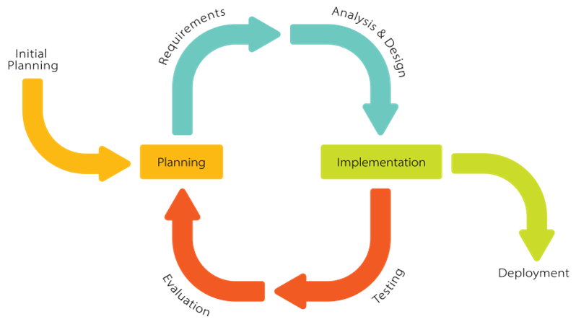

**Figure 29. Software methodology of the system using Iterative model**

The Iterative Model in System Development Life Cycle (SDLC) is chosen as the development strategy for this application for a web-based rental house locator with filtered search and mapping. The Iterative Model phase is an iterative process that starts with the straightforward implementation of a certain group of software requirements as its starting point. After that, it repeatedly improves the constantly evolving versions until the whole system is finally put into action. The design undergoes iterative revisions so that it can accommodate newly developed capabilities, and these revisions are known as iterations. The fundamental idea behind this method is to construct a system in phases, completing each stage either incrementally or through iterative cycles.

**System Testing**

During the testing phase, the researcher should cite the testing procedures conducted in the study.

## **System Evaluation**

The system was evaluated based on modified ISO/IEC 25010 Software and Data Quality Evaluation Instrument. This is in terms of functional suitability, performance efficiency, compatibility, interaction capability, reliability, security, maintainability, flexibility, and safety as shown and n Table 3.

**Table 3. Software and data quality evaluation instrument**

|  |  |  |  |  |  |  |  |  |  |
| --- | --- | --- | --- | --- | --- | --- | --- | --- | --- |
| **INDICATOR** | **5** | | **4** | | **3** | | **2** | | **1** |
| **A. Functional Suitability** | | | | | | | | | |
| 1. ***Functional completeness*** - degree to which the set of functions covers all the specified tasks and intended users' objectives. |  |  | |  | |  | |  | |
| 1. ***Functional correctness*** - degree to which a product or system provides accurate results when used by intended users. |  |  | |  | |  | |  | |
| 1. ***Functional appropriateness*** - degree to which the functions facilitate the accomplishment of specified tasks and objectives. |  |  | |  | |  | |  | |
| **B. Performance Efficiency** | | | | | | | | | |
| 1. ***Time behaviour*** - degree to which the response time and throughput rates of a product or system, when performing its functions, meet requirements. |  |  | |  | |  | |  | |
| 1. ***Resource utilization*** - degree to which the amounts and types of resources used by a product or system, when performing its functions, meet requirements. |  |  | |  | |  | |  | |
| 1. ***Capacity*** - degree to which the maximum limits of a product or system parameter meet requirements. |  |  | |  | |  | |  | |
| **C. Compatibility** | | | | | | | | | |
| 1. ***Co-existence*** - degree to which a product can perform its required functions efficiently while sharing a common environment and resources with other products, without detrimental impact on any other product. |  |  | |  | |  | |  | |
| 1. ***Interoperability*** - degree to which a system, product or component can exchange information with other products and mutually use the information that has been exchanged. |  |  | |  | |  | |  | |
| **D. Interaction Capability** | | | | | | | | | |
| 1. ***Appropriateness recognizability*** - degree to which users can recognize whether a product or system is appropriate for their needs. |  |  | |  | |  | |  | |
| 1. ***Learnability*** - degree to which the functions of a product or system can be learnt to be used by specified users within a specified amount of time. |  |  | |  | |  | |  | |
| 1. ***Operability***- degree to which a product or system has attributes that make it easy to operate and control. |  |  | |  | |  | |  | |
| 1. ***User error protection*** - degree to which a system prevents users against operation errors. |  |  | |  | |  | |  | |
| 1. ***User engagement*** - degree to which a user interface presents functions and information in an inviting and motivating manner encouraging continued interaction. |  |  | |  | |  | |  | |
| 1. ***Inclusivity*** - degree to which a product or system can be used by people of various backgrounds (such as people of various ages, abilities, cultures, ethnicities, languages, genders, economic situations, etc.). |  |  | |  | |  | |  | |
| 1. ***User assistance*** - degree to which a product can be used by people with the widest range of characteristics and capabilities to achieve specified goals in a specified context of use. |  |  | |  | |  | |  | |
| 1. ***Self-descriptiveness*** -degree to which a product presents appropriate information, where needed by the user, to make its capabilities and use immediately obvious to the user without excessive interactions with a product or other resources (such as user documentation, help desks or other users). |  |  | |  | |  | |  | |
| **E. Reliability** | | | | | | | | | |
| 1. ***Faultlessness*** - degree to which a system, product or component performs specified functions without fault under normal operation. |  |  | |  | |  | |  | |
| 1. ***Availability*** - degree to which a system, product or component is operational and accessible when required for use. 2. ***Fault tolerance*** - Degree to which a system, product or component operates as intended despite the presence of hardware or software faults. |  |  | |  | |  | |  | |
| 1. ***Recoverability*** - degree to which, in the event of an interruption or a failure, a product or system can recover the data directly affected and re-establish the desired state of the system. |  |  | |  | |  | |  | |
| **F. Security** | | | | | | | | | |
| 1. ***Confidentiality*** - degree to which a product or system ensures that data are accessible only to those authorized to have access. |  |  | |  | |  | |  | |
| 1. *Integrity* - degree to which a system, product or component ensures that the state of its system and data are protected from unauthorized modification or deletion either by malicious action or computer error. |  |  | |  | |  | |  | |
| 1. ***Non-repudiation*** - degree to which actions or events can be proven to have taken place so that the events or actions cannot be repudiated later. |  |  | |  | |  | |  | |
| 1. ***Accountability -*** degree to which the actions of an entity can be traced uniquely to the entity. |  |  | |  | |  | |  | |
| 1. ***Authenticity*** - degree to which the identity of a subject or resource can be proved to be the one claimed. |  |  | |  | |  | |  | |
| 1. ***Resistance*** - degree to which the product or system sustains operations while under attack from a malicious actor. |  |  | |  | |  | |  | |
| **G. Maintainability** | | | | | | | | | |
| 1. ***Modularity*** - degree to which a system or computer program is composed of discrete components such that a change to one component has minimal impact on other components. |  |  | |  | |  | |  | |
| 1. ***Reusability*** - degree to which a product can be used as an asset in more than one system, or in building other assets. |  |  | |  | |  | |  | |
| 1. ***Analyzability*** - degree of effectiveness and efficiency with which it is possible to assess the impact on a product or system of an intended change to one or more of its parts, to diagnose a product for deficiencies or causes of failures, or to identify parts to be modified. |  |  | |  | |  | |  | |
| 1. ***Modifiability*** - degree to which a product or system can be effectively and efficiently modified without introducing defects or degrading existing product quality. |  |  | |  | |  | |  | |
| 1. ***Testability*** - degree of effectiveness and efficiency with which test criteria can be established for a system, product or component and tests can be performed to determine whether those criteria have been met. |  |  | |  | |  | |  | |
| **H. Flexibility** | | | | | | | | | |
| 1. ***Adaptability*** - degree to which a product or system can effectively and efficiently be adapted for or transferred to different hardware, software or other operational or usage environments. |  |  | |  | |  | |  | |
| 1. ***Scalability*** - degree to which a product can handle growing or shrinking workloads or to adapt its capacity to handle variability. |  |  | |  | |  | |  | |
| 1. ***Installability*** - degree of effectiveness and efficiency with which a product or system can be successfully installed and/or uninstalled in a specified environment. |  |  | |  | |  | |  | |
| 1. ***Replaceabilit***y - degree to which a product can replace another specified software product for the same purpose in the same environment. |  |  | |  | |  | |  | |
| 1. **Safety** | | | | | | | | | |
| 1. ***Operational constraint*** - degree to which a product or system constrains its operation to within safe parameters or states when encountering operational hazard. |  |  | |  | |  | |  | |
| 1. ***Risk identification*** - degree to which a product can identify a course of events or operations that can expose life, property or environment to unacceptable risk. |  |  | |  | |  | |  | |
| 1. ***Fail safe*** - degree to which a product can automatically place itself in a safe operating mode, or to revert to a safe condition in the event of a failure. |  |  | |  | |  | |  | |
| 1. ***Hazard warning*** - degree to which a product or system provides warnings of unacceptable risks to operations or internal controls so that they can react in sufficient time to sustain safe operations. |  |  | |  | |  | |  | |
| 1. ***Safe integration*** - degree to which a product can maintain safety during and after integration with one or more components. |  |  | |  | |  | |  | |

**Data analysis plan.** For the data analysis of data, Table 4 shows the descriptive interpretation of the mean.

**Table 4. Descriptive interpretation of the mean**

|  |  |
| --- | --- |
| **NUMERICAL SCALE** | **DESCRIPTIVE INTERPRETATION** |
| 4.51 – 5.00 | Excellent |
| 3.51 – 4.50 | Very Good |
| 2.51 – 3.50 | Good |
| 1.51 – 2.50 | Fair |
| 1.50 – below | Poor |

## **Implementation Plan**

Table 5 shows the implementation plan of the system

**Table 5. Implementation plan**

|  |  |  |  |
| --- | --- | --- | --- |
| **STRATEGY** | **ACTIVITIES** | **PERSONS INVOLVED** | **DURATION** |
| Approval from the company administrator | Letters | Researchers, Administrator | 1 day |
| System’s installation | Installation of the system and required software and hardware | Researchers, Administrator | 5 hours |
|  | Flyers | Administrator, Employee |  |
| Information distribution | Posters | Administrator, Employee | 1 day |
|  | Manuals | Administrator, Employee |  |
| 3-day training | Hands-on training and lectures | Administrator, Employee  Researcher | 3 days |

# **RESULTS AND DISCUSSION**

This chapter presents the results of the system design and development, system testing, and system evaluation.

## **System Design and Development**

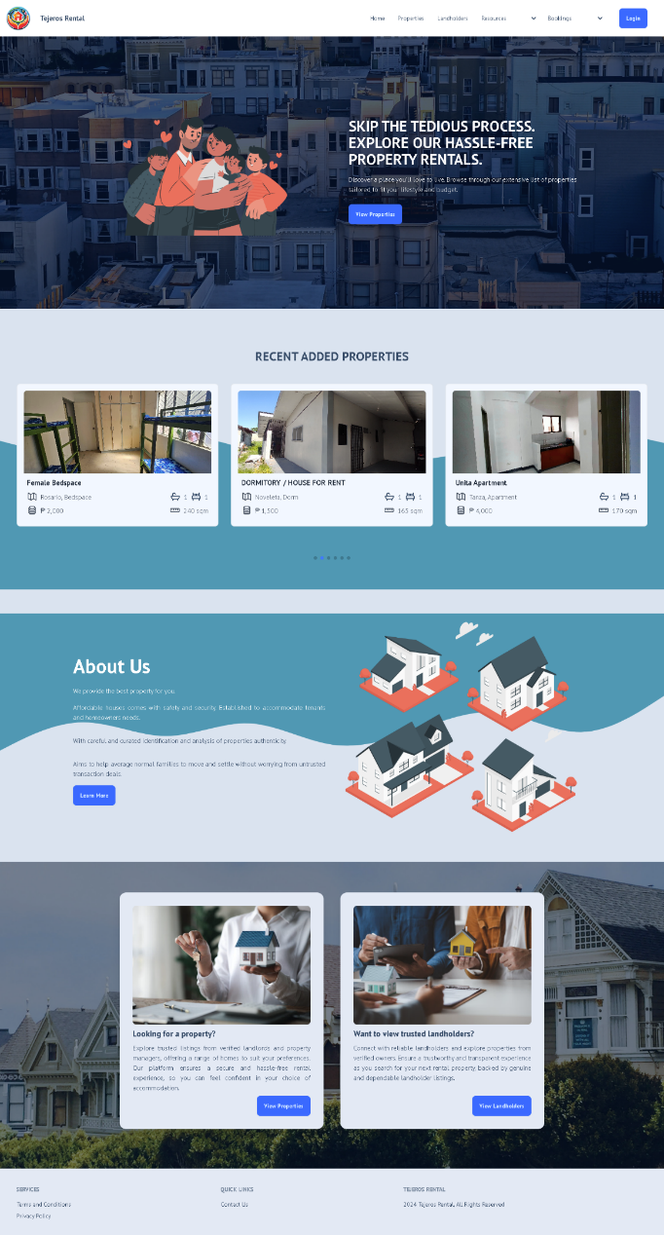 The researchers used Iterative model to developed the system. As the results of design and development, Figure 30 shows the login screen of the system.

**Figure 30. Front Page**

Figure 30 shows the preview content of the system regarding to renting a house property.

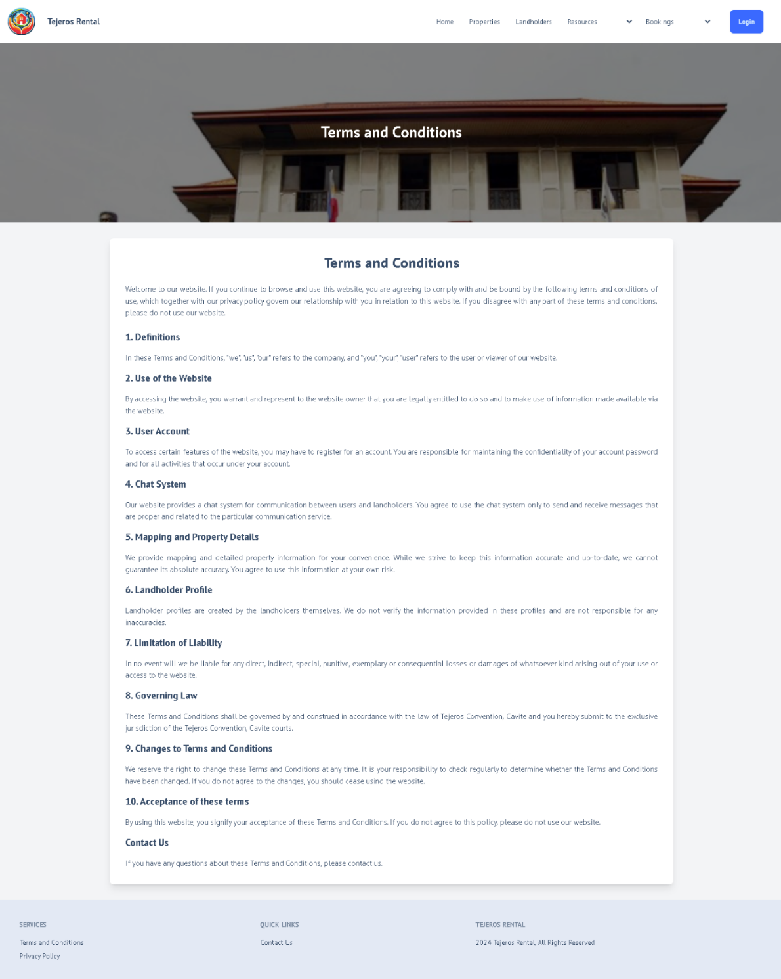

**Figure 31. Terms and Condition**

Figure 31 shows the set of rules inside the system effective and applicable for all the participants including the end-user and the property owner set by the admin.

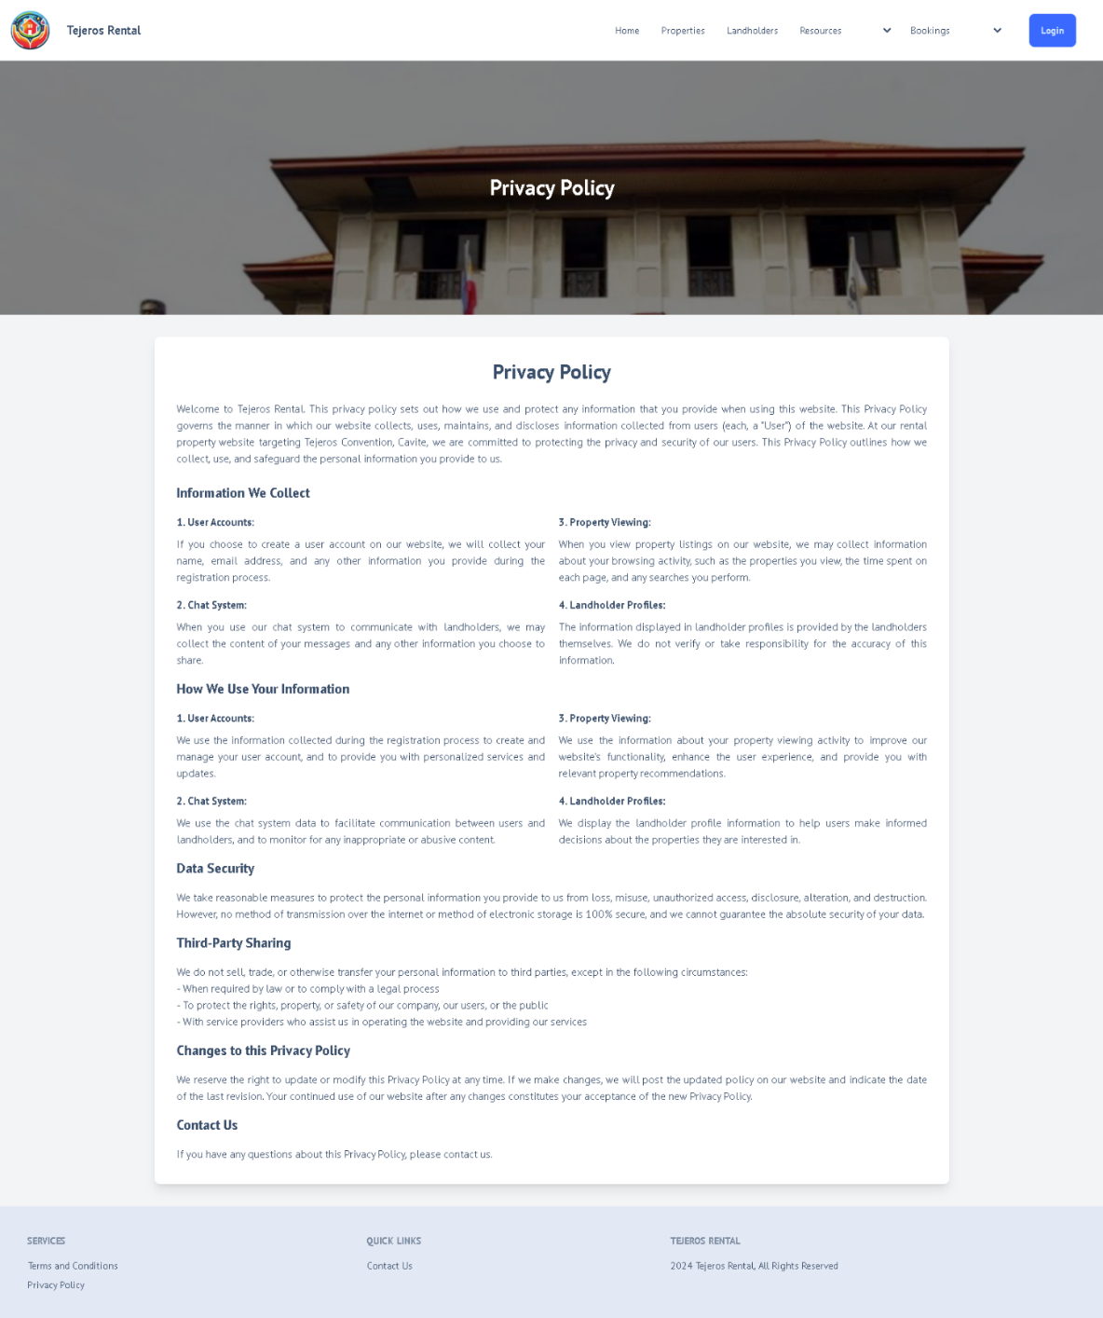

**Figure 32. Privacy Policy**

Figure 32 show the policy needed in executing every step in using the system.

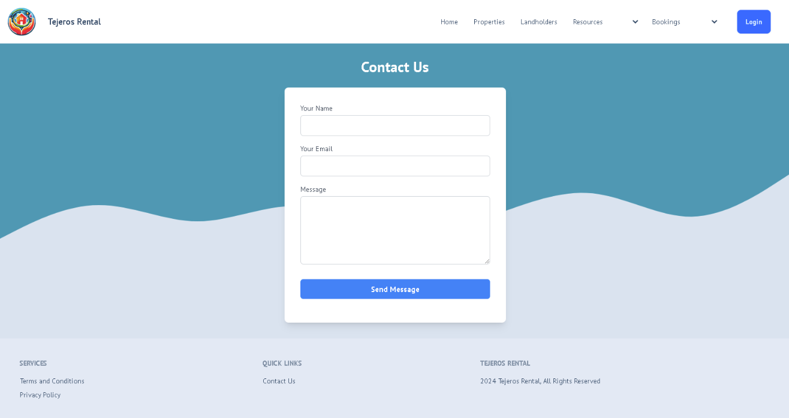

**Figure 34. Contact Us**

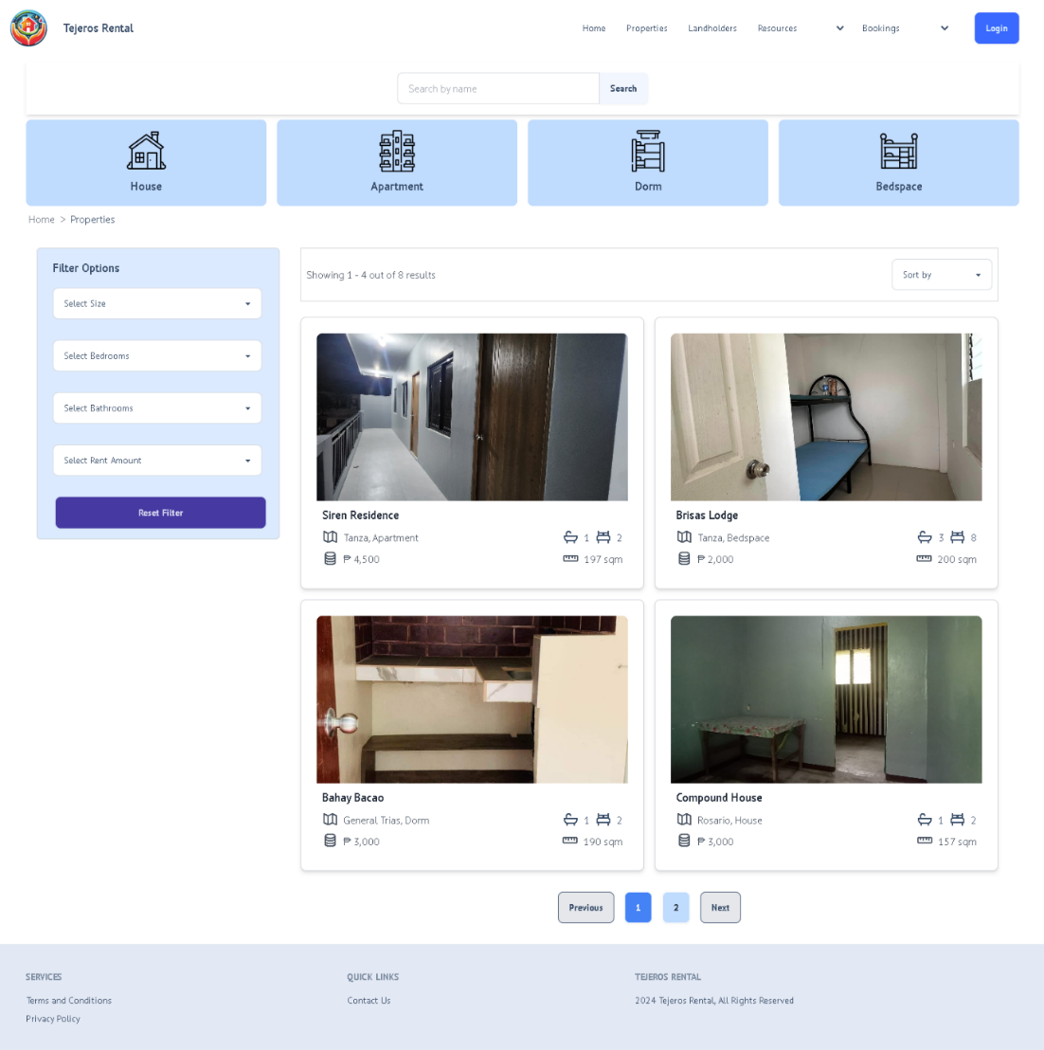Figure 34 shows the modal where the user can input their name and email to comply or sent the message regarding to their concern.

**Figure 35. Properties**

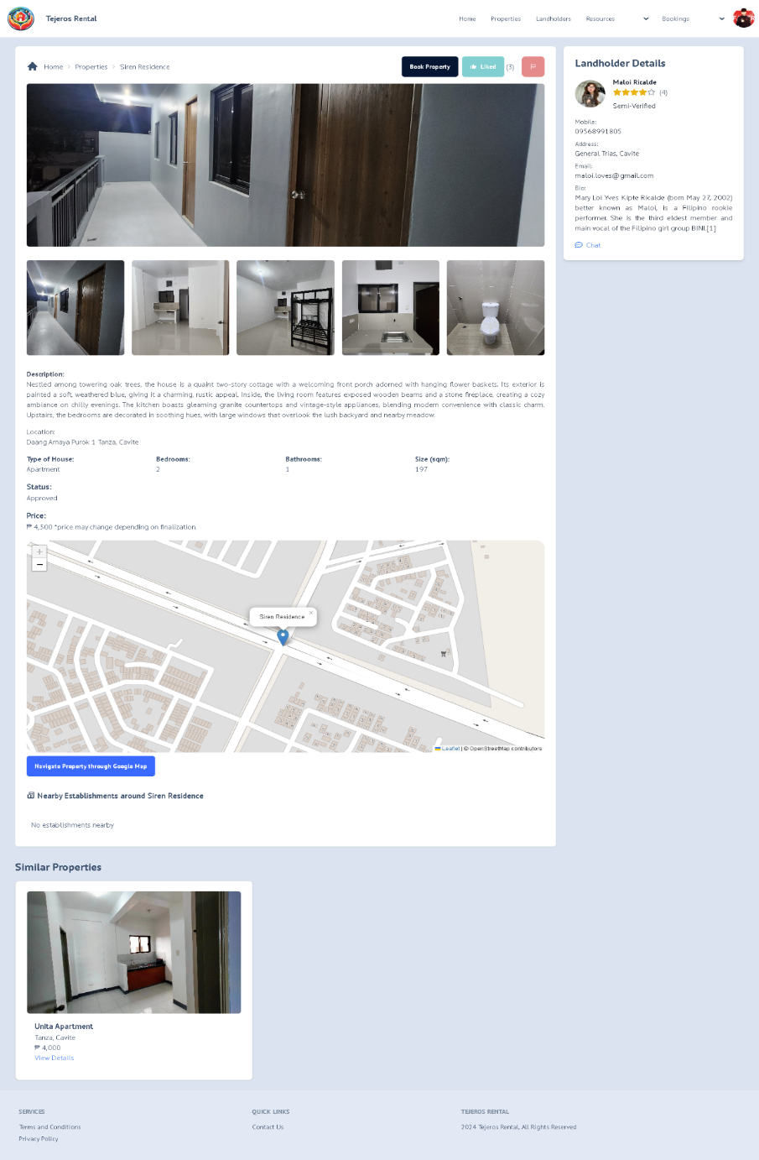Figure 35 shows the registered properties owned by the property owner allowing them to display in end-user interface

**Figure 36. Property Information**

Figure 36. shows the information of the property whereas, the user can “book”, “liked”, “report” or message the property owner.

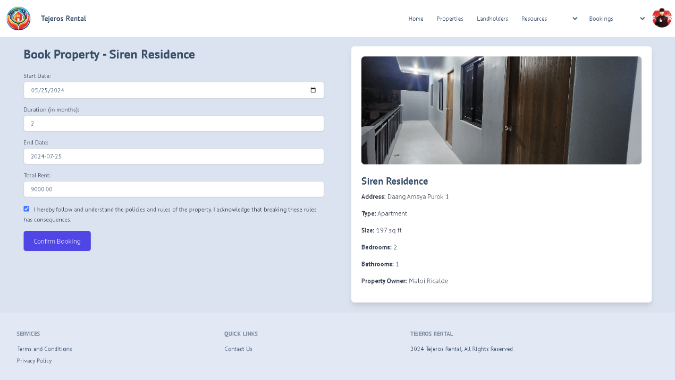

**Figure 37. Booking Page**

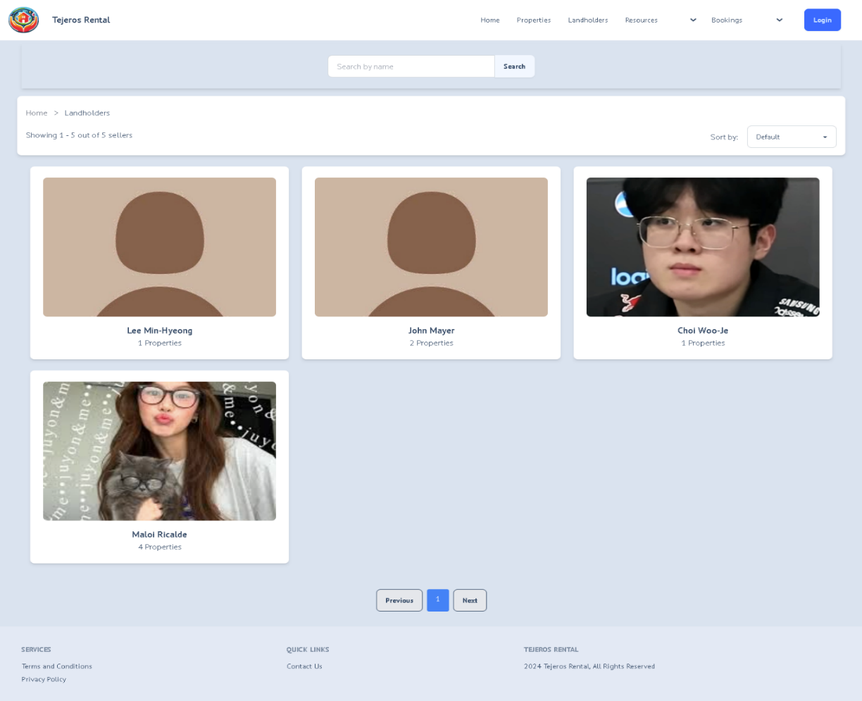Figure 37 shows the page where the user can choose a start date and duration for their stay and automatically display the end-date and the total rent. There is also a verification for booking that indicates that the user wants to book a certain property.

**Figure 38. List of Landlords**

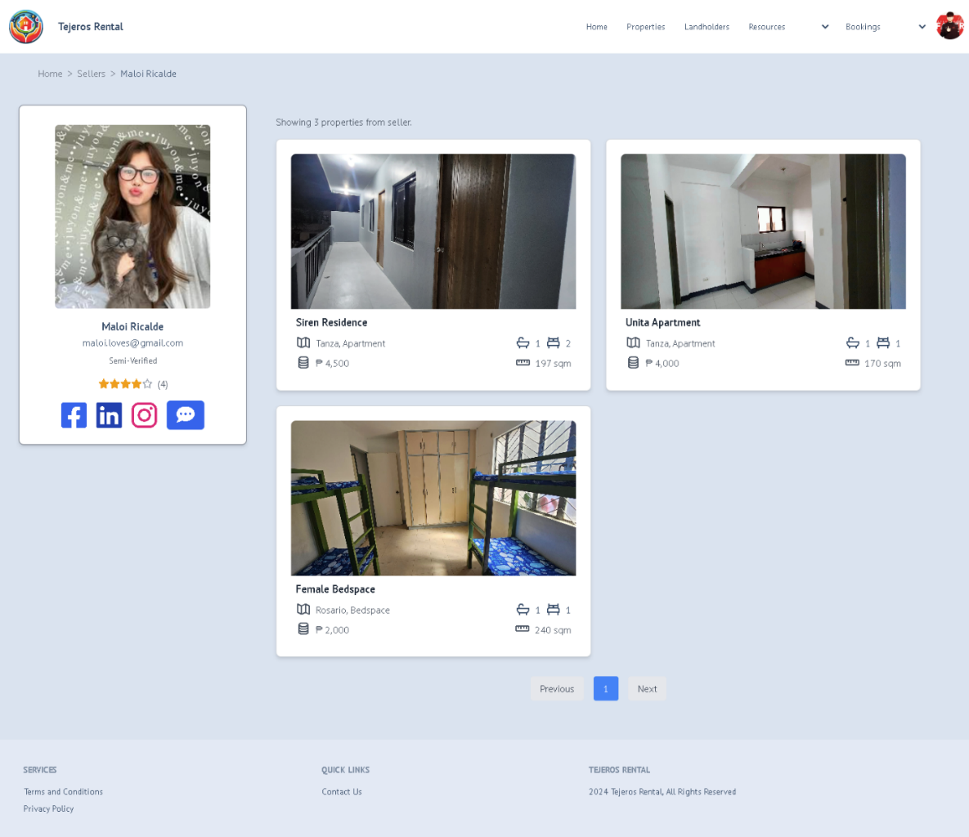Figure 38 shows the list of the landlords and the number of properties they owned.

**Figure 39. Landlord Details**

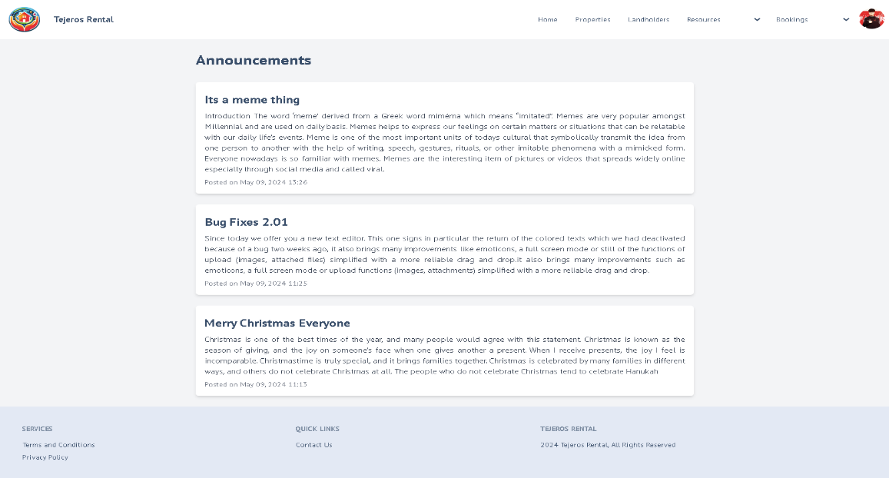Figure 39 shows the name, ratings, social media accounts, a chat system and displayed properties.

**Figure 40. Announcement**

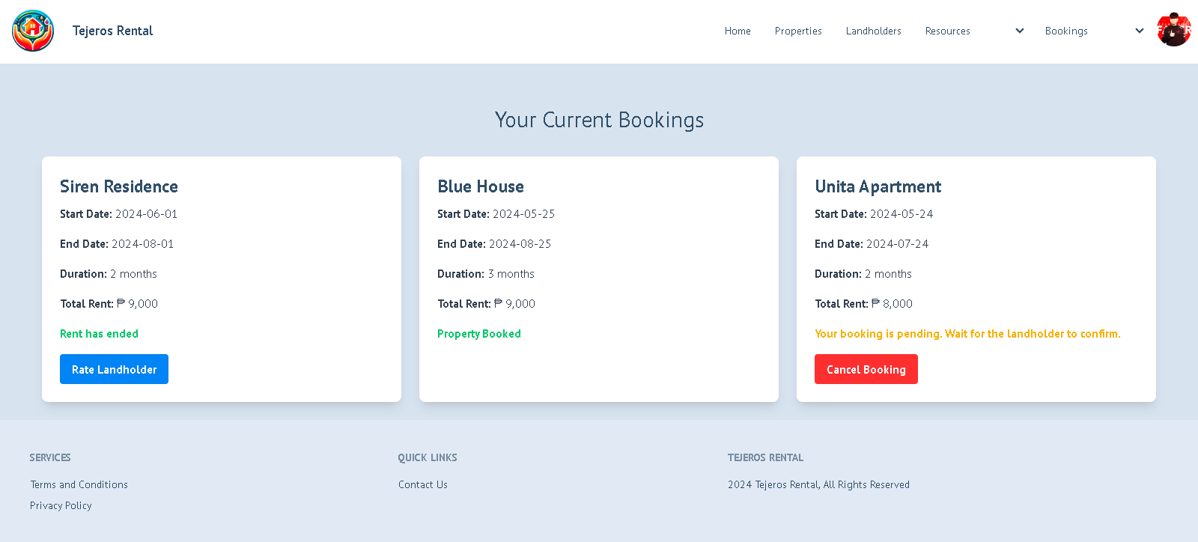Figure 40 shows the announcement set by the admin. Its also regarding to the upcoming maintenance, holiday, or bugs that need to be fix.

**Figure 41. Current Bookings**

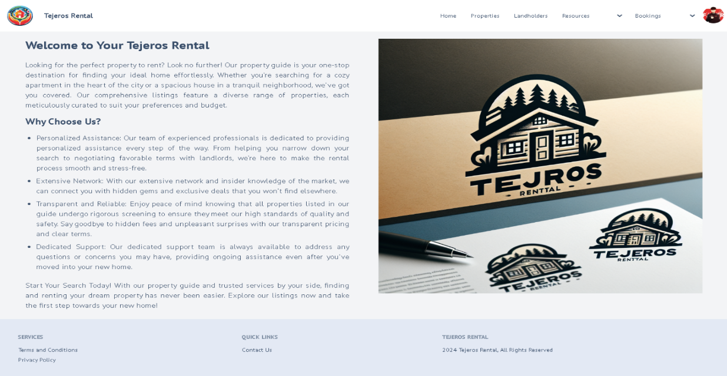Figure 41 shows the details of the property the user currently booked.

**Figure 42. Property Guide**

Figure 42 shows the start up search for a new user and give them a assurance reading the guideline.

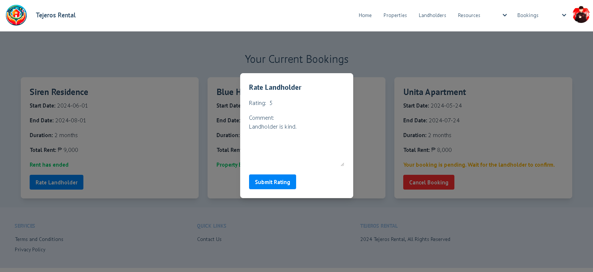

**Figure 43. Rating Landholder**

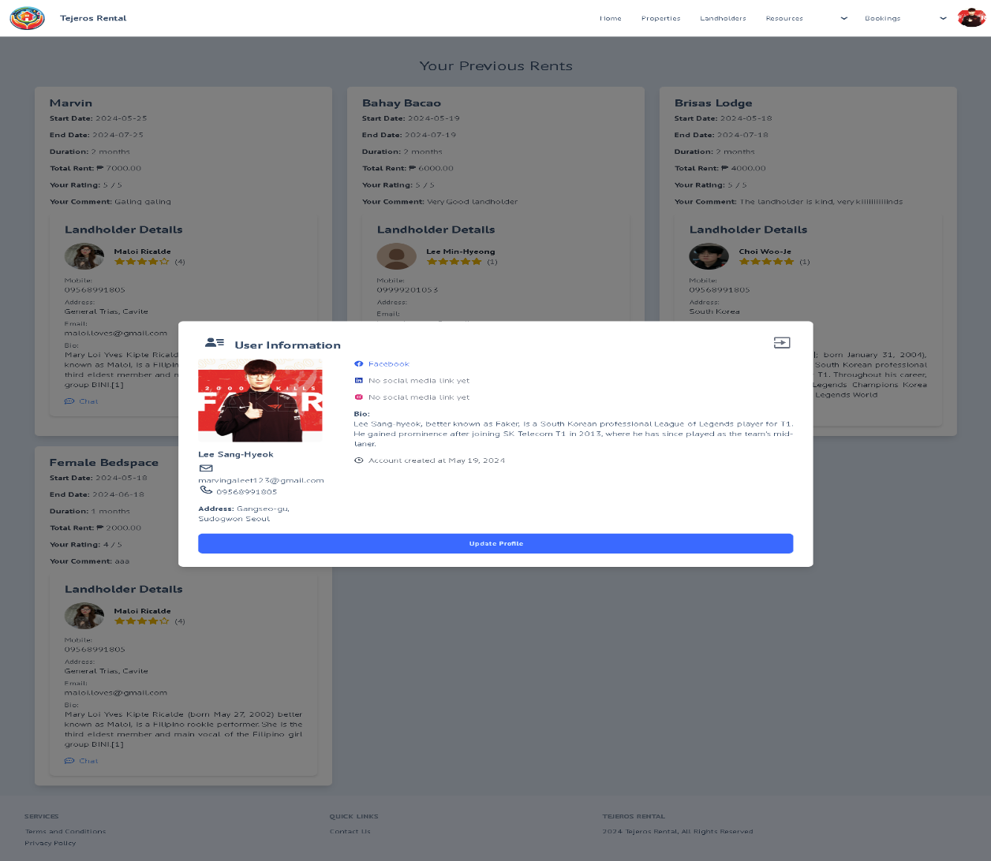Figure 43 shows the modal with how the user will rate property and submit. The ratings will reflect the landholder whether they met the satisfaction and expectation of the user or not.

**Figure 44. Update Profile**

Figure 44 shows the modal allowing the user to modify their credentials or information.

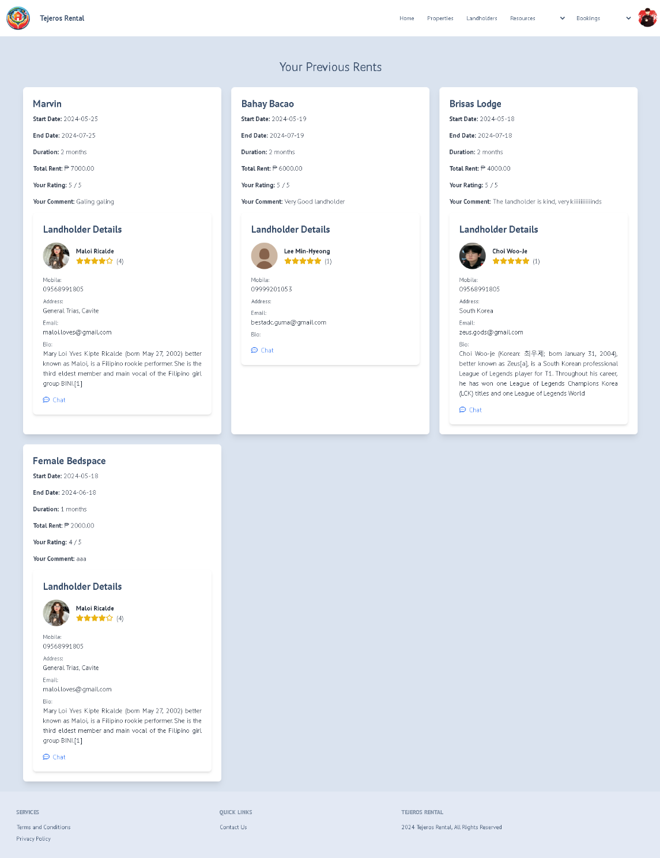

**Figure 45. Previous Rent**

Figure 45 shows the previous rent page allowing the user to view their recent rentals they stay including the details of the landlords, their ratings and the name of the properties.

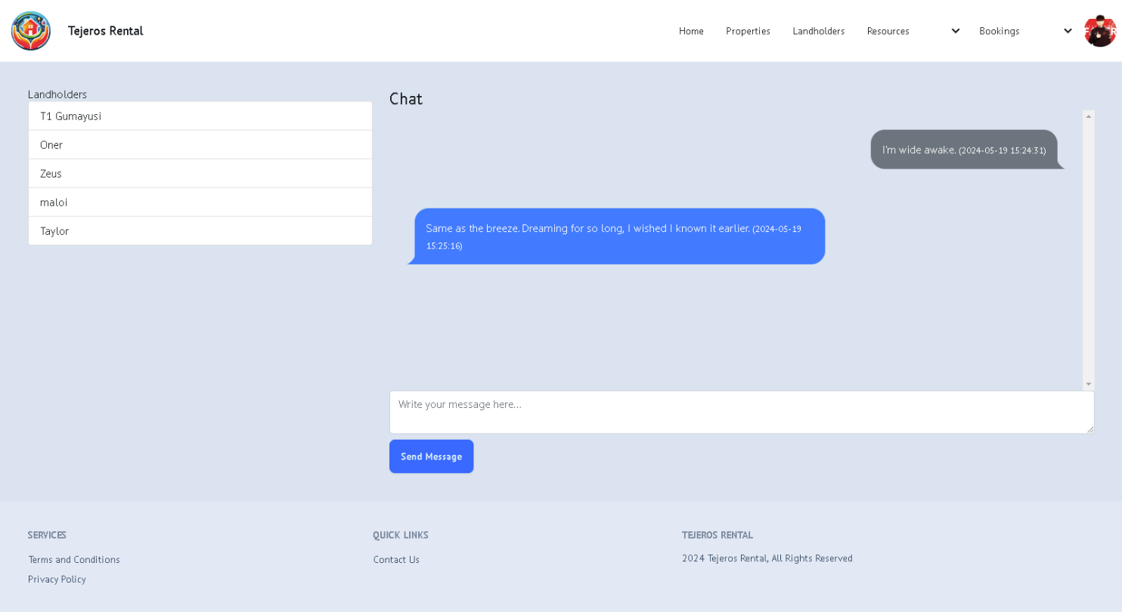

**Figure 46. Chat system**

Figure 46 show the chat system where the user can communicate to different property owners regarding their deals, concerns or any sort of discussion.

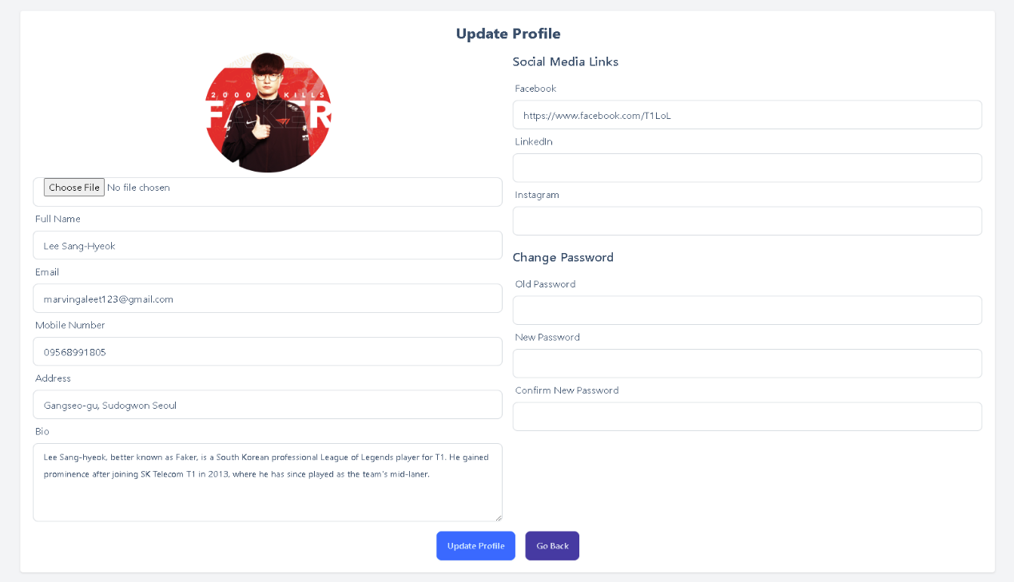

**Figure 47. Update Profile**

Figure 47 shows the update page allowing the user to modify their credentials or information.

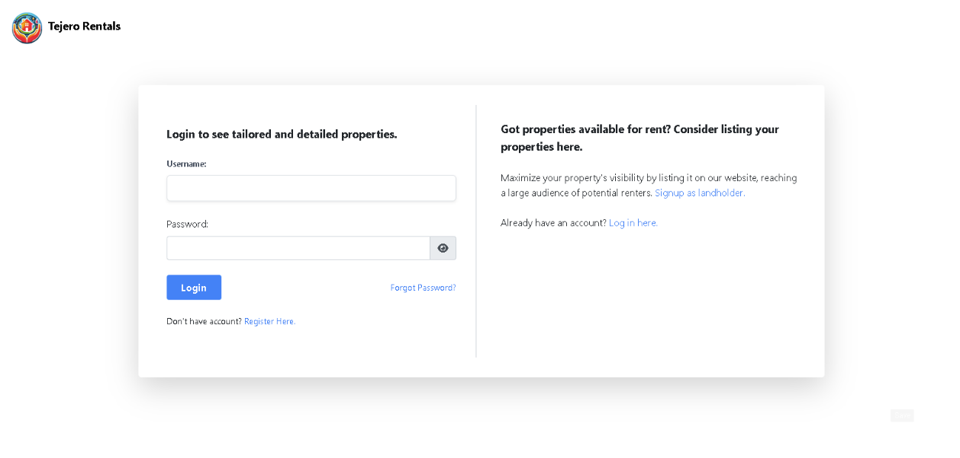

**Figure 48. Login Page**

Figure 48 shows the login page for the end-user, landlords and admin allowing them to have a full access based on their position in different interface.

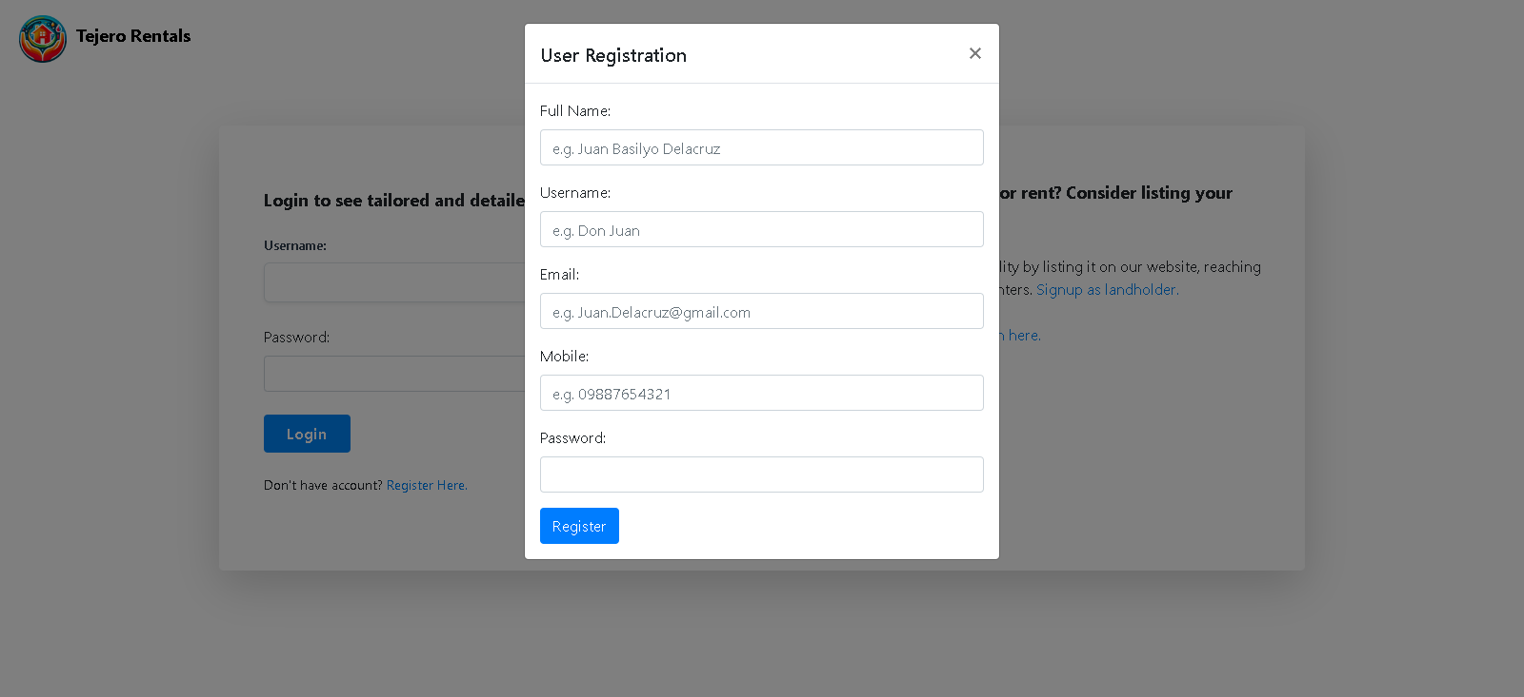

**Figure 49. User Registration**

Figure 49 shows the user registration page where the user required to register first to have an access of a system.

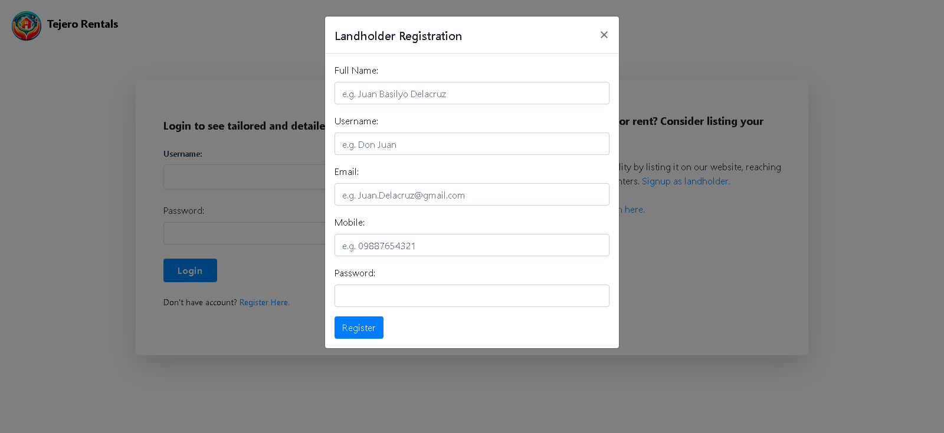

**Figure 50. Landholder Registration**

Figure 50 shows the landlord registration page where the landlord required to register first to have an access of a system and to add and manage its property.

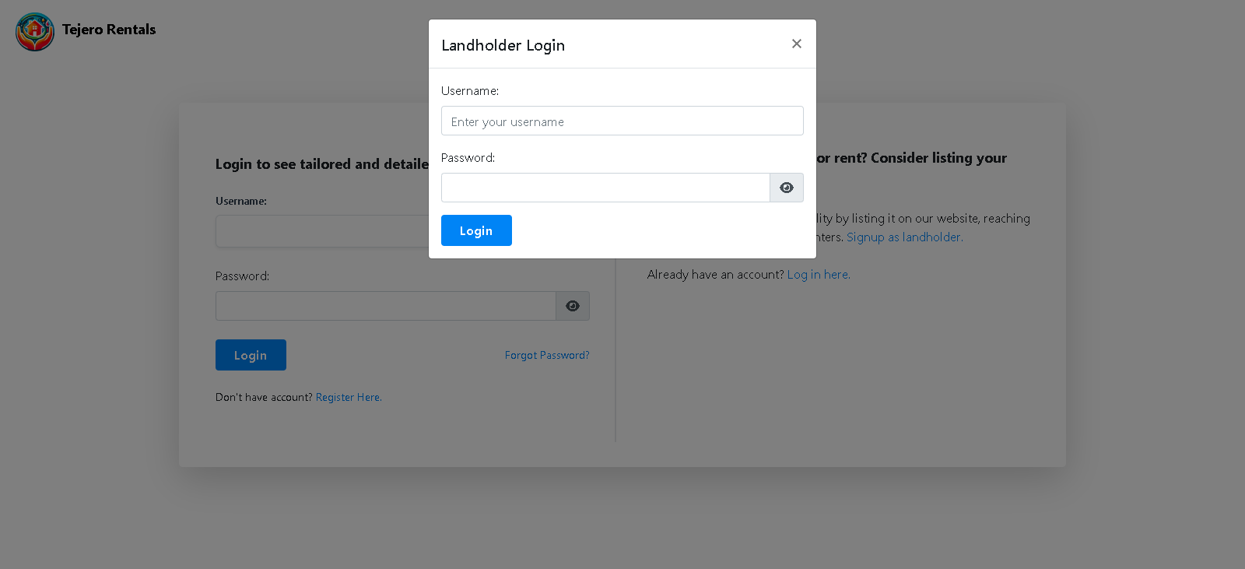

**Figure 51. Landholder login Page**

Figure 51 shows the login modal only applicable for a landholder user.



**Figure 52. Password Reset**

****Figure 52 shows the password reset page by which needed if the user forgot the password and have a desire to retrieve the account.

**Figure 53. Verify OTP**

Figure 53 requires the user to enter an OTP sent from their Gmail account.



**Figure 54. Reset Password**

Figure 54 shows after the validation of an OTP confirms the user. After that, the user can now enter its new password.

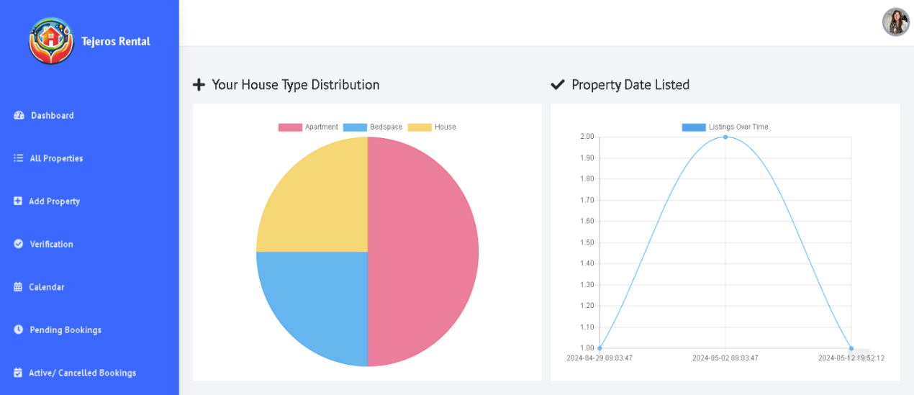

**Figure 55. Dashboard**

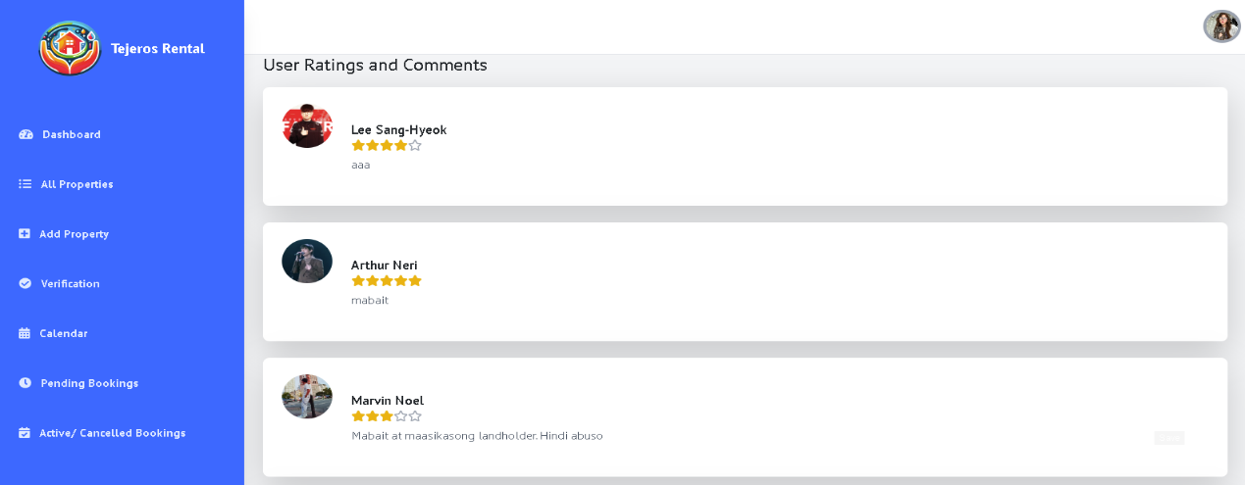Figure 55 shows the dashboard of the landlord’s user with its house type distribution and property date listed.

**Figure 56. User Ratings and Comments**

Figure 56 shows the ratings and comments of a certain user.

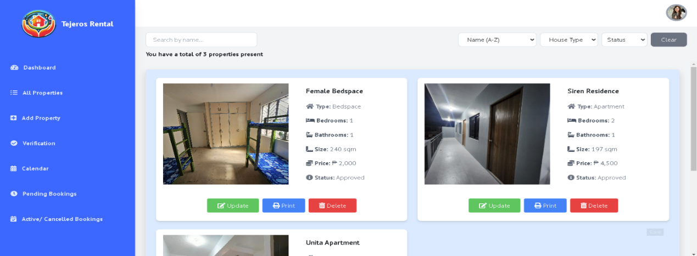

**Figure 57. All properties**

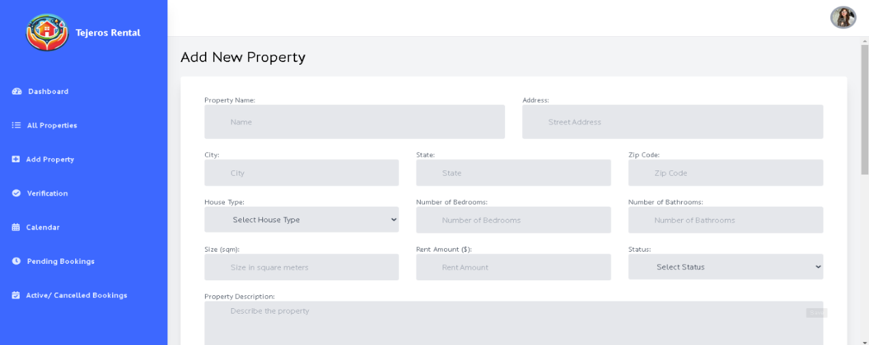Figure 57 shows all the properties of a certain landlord and display the details as well as whether they want to update, print and delete the property.

**Figure 58. Add Property**

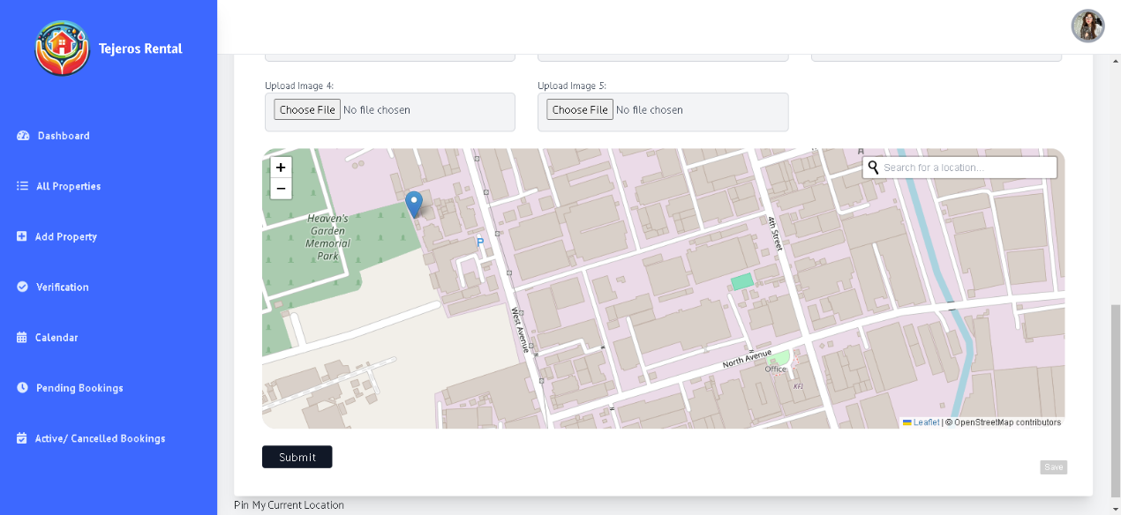Figure 58 shows the page where the landholder can add a property by putting the details.

**Figure 59. Set location**

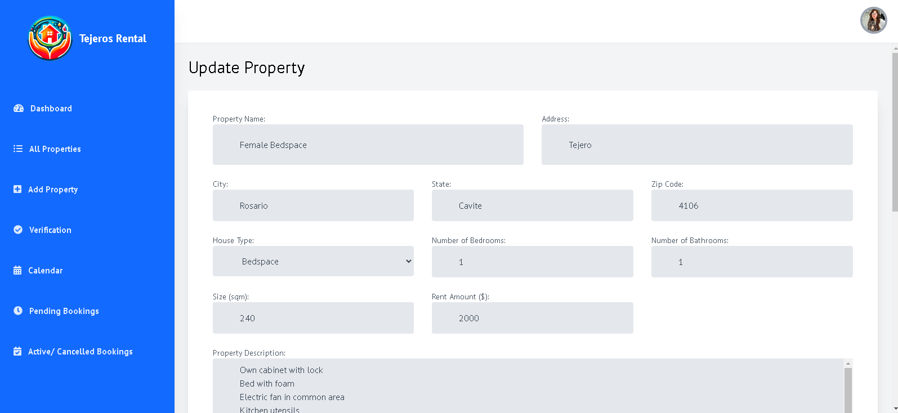Figure 59 show the map where the landholder can add image and pinpoint the location of its property.

**Figure 60. Update property**

Figure 60 shows the page allowing the landholders to modify the details of its certain property.

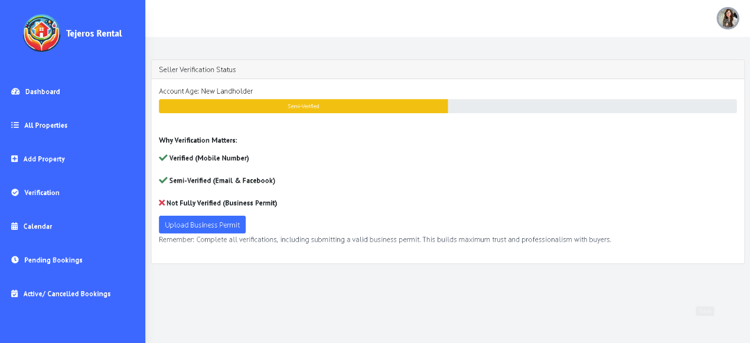

**Figure 61. Verification Status**

Figure 61 shows the verification status of a landholder without not being fully verified and requires to submit a permit.

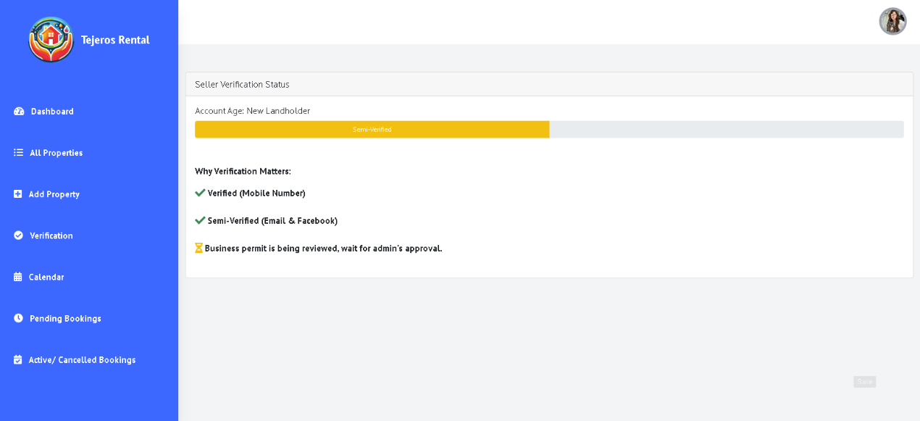

**Figure 62. Verification status (2)**

Figure 62 shows the verification status of a landholder that submitted a business permit.

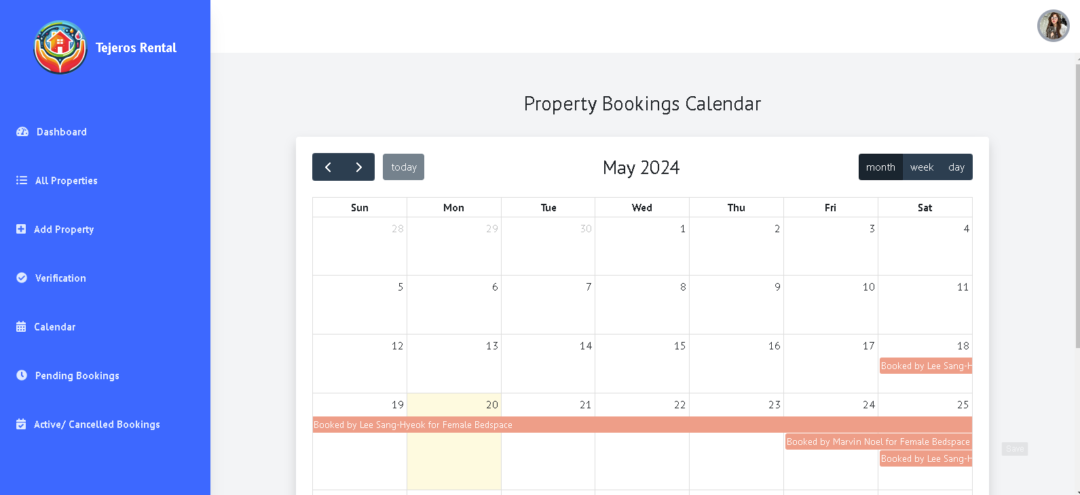

**Figure 63. Property Booking Calendar**

Figure 63 shows the page of a calendar by which allows the landholder user to monitor the end date of the renter and collect their rent payment.

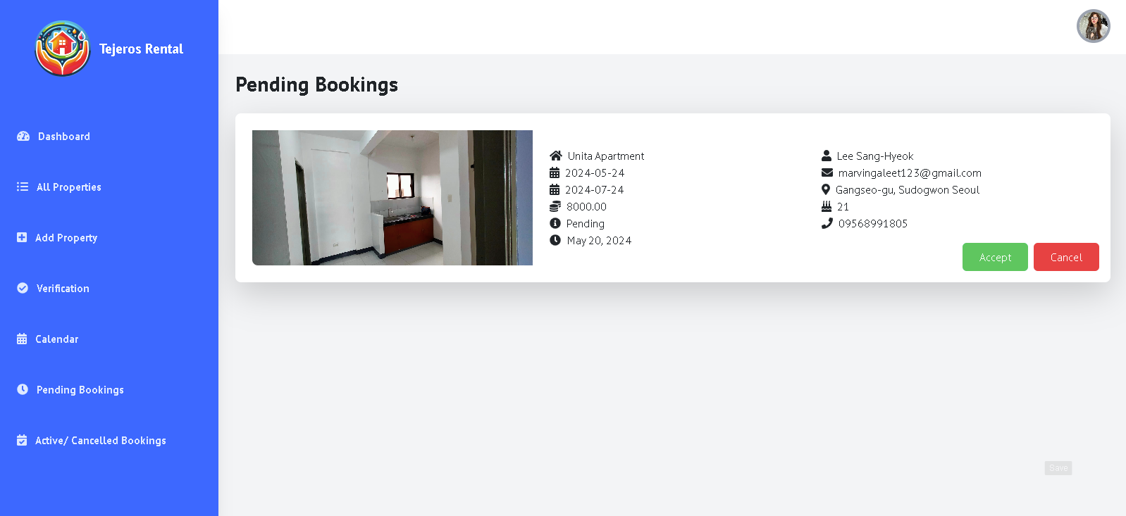

**Figure 64. Pending Bookings**

Figure 64 shows the pending bookings page where the landlords can accept or cancel the booking**.**

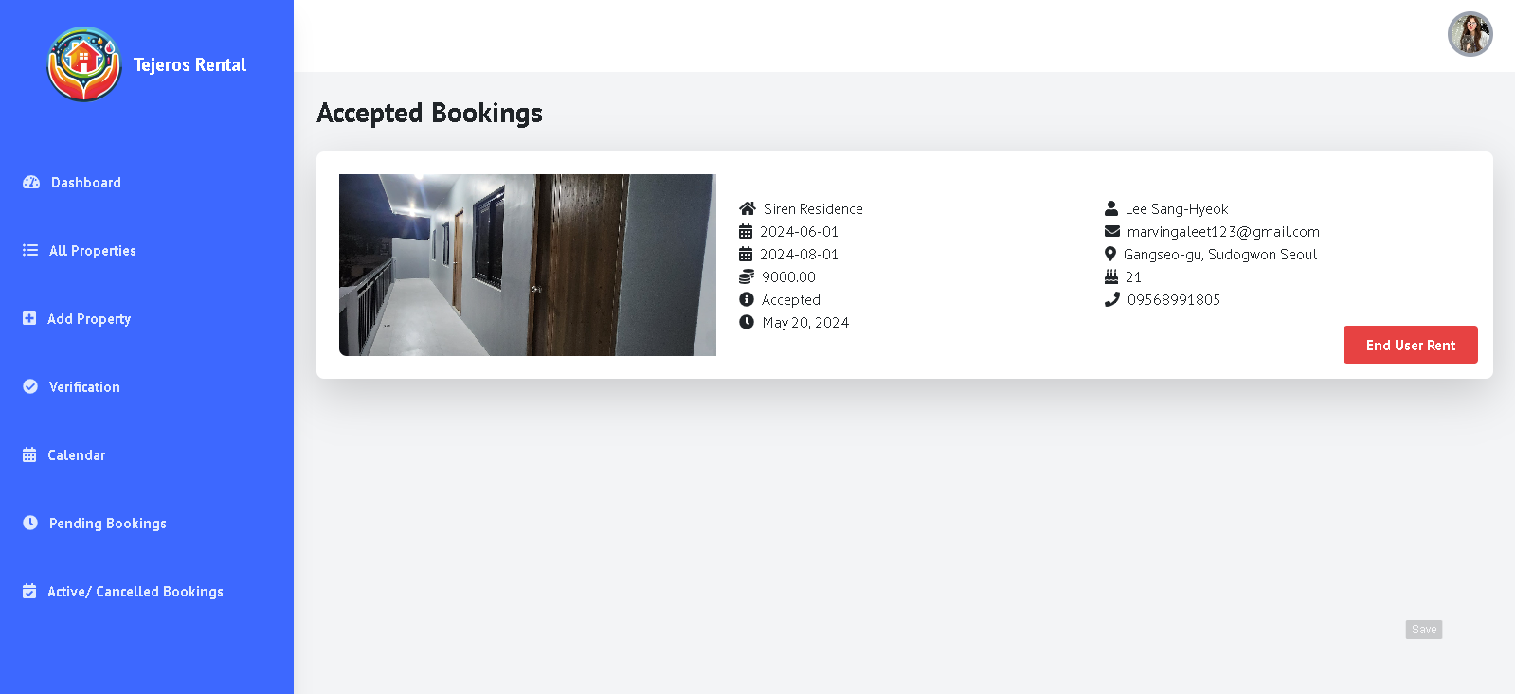

**Figure 65. Accepted Bookings**

Figure 65 shows the accepted bookings of a user and the property details.

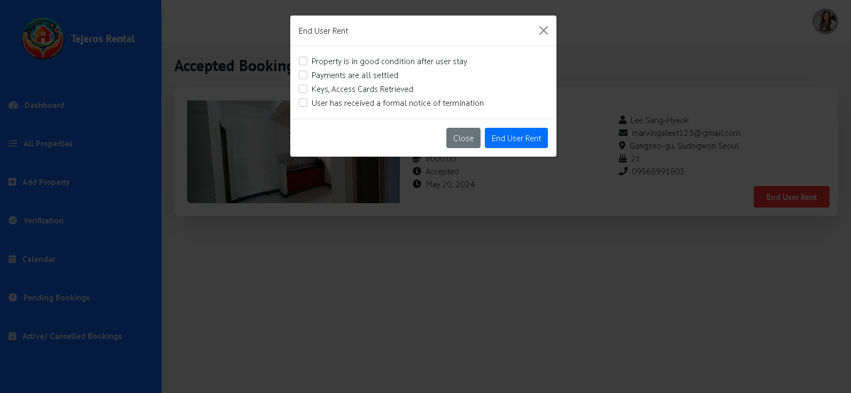

**Figure 66. End-User Rent**

Figure 66 shows the modal where the landlords can overview the condition of the user in staying in rented property.

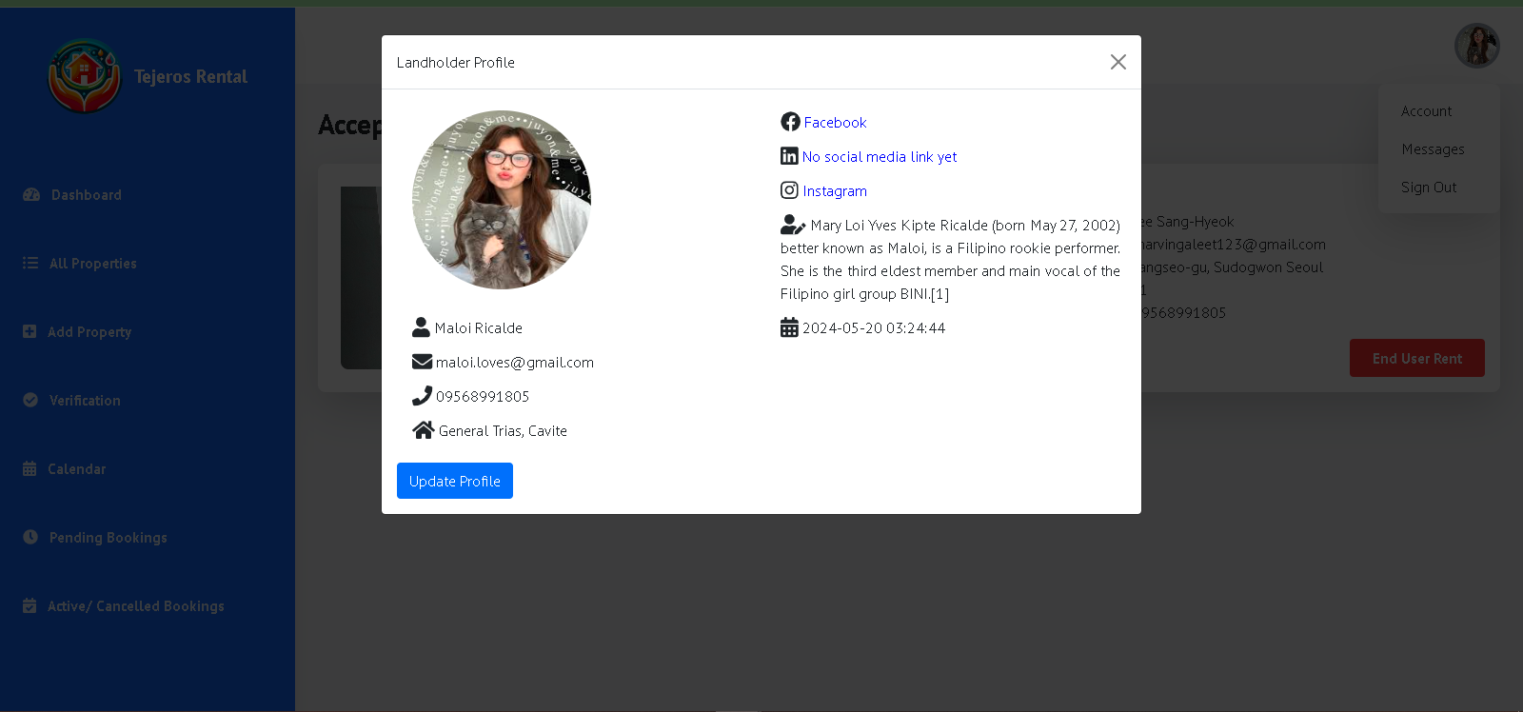

**Figure 67. Landlord Profile**

Figure 67 shows the modal of a profile and details of a certain landlords. They can also modify their credentials by clicking the “update profile”.

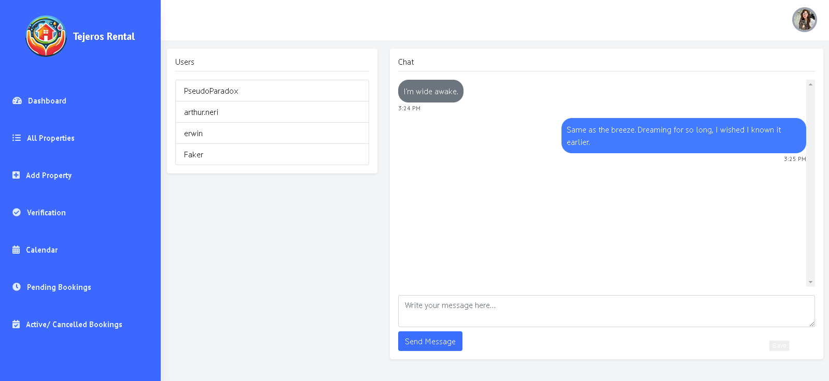

**Figure 68. Chat system (landlord)**

Figure 68 shows the chat system of a landlord where it allows to communicate with the users regarding to their discussion and concern.

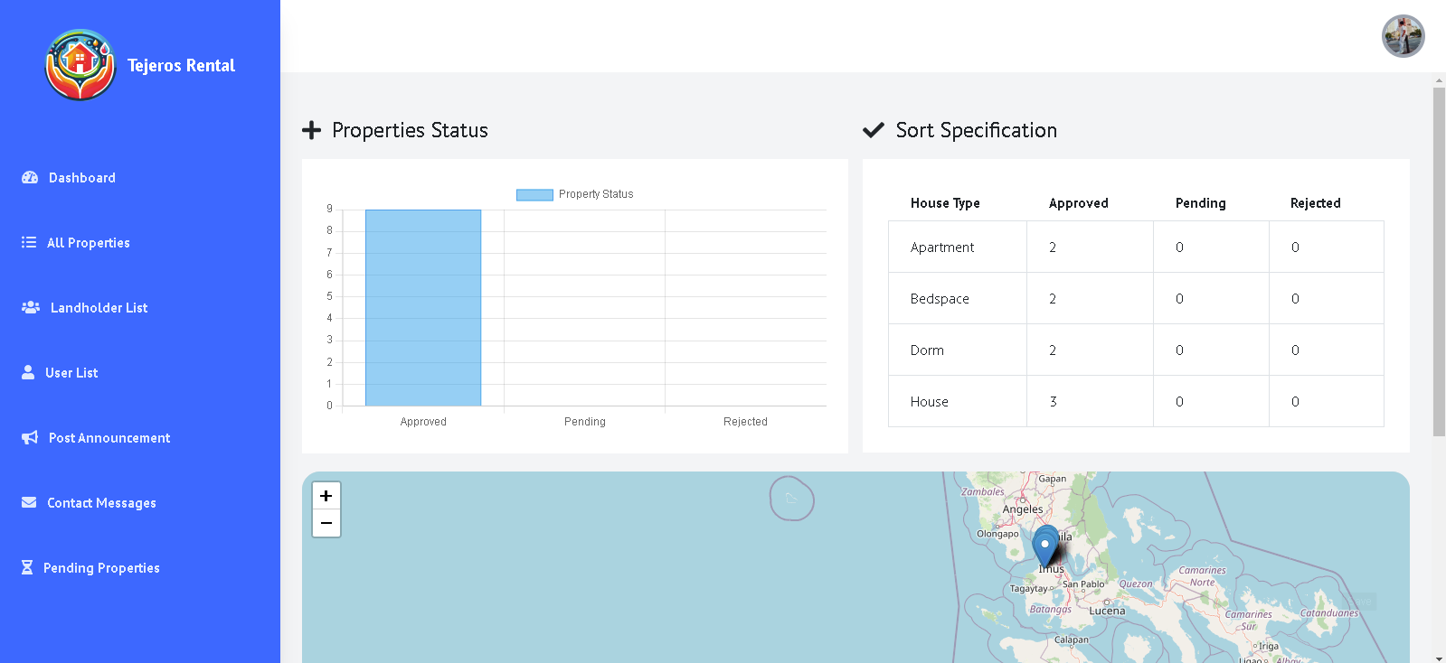

**Figure 69. Dashboard (admin)**

Figure 69 shows the dashboard of an admin with property status, sort specification and the map.

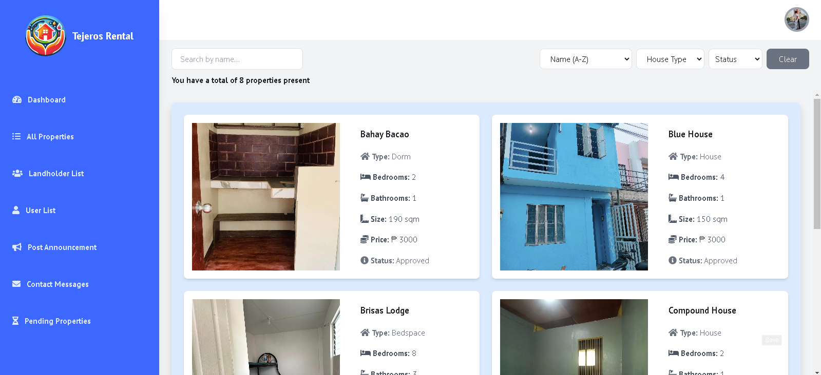

**Figure 70. All Properties**

Figure 70 shows the list of the properties of every property owner with property details, amount and status.

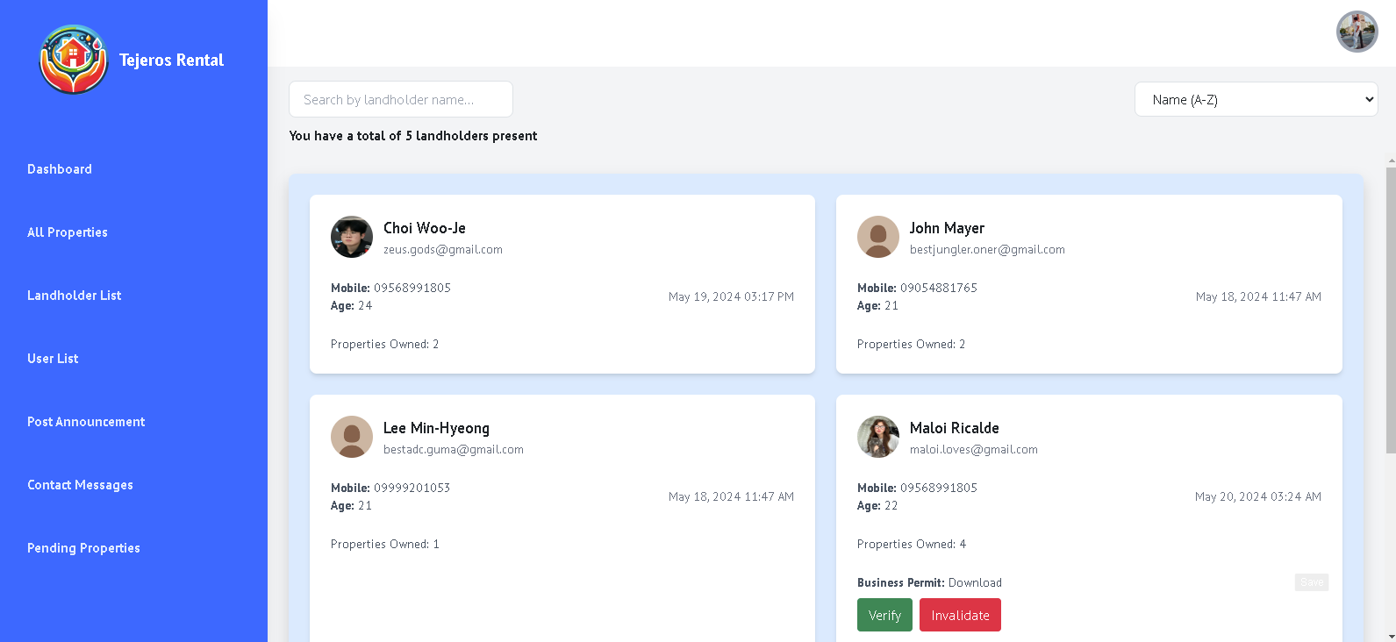

**Figure 71. Landholder List**

Figure 71 shows the list of all the landholder which allows the admin to verify or not the landholders.

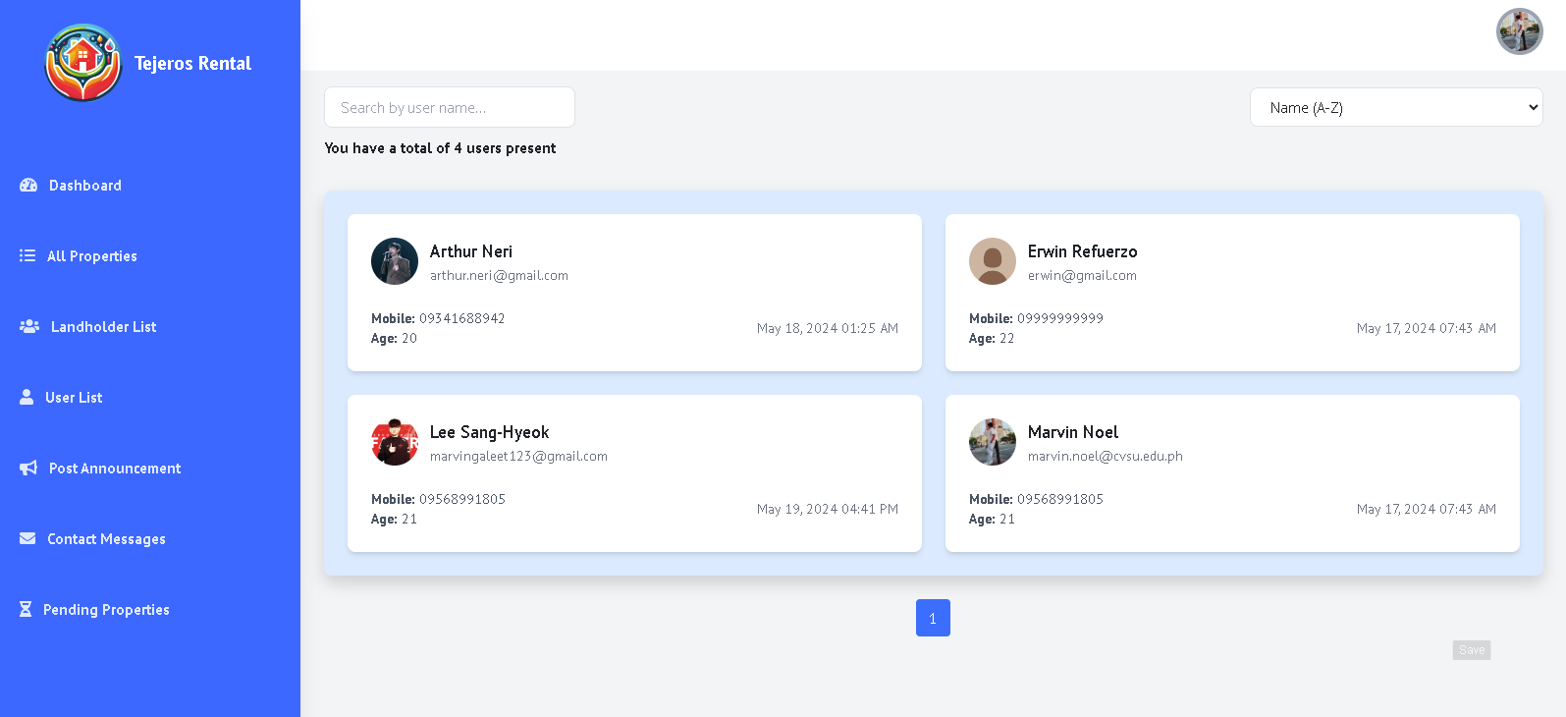

**Figure 72. Users List**

Figure 72 shows the list of the user register and display their name, mobile number and age.

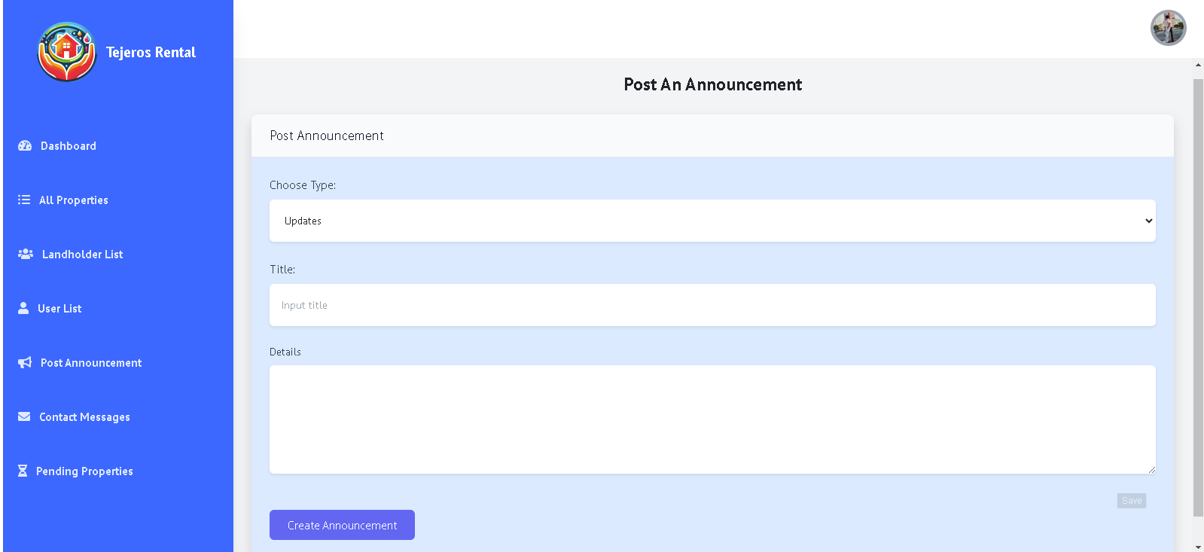

**Figure 73. Announcement**

Figure 73 shows the page where the admin can post an announcement which can view by the users and landlords.

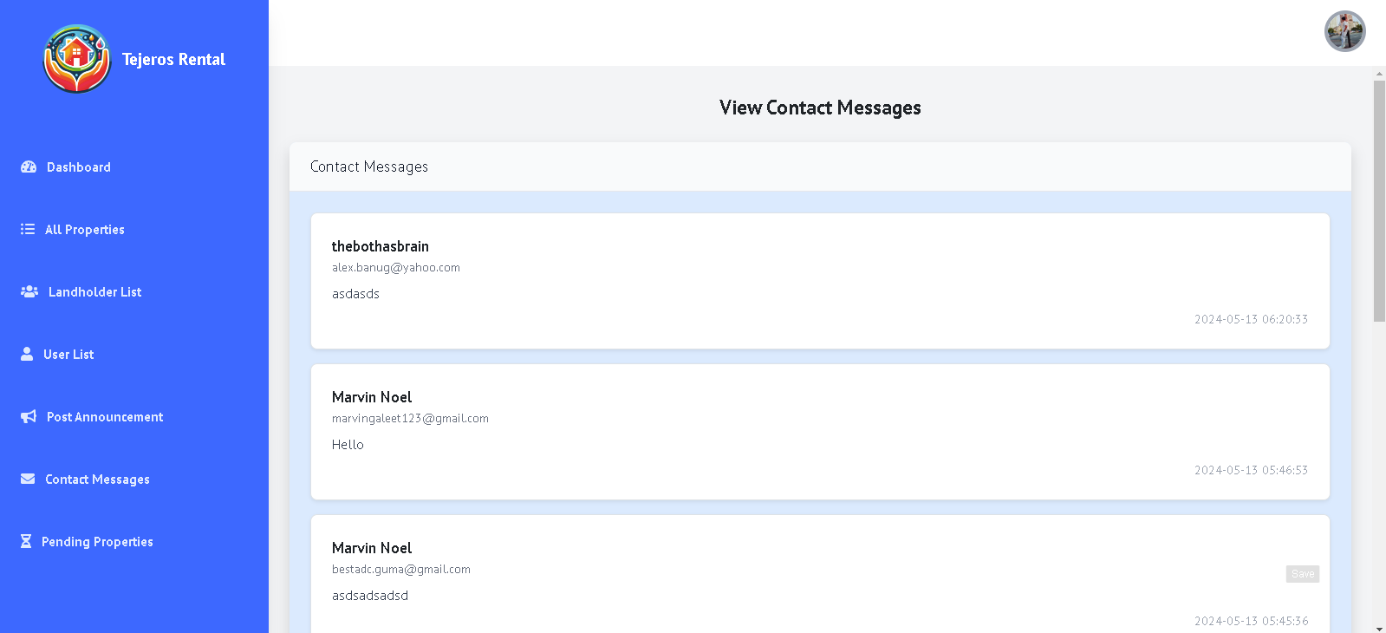

**Figure 74. Messages**

Figure 74 shows the list of messages which allows the admin to view their concerns base on their own circumstances.

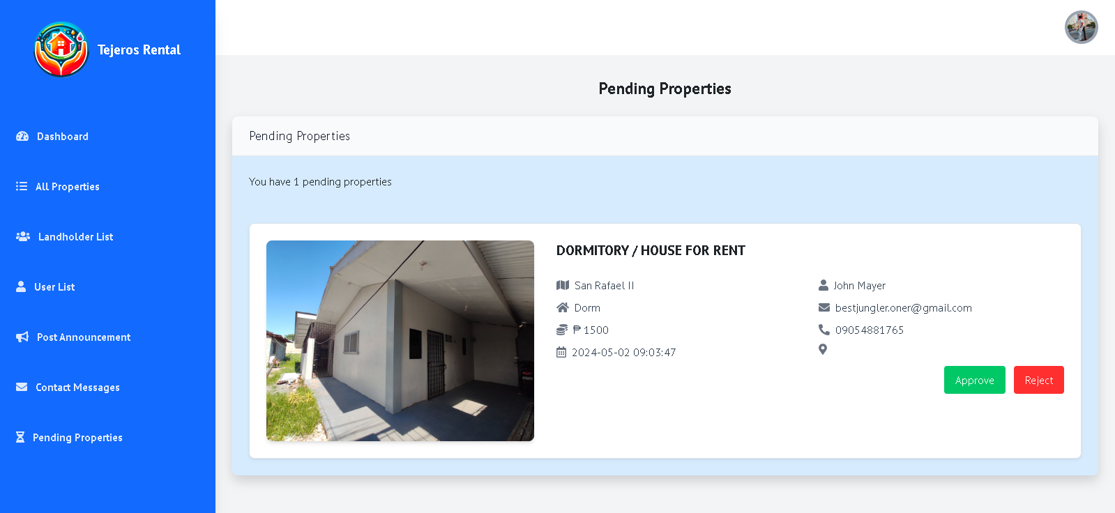

**Figure 75. Pending properties**

Figure 75 shows the list of pending properties that the admin can accept or reject base on its decision.

## **System Testing**

Table 6 shows the results of functional test of different modules of the system.

**Table 6. Functional testing**

|  |  |  |  |  |  |
| --- | --- | --- | --- | --- | --- |
| **Module** | **Login and Registration Page** | | | | |
| **Test Case** | **Action** | **Expected System Response** | **Number of Execution** | **Results** | **Status** |
| ULP | Click the “Login” button | If account was registered, the user will be redirected to user home. | 1 | Redirected to User Home Page | Passed |
| ULP | Click the “Register Here” button | A modal popup form will show allowing users to put their credentials | 1 | Modal Popup Form Appeared for Registration to Users | Passed |
| ULP | Click “Register”  button | An alert showing success registration and redirects back to login page | 1 | Alert display showing success and redirects back to login page. | Passed |
| LLP | Click the “Login in here.” button | A modal popup form will show allowing landholders to put their credentials | 1 | Modal Popup Form Appeared for Landholders to login | Passed |
| LLP | Click the “Login” button” | If account was registered, the landholder will be redirected to landholder dashboard. | 1 | Alert display showing success and redirects landholder to landholder dashboard | Passed |
| LLP | Click the “Signup as landholder.” button | A modal popup will show allowing landholders to put their credentials. | 1 | Modal Popup Form Appeared for Registration to Landholders | Passed |
| LLP | Click “Register” button | An alert showing success registration and redirects back to login page | 1 | Alert display showing success and redirects to landholder dashboard. | Passed |
| ALP | Click the “Login” button | If account is registered and recognize its role as admin, it will redirect to admin dashboard | 1 | Redirected to Admin Dashboard | Passed |

|  |  |  |  |  |  |
| --- | --- | --- | --- | --- | --- |
| **Module** | **User Header** | | | | |
| **Test Case** | **Action** | **Expected System Response** | **Number of Execution** | **Results** | **Status** |
| UL | Click “Login” button | If user is not logged in yet, this login button will appear and takes user to login page | 1 | User is redirected to login page | Passed |
| UH | Click “Home” button | The user will be redirected to user home page. | 1 | Redirected to User Home Page | Passed |
| UP | Click the “Properties” button | The user will be redirected to properties page. | 1 | Redirected to Properties Page | Passed |
| UL | Click “Landholders”  button | The user will be redirected to landholder’s page | 1 | Redirected to Landholder Page | Passed |
| UR | Click “Resources” button | A dropdown “Announcements” and “Property Guide” will show | 1 | Two dropdown item displays | Passed |
| UA | Click “Announcements” button | User will be redirected to Announcement page | 1 | Redirected to Announcements Page | Passed |
| UPG | Click “Property Guide” button | User will be redirected to Property Guide Page | 1 | Redirected to Property Guide Page | Passed |
| UB | Click “Bookings” button | A dropdown “Current Bookings” and “Previous Rents” will show | 1 | Two dropdown item displays | Passed |
| UCB | Click “Current Bookings” button | User will be redirected to current bookings page | 1 | Redirected to Current Bookings Page | Passed |
| UPR | Click “Previous Rents” button | User will be redirected to previous rent page | 1 | Redirected to Previous Rent Page | Passed |
| UPF | Click image icon button | Dropdown Profile, Messages, and Logout will show | 1 | Three dropdown items displayed | Passed |
| UPI | Click “Profile” button | User information popup modal will display | 1 | User Information Modal Displayed | Passed |
| UPUP | Click “Update Profile” button | User will be redirected to user profile form | 1 | User redirected to user profile form | Passed |
| UPUP1 | Click “Update Profile button” | An alert will show displaying success of profile edit | 1 | Alert shows successful profile edit | Passed |
| UPGB | Click “Go Back” button | User will be redirected to user home after clicking | 1 | User redirected to user home | Passed |
| UPM | Click “Messages’ button | User will be redirected to chat page | 1 | User redirected to chat page | Passed |
| UPSM | Click “Send Message” button | Message will be sent to the receiver the user chose | 1 | Message sent to the receiver | Passed |
| ULO | Click “Logout” button | User will be logged out and redirected to login page | 1 | User is logged out and redirected to login | Passed |

|  |  |  |  |  |  |
| --- | --- | --- | --- | --- | --- |
| **Module** | **User Footer** | | | | |
| **Test Case** | **Action** | **Expected System Response** | **Number of Execution** | **Results** | **Status** |
| UTC | Click “Terms and Conditions” button | The user will be redirected to terms and conditions page. | 1 | Redirected to Terms and Conditions Page | Passed |
| UPP | Click “Privacy Policy” button | The user will be redirected to Privacy Policy page. | 1 | Redirected to Privacy Policy page | Passed |
| UCU | Click “Contact Us” button | The user will be redirected to Contact Us page. | 1 | Redirected to Contact us page | Passed |
| USM | Click “Send Message” button | The user will be redirected to user home | 1 | Redirected to user home | Passed |

|  |  |  |  |  |  |
| --- | --- | --- | --- | --- | --- |
| **Module** | **User Home Page** | | | | |
| **Test Case** | **Action** | **Expected System Response** | **Number of Execution** | **Results** | **Status** |
| UHVP | Click “View Properties” button | The user will be redirected to properties page. | 1 | Redirected to Properties Page | Passed |
| UHLM | Click the “Learn More” button | The user will be redirected to guide page. | 1 | Redirected to Guide Page | Passed |
| UHVL | Click “View Landholders”  button | The user will be redirected to landholder page | 1 | Redirected to Landholder Page | Passed |

|  |  |  |  |  |  |
| --- | --- | --- | --- | --- | --- |
| **Module** | **Properties Page** | | | | |
| **Test Case** | **Action** | **Expected System Response** | **Number of Execution** | **Results** | **Status** |
| UPS | Click “Search” button | If search input has data, the item will display to the grid | 1 | Data is displayed based on gathered input | Passed |
| UPH | Click the “House” button | User will be redirected to category page, displaying house properties | 1 | Redirected to Category Page displaying house properties | Passed |
| UPA | Click the “Apartment” button | User will be redirected to category page, displaying apartment properties | 1 | Redirected to Category Page displaying Apartment properties | Passed |
| UPD | Click the “Dorm” button | User will be redirected to category page, displaying dorm properties | 1 | Redirected to Category Page displaying Dorm properties | Passed |
| UPB | Click the “Bedspace” button | User will be redirected to category page, displaying bedspace properties | 1 | Redirected to Category Page displaying Bedspace properties | Passed |
| UPSB | Click “Sort by” button | A dropdown will display “Newest Listings”, “Oldest Listings”, “Lowest Price”, “Highest price” | 1 | Four items in dropdown displayed | Passed |
| UPNL | Click “Newest Listings” button | Grid will display newest properties | 1 | Grid displayed newest properties | Passed |
| UPOL | Click “Oldest Listings” button | Grid will display oldest properties | 1 | Grid displayed oldest properties | Passed |
| UPLP | Click “Lowest Price” button | Grid will display low price properties | 1 | Grid displayed low priced properties | Passed |
| UPHP | Click “Highest Price” button | Grid will display high price properties | 1 | Grid displayed high priced properties | Passed |
| UPSZ | Click “Select Size” button | Dropdown will display “50-100 sqm”, “100-200 sqm”, “200 sqm and up” | 1 | Three items from dropdown are displayed | Passed |
| UPSM | Click “50-100 sqm” button | Properties that have 50 to 100 sqm size will display | 1 | Properties with 50 to 100 sqm size are displayed | Passed |
| UPMD | Click “100-200 sqm” button | Properties that have 100 to 200 sqm size will display | 1 | Properties with 100 to 200 sqm size are displayed | Passed |
| UPLG | Click “200 sqm and up” button | Properties that have 200 sqm size and more will display | 1 | Properties with 200 sqm size or more are displayed | Passed |
| UPBD | Click “Select Bedrooms” button | Dropdown will display 1, 2, 3, 4, 5+ Bedrooms | 1 | Five items from dropdown are displayed | Passed |
| UPBD1 | Click “1 Bedroom” button | Properties that have 1 bedroom will display | 1 | Properties with 1 bedroom are displayed | Passed |
| UPBD2 | Click “2 Bedrooms” button | Properties that have 2 bedrooms will display | 1 | Properties with 2 bedrooms are displayed | Passed |
| UPBD3 | Click “3 Bedrooms” button | Properties that have 3 bedrooms will display | 1 | Properties with 3 bedrooms are displayed | Passed |
| UPBD4 | Click “4 Bedrooms” button | Properties that have 4 bedrooms will display | 1 | Properties with 4 bedrooms are displayed | Passed |
| UPBD5 | Click “5+ Bedrooms” button | Properties that have 5+ bedrooms will display | 1 | Properties with 5+ bedrooms are displayed | Passed |
| UPBT | Click “Select Bathrooms” button | Dropdown will display 1, 2, 3, 4, 5+ Bathrooms | 1 | Five items from dropdown are displayed | Passed |
| UPBT1 | Click “1 Bathroom” button | Properties that have 1 bathroom will display | 1 | Properties with 1 bathroom are displayed | Passed |
| UPBT2 | Click “2 Bathrooms” button | Properties that have 2 bathrooms will display | 1 | Properties with 2 bathrooms are displayed | Passed |
| UPBT3 | Click “3 Bathrooms” button | Properties that have 3 bathrooms will display | 1 | Properties with 3 bathrooms are displayed | Passed |
| UPBT4 | Click “4 Bathrooms” button | Properties that have 4 bathrooms will display | 1 | Properties with 4 bathrooms are displayed | Passed |
| UPBT5 | Click “5+ Bathrooms” button | Properties that have 5+ bathrooms will display | 1 | Properties with 5+ bathrooms are displayed | Passed |
| UPRA | Click “Select Rent Amount” button | Dropdown will display “Lower 2000”, “3000”, “4000 and up” | 1 | Three items from dropdown are displayed | Passed |
| UPRA1 | Click “Lower 2000” button | Properties that have 2000 and lower rent amount will display | 1 | Properties with 2000 and lower rent amount are displayed | Passed |
| UPRA2 | Click “3000” button | Properties that have 3000 rent amounts will display | 1 | Properties with 3000 rent amounts are displayed | Passed |
| UPRA3 | Click “4000 and up” button | Properties that have 4000 and higher rent amount will display | 1 | Properties with 4000 and higher rent amount are displayed | Passed |
| UPRF | Click “Reset Filter” button | Property display will reset and attributes will reset | 1 | Property reset and attributes are reset. | Passed |
| UPSP | Click Property Grid | User will be redirected to the property he/she clicked in the grid | 1 | User redirected to property he/she clicked | Passed |
| UPP | Click “Previous” button | User will be redirected to previous page otherwise it will stay in page 1 | 1 | User goes to previous page/ user stayed on page 1 | Passed |
| UPN | Click Number buttons | User will be redirected to specific page number it clicked | 1 | User was redirected to the property page clicked | Passed |
| UPN | Click “Next” button | User will be redirected to next page otherwise it will stay in last page | 1 | User goes to next page/ user stayed on last page | Passed |

|  |  |  |  |  |  |
| --- | --- | --- | --- | --- | --- |
| **Module** | **Landholders Page** | | | | |
| **Test Case** | **Action** | **Expected System Response** | **Number of Execution** | **Results** | **Status** |
| ULS | Click “Search” button | If search input has data, the item will display to the grid | 1 | Data is displayed based on gathered input | Passed |
| ULSB | Click “Sort by” button | A dropdown will display “Newest Seller”, “Oldest Seller”, “Name (Ascending)” | 1 | Three items in dropdown displayed | Passed |
| ULNS | Click “Newest Seller” button | Grid will display newest sellers | 1 | Grid displayed newest sellers | Passed |
| ULOS | Click “Oldest Seller” button | Grid will display oldest sellers | 1 | Grid displayed oldest sellers | Passed |
| ULNA | Click “Name (Ascending)” button | Grid will display landholder’s name in ascending order. | 1 | Grid displayed landholder name in ascending order. | Passed |
| ULSL | Click Landholder Grid | User will be redirected to the landholder details clicked in the grid | 1 | User redirected to landholder clicked | Passed |
| ULP | Click “Previous” button | User will be redirected to previous page otherwise it will stay in page 1 | 1 | User goes to previous page/ user stayed on page 1 | Passed |
| ULN | Click Number buttons | User will be redirected to specific page number it clicked | 1 | User was redirected to the property page clicked | Passed |
| ULN | Click “Next” button | User will be redirected to next page otherwise it will stay in last page | 1 | User goes to next page/ user stayed on last page | Passed |

|  |  |  |  |  |  |
| --- | --- | --- | --- | --- | --- |
| **Module** | **Landholder Detail Page** | | | | |
| **Test Case** | **Action** | **Expected System Response** | **Number of Execution** | **Results** | **Status** |
| LDPL | Click Property Grid | User will be redirected to the property details clicked in the grid | 1 | User redirected to property clicked | Passed |
| LDP | Click “Previous” button | User will be redirected to previous page otherwise it will stay in page 1 | 1 | User goes to previous page/ user stayed on page 1 | Passed |
| LDNB | Click Number buttons | User will be redirected to specific page number it clicked | 1 | User was redirected to the property page clicked | Passed |
| LDN | Click “Next” button | User will be redirected to next page otherwise it will stay in last page | 1 | User goes to next page/ user stayed on last page | Passed |
| LDFA | Click “Facebook Icon” button | User will be redirected to landholder face book account | 1 | User is redirected to landholder’s face book account | Passed |
| LDLA | Click “LinkedIn Icon” button | User will be redirected to landholder LinkedIn account | 1 | User is redirected to landholder’s LinkedIn account | Passed |
| LDIA | Click “Instagram Icon” button | User will be redirected to landholder Instagram account | 1 | User is redirected to landholder’s Instagram account | Passed |
| LDCM | Click “Message Icon” button | User will be redirected to chat page | 1 | User is redirected to chat page | Passed |

|  |  |  |  |  |  |
| --- | --- | --- | --- | --- | --- |
| **Module** | **Property Details** | | | | |
| **Test Case** | **Action** | **Expected System Response** | **Number of Execution** | **Results** | **Status** |
| PDH | Click “Home” button | The user will be redirected to user home page. | 1 | Redirected to User Home Page | Passed |
| PDP | Click “Properties” button | The user will be redirected to Properties page. | 1 | Redirected to Properties page | Passed |
| PDB | Click “Book Property” button | The user will be redirected to booking page with the property user clicked | 1 | Redirected to booking page of property the user clicked | Passed |
| PDL | Click “Like” button | The number of likes will increase by one | 1 | Total number of likes increased by one | Passed |
| PDUL | Click “Liked” button | The number of likes will decrease by one | 1 | Total number of likes decreased by one | Passed |
| PDR | Click “Flag Icon” button | A modal for report form will show | 1 | Modal for reporting property is displayed | Passed |
| PDI | Click Image Media | A modal for displaying the whole image will display | 1 | Modal displaying whole image is displayed | Passed |
| PDC | Click “Chat” button | The user is redirected to landholder chat box | 1 | User redirected to landholder chat box | Passed |
| PDN | Click “Navigate Property through Google Map” button | The user will be redirected to google map showing the navigation through user location to property location | 1 | User redirected to google map displaying user current location going through property location | Passed |
| PDV | Click “View Details” button | User will be redirected to the property details container clicked | 1 | User redirected to property details clicked | Passed |

|  |  |  |  |  |  |
| --- | --- | --- | --- | --- | --- |
| **Module** | **Booking Property** | | | | |
| **Test Case** | **Action** | **Expected System Response** | **Number of Execution** | **Results** | **Status** |
| BPST | Click “Calendar” button | A calendar dropdown will show | 1 | Calendar dropdown displayed | Passed |
| BPD | Input Duration button | The user will be able to input a number of months duration | 1 | User is prompt to input number for months | Passed |
| BPCHB | Click “Checkbox” button | The checkbox will be checked | 1 | Checkbox is checked when user clicked | Passed |
| BPCB | Click “Confirm Booking” | An alert will prompt if the property is already booked or not, then the user is redirected to Current Bookings page | 1 | User is redirected to Current Bookings | Passed |

|  |  |  |  |  |  |
| --- | --- | --- | --- | --- | --- |
| **Module** | **Current Bookings** | | | | |
| **Test Case** | **Action** | **Expected System Response** | **Number of Execution** | **Results** | **Status** |
| CBCB | Click “Cancel Booking” button | A prompt will show confirming cancellation of booking | 1 | Prompt displayed confirming cancellation of booking | Passed |
| CBRL | Click “Rate Landholder” button | A modal will show displaying a form for rating the landholder | 1 | Modal displayed a form for rating landholder | Passed |
| CBSR | Click “Submit Rating” button | An alert will show confirming success of landholder rating | 1 | Alert displayed confirming success of rating landholder | Passed |
| CBC | Click “Cancel” button | An alert showing cancellation of booking success | 1 | An alert is displayed for success of cancellation booking | Passed |

|  |  |  |  |  |  |
| --- | --- | --- | --- | --- | --- |
| **Module** | **Landholder Tabs and Header** | | | | |
| **Test Case** | **Action** | **Expected System Response** | **Number of Execution** | **Results** | **Status** |
| LD | Click “Dashboard” button | Landholder will be redirected to dashboard page | 1 | Landholder redirected to dashboard page | Passed |
| LALP | Click “All Properties” button | Landholder will be redirected to All Properties page | 1 | Landholder redirected to all properties page | Passed |
| LADP | Click “Add Property” button | Landholder will be redirected to Add property page | 1 | Landholder redirected to add property page | Passed |
| LV | Click “Verification” button | Landholder will be redirected to Verification page | 1 | Landholder redirected to verification page | Passed |
| LC | Click “Calendar” button | Landholder will be redirected to Calendar page | 1 | Landholder redirected to calendar page | Passed |
| LPB | Click “Pending Bookings” button | Landholder will be redirected to pending bookings page | 1 | Landholder redirected to pending bookings | Passed |
| LACB | Click “Active/ Cancelled Bookings” button | Landholder will be redirected to active/ cancelled bookings button | 1 | Landholder redirected to active/ cancelled bookings | Passed |
| LPF | Click image icon button | Dropdown Account, Messages, and Sign Out will show | 1 | Three dropdown items displayed | Passed |
| LA | Click “Account” button | Landholder information popup modal will display | 1 | Landholder Information Modal Displayed | Passed |
| LUP | Click “Update Profile” button | Landholder will be redirected to landholder profile form | 1 | Landholder redirected to landholder profile form | Passed |
| LUP1 | Click “Save Changes” button | An alert will show displaying success of landholder profile edit | 1 | Alert shows successful landholder profile edit | Passed |
| LCB | Click “Close” button | Landholder will be redirected back to page | 1 | Landholder redirected back to page | Passed |
| LM | Click “Messages’ button | Landholder will be redirected to chat page | 1 | Landholder redirected to chat page | Passed |
| LSM | Click “Send Message” button | Message will be sent to the receiver the landholder chose | 1 | Message sent to the receiver | Passed |
| LSO | Click “Sign Out” button | Landholder will be logged out and redirected to login page | 1 | Landholder is logged out and redirected to login | Passed |

|  |  |  |  |  |  |
| --- | --- | --- | --- | --- | --- |
| **Module** | **Landholder Properties** | | | | |
| **Test Case** | **Action** | **Expected System Response** | **Number of Execution** | **Results** | **Status** |
| LPUP | Click “Update” button | Landholder will be redirected to update property page | 1 | Landholder redirected to update property page | Passed |
| LPUP1 | Click “Update Property” button | Landholder will be redirected to properties page | 1 | Landholder redirected back to properties | Passed |
| LPDL | Click “Delete” button | A prompt will show displaying confirmation of deletion | 1 | Prompt displayed confirming deletion of property | Passed |
|  |  |  |  |  |  |

|  |  |  |  |  |  |
| --- | --- | --- | --- | --- | --- |
| **Module** | **Admin Tabs and Header** | | | | |
| **Test Case** | **Action** | **Expected System Response** | **Number of Execution** | **Results** | **Status** |
| AD | Click “Dashboard” button | Admin will be redirected to dashboard page | 1 | Admin redirected to dashboard page | Passed |
| AALP | Click “All Properties” button | Admin will be redirected to All Properties page | 1 | Admin redirected to all properties page | Passed |
| ALL | Click “Landholder List” button | Admin will be redirected to All Landholder page | 1 | Admin redirected to all landholder page | Passed |
| AUL | Click “User List” button | Admin will be redirected to List of user page | 1 | Admin redirected to user list page | Passed |
| APA | Click “Post Announcement” button | Admin will be redirected to Announcement Posting page | 1 | Admin redirected to Announcement Posting page | Passed |
| ACM | Click “Contact Messages” | Admin will be redirected to Contact Messages page | 1 | Admin redirected to Contact messages page | Passed |
| APP | Click “Pending Properties” button | Landholder will be redirected to pending properties page | 1 | Landholder redirected to pending properties page | Passed |
| LSO | Click “Sign Out” button | Landholder will be logged out and redirected to login page | 1 | Landholder is logged out and redirected to login | Passed |

## **System Evaluation**

The system was evaluated by 30 respondents based on their position, age, and sex as shown in Table 7.

**Table 7. Distribution of the evaluators**

|  |  |  |  |
| --- | --- | --- | --- |
| **CATEGORY** | | **NUMBER** | **PERCENTAGE** |
| Position | Developers | 5 | 50 |
|  | End-Users | 25 | 50 |
| Age | 18 - 24 | 9 | 50 |
|  | 25 - 34 | 14 | 50 |
|  | 35 - 44 | 7 | 0 |
|  | 45 - 54 | 0 | 0 |
|  | 55 - 64 | 0 | 0 |
|  | 65 or over | 0 | 0 |
| Sex | Male | 20 | 50 |
|  | Female | 10 | 50 |

Table 8. Table ko

|  |  |  |
| --- | --- | --- |
|  |  |  |

Table 8 shows the results of perception of the respondents on functional suitability of the system.

**Table 9. Perception of the respondents on functional suitability**

|  |  |  |
| --- | --- | --- |
| **SUB-CRITERIA** | **AVERAGE SCORE** | **DESCRIPTIVE INTERPRETATION** |
| 1. Functional completeness | 4.60 | Excellent |
| 2. Functional correctness | 4.67 | Excellent |
| 3. Functional appropriateness | 4.83 | Excellent |
| **SUB-TOTAL** | **4.70** | Excellent |

Table 9 shows the results of perception of the respondents on performance efficiency of the system.

**Table 10. Perception of the respondents on performance efficiency**

|  |  |  |
| --- | --- | --- |
| **SUB-CRITERIA** | **AVERAGE SCORE** | **DESCRIPTIVE INTERPRETATION** |
| 1. Time behavior | 4.77 | Excellent |
| 2. Resource utilization | 4.80 | Excellent |
| 3. Capacity | 4.77 | Excellent |
| **SUB-TOTAL** | **4.78** | Excellent |

Table 10 shows the results of perception of the respondents on compatibility of the system.

**Table 11. Perception of the respondents on compatibility of the system**

|  |  |  |
| --- | --- | --- |
| **USABILITY** | **AVERAGE SCORE** | **DESCRIPTIVE INTERPRETATION** |
| 1. Co-existence | 4.60 | Excellent |
| 2. Interoperability | 4.87 | Excellent |
| **SUB-TOTAL** | **4.73** | **Excellent** |

Table 11 shows the results of perception of the respondents on interaction capability of the system.

**Table 12. Perception of the respondents on interaction capability of the system**

|  |  |  |
| --- | --- | --- |
| **SUC-CRITERIA** | **AVERAGE SCORE** | **DESCRIPTIVE INTERPRETATION** |
| 1. Appropriateness recognizability | 4.67 | Excellent |
| 2. Learnability | 4.83 | Excellent |
| 3. Operability | 4.70 | Excellent |
| 1. User error protection | 4.57 | Excellent |
| 1. User engagement | 4.67 | Excellent |
| 1. Inclusivity | 4.63 | Excellent |
| 1. User assistance | 4.77 | Excellent |
| 1. Self-descriptiveness | 4.83 | Excellent |
| **SUB-TOTAL** | **4.71** | Excellent |

Table 12 shows the results of perception of the respondents on reliability of the system.

**Table 13. Perception of the respondents on reliability of the system**

|  |  |  |
| --- | --- | --- |
| **SUB-CRITERIA** | **AVERAGE SCORE** | **DESCRIPTIVE INTERPRETATION** |
| 1. Faultlessness | 4.70 | Excellent |
| 2. Availability | 4.73 | Excellent |
| 3. Fault tolerance | 4.83 | Excellent |
| 1. Recoverability | 4.77 | Excellent |
| **SUB-TOTAL** | **4.76** | Excellent |

Table 13 shows the results of perception of the respondents on security of the system.

**Table 14. Perception of the respondents on security of the system**

|  |  |  |
| --- | --- | --- |
| **SUB-CRITERIA** | **AVERAGE SCORE** | **DESCRIPTIVE INTERPRETATION** |
| 1. Confidentiality | 4.90 | Excellent |
| 1. Integrity | 4.83 | Excellent |
| 1. Non-repudiation | 4.67 | Excellent |
| 1. Accountability | 4.83 | Excellent |
| 1. Authenticity | 4.80 | Excellent |
| 1. Resistance | 4.73 | Excellent |
| **SUB-TOTAL** | **4.79** | Excellent |

Table 14 shows the results of perception of the respondents on the maintainability of the system.

**Table 15. Perception of the respondents on security of the system**

|  |  |  |
| --- | --- | --- |
| **SUB-CRITERIA** | **AVERAGE SCORE** | **DESCRIPTIVE INTERPRETATION** |
| 1. Modularity | 4.57 | Excellent |
| 1. Reusability | 4.80 | Excellent |
| 1. Analyzability | 4.83 | Excellent |
| 1. Modifiability | 4.77 | Excellent |
| 1. Testability | 4.97 | Excellent |
| **SUB-TOTAL** | **4.79** | Excellent |

Table 15 shows the results of perception of the respondents on the flexibility of the system.

**Table 16. Perception of the respondents on flexibility of the system**

|  |  |  |
| --- | --- | --- |
| **SUB-CRITERIA** | **AVERAGE SCORE** | **DESCRIPTIVE INTERPRETATION** |
| 1. Adaptability | 4.77 | Excellent |
| 1. Scalability | 4.80 | Excellent |
| 1. Installability | 4.90 | Excellent |
| 1. Replaceability | 4.77 | Excellent |
| **SUB-TOTAL** | **4.81** | Excellent |

Table 16 shows the results of perception of the respondents on the safety of the system.

**Table 17. Perception of the respondents on the safety of the system**

|  |  |  |
| --- | --- | --- |
| **SUB-CRITERIA** | **AVERAGE SCORE** | **DESCRIPTIVE INTERPRETATION** |
| 1. Operational constraint | 4.83 | Excellent |
| 1. Risk identification | 4.73 | Excellent |
| 1. Fail safe | 4.70 | Excellent |
| 1. Hazard warning | 4.50 | Very Good |
| 1. Safe integration | 4.57 | Excellent |
| **SUB-TOTAL** | **4.67** | **Very Good** |

Table 17 shows the summary of perception of the evaluators in all sub-criteria for the evaluation of the system.

**Table 18. Summary of the perception of the evaluators**

|  |  |  |
| --- | --- | --- |
| **CRITERIA** | **AVERAGE SCORE** | **DESCRIPTIVE INTERPRETATION** |
| 1. Functional Suitability | 4.70 | Excellent |
| 2. Performance Efficiency | 4.78 | Excellent |
| 3. Compatibility | 4.73 | Excellent |
| 1. Interaction Capability | 4.71 | Excellent |
| 1. Reliability | 4.76 | Excellent |
| 1. Security | 4.79 | Excellent |
| 1. Maintainability | 4.79 | Excellent |
| 1. Flexibility | 4.81 | Excellent |
| 1. Safety | 4.67 | Excellent |
| **OVERALL TOTAL** | **4.47** | Excellent |

## **System Implementation**

The researcher started the implementation of the system on (Date). Table 18 shows the summary of the results of implementation.

**Table 19. Summary of implementation results**

|  |  |  |  |  |
| --- | --- | --- | --- | --- |
| **STRATEGY** | **ACTIVITIES** | **PERSONS INVOLVED** | **DURATION** | **REMARK** |
| Approval from the company administrator | Letters | Researchers, Administrator | 1 day | Approved |
| System’s installation | Installation of the system and required software and hardware | Researchers, Administrator | 5 hours | Installed |
|  | Flyers | Administrator, Employee |  |  |
| Information distribution | Posters | Administrator, Employee | 1 day | Accomplished |
|  | Manuals | Administrator, Employee |  |  |
| 3-day training | Hands-on training and lectures | Administrator, Employee  Researcher | 3 days | Accomplished |

# **SUMMARY, CONCLUSION AND RECOMMENDATIONS**

## **Summary**

This study aims to lessen the challenges faced by both renters and property owners, with the goal of addressing the unique circumstances they encounter in the rental and commercialization of properties. The study was conducted from January to May 2024, resulting in the development of a capstone project aimed at gaining a deeper understanding of a specific problem. Through the use of relevant literature, the project gathered insights and supported arguments related to the existing problem. This led to the identification of the need to build a web system, which was successfully completed within the specified time frame. Furthermore, employing an iterative model for system development is essential in order to create a web application through a systematic and progressive process, with the aim of achieving a successful and user-friendly system. The researcher's objective is to construct a valuable and convenient system that benefits both parties involved. The system consists of multiple modules that display the property listings of various property owners. Each module contains identical information to facilitate communication. The filtered option enables renters to select their preferred housing type and pricing. Additionally, providing assistance to low-income earners, who are the main focus, by enabling them to rent an affordable, low-cost housing option might help them preserve money for other essential needs or significant matters. The mapping assists potential renters in pinpointing the location of the residence they choose in a specific neighborhood of Tejero. The booking feature that enables them to reserve a certain sort of residence. Property owners with poorly defined locations now have the opportunity to commercialize their properties via the internet, thereby increasing the likelihood of attracting possible tenants at any time. The purpose of their attempt to access the system is to gain approval from the administrator, who is appointed by the barangay officials, and undergo verification. The researcher created a website that functions as a web-based tool for locating rental houses. The website includes features such as filtered search and mapping. The researcher collected the necessary data and information from both potential renters and property owners. The modified ISO/IEC 25010 standard was used as a medium for testing the website, and the evaluation resulted in a total score of 4.47, with excellent feedback. The score confirmed that the system functionality operated correctly according to the intended design.

The evaluation results indicate that the web-based house locator with filtered search and mapping features, effectively and conveniently attracts both potential renters and property owners based on their preferences and needs. The success of this project and study can be attributed to the diligent effort and motivation to address an existing problem.

## **Conclusion**

In conclusion, the researcher has successfully created a web-based house locator with filtered search and mapping. This study addresses the difficulties faced by renters in finding their desired house, while also helping property owners to market their less-known properties in the tejero area and attract potential tenants. ISO/IEC 25010 facilitates the collection of necessary data and information to achieve a successful outcome and attain an exceptional score. Firstly, it has underlined the necessity of the website, specifically the module of the system that facilitates efficient and convenient searching, filtering, locating, and managing of user accounts. Furthermore, it will exhibit the characteristics of a property owner in order to entice prospective tenants. Additionally, it will ultimately enhance their income. Finally, the effectiveness of a module provides impressive feedback, leading to a high success rate. The optimal utilization of the website will enlighten and excite individuals in need, as it can be beneficial for all participants who collaborate with us during the process of collecting data.

## **Recommendations**

As a result of further understanding of the system, though it has a success functionality, it may be missing or lacking in someone’s point of view. The list below is the following recommendation:

1. The system should possess accurate position of user and provide a line direction that’s serves as absolute guide with km measurement for the user to know how long they should travel.

2. An additional payment option or module is available for the end-user, allowing them to make payments through bank-to-bank transfers or any other payment mechanism.

# **REFERENCES**

[USE APA FORMAT]

Banag, C. T., Cajigas, C. P., Lewis, K. P., Senaris, J. S., & Villavicencio, K. A. (2023). *CvSU Manual for Capstone Project.* Cavite: Mindshapers Co., Inc.

# **APPENDIX TABLE**

[EACH APPENDIX TABLE SHOULD BE IN SEPARATED PAGES]

**Appendix Table 1. Title of Appendix Table 1**

**Appendix Table 2. Title of Appendix Table 2**

# **APPENDIX FIGURES**

[EACH APPENDIX FIGURE SHOULD BE IN SEPARATED PAGES]

**Appendix Figure 1. Title of Appendix Figure 1**

**Appendix Figure 2. Title of Appendix Figure 2**

# **APPENDICES**

[EACH APPENDIX SHOULD BE IN SEPARATED PAGES]

**Appendix A. Relevant Source Code**

**Appendix B. Evaluation Tool or Test Documents**

**Appendix C. Sample Input/Output/Reports**

**Appendix D. User’s Guide**

**Appendix E. Process/Data/Information Flow**

**Appendix F. Screen Layouts**

**Appendix G. Test Results**

**Appendix H. Sample Generated Outputs**

**Appendix I. Photo Documentation (during data gathering and evaluation)**

**Appendix J. Curriculum Vitae**

**Appendix K. Request for Title Approval Defense**

**Appendix L. Title Approval Sheet**

**Appendix M. Request for Adviser and Technical Critic**

**Appendix N. Program of Work (Gantt Chart)**

**Appendix O. Budgetary Requirements**

**Appendix P. Request for Proposal Defense**

**Appendix Q. Proposal Defense Evaluation**

**Appendix R. Outline Approval Sheet**

**Appendix S. Routing Slip before ERB**

**Appendix T. Certificate of Approval (Ethics Review Board)**

**Appendix U. Request for Final Defense**

**Appendix V. Final Defense Evaluation**

**Appendix W. Certificate of Completion**

**Appendix X. Routing Slip**

**Appendix Y. Certificate from the English Critic**